FPT UNIVERSITY
SWD391
SKIN TIME SYSTEM

SKINTIME
Group Members | Nguyễn Anh Huy (Leader)- BE - SE171255  Lê Minh Trí - BE - SE170573  Phan Lê Giang - BE - SE183348  Nguyễn Phúc Tấn - FE - SE170572  Nguyễn Thị Ngọc Thư - FE - SE171992  Phan Thị Hoài Diễm - FE - SE172790
Supervisor | Nguyễn Ngọc Lâm

Table Of Content
I. Project Introduction 6
1. Overview 6
1.1 Project Information 6
1.2 Project Team 6
2. Product Background 7
3. Existing Systems 7
4. Business Opportunity 7
5. Project Scope & Limitations 7
II. Project Management Plan 8
III. Software Requirement Specification 13
1. Product Overview - Huy 13
1.1 Actors - Huy 13
2. User Requirements 14
2.1 Use case diagram 15
2.2 Use case briefly description 15
2.3 Use case specification 18
UC-01: View List Services 18
UC-02: Post service feedback 19
UC-03: Create New Services 20
UC-04: Edit Services 21
UC-05: Delete Services 22
UC-06: Scan QR 23
UC-07: Create event 23
UC-08: Approve/ declince event 24
UC-09: Do Personal Preference Quizzes 25
UC-10: Removed event 26
UC-11: Cancel ticket event 27
UC-12: Cancel Service 28
UC-13: Record Service Progress 30
UC-14: Staff Check-in for Customer Service 31
UC-15: Staff Reschedule Next Step Session 32
UC-16: Manage Customer Feedback 33
UC-17: Generate Reports 34
UC-18: Export PDF/Excel 35
UC-19: Send account creation request 35
UC-20: Book Service Reservation 36
UC-21: Cancel a reservation 37
UC-22: Pay Service Deposit 38
UC-23: Register Event 39
2.3 Activity diagram 41
1. Create Event - Giang 41
2. Update Event - Huy 42
3. Cancel Ticket Event - Trí 43
4. Register Event - Giang 44
5. Check-in Event - Huy 45
6. Create Service - Giang 46
7. Update Step Date - Thư 47
8. Delete Service - Diễm 48
9. Book Service - Huy 49
10. Cancel Booking - Giang 50
11. Create Account - Tấn 51
12. Update Account - Tấn 52
13. Delete Account - Tấn 53
14. Create Quiz - Trí 54
15. Update quiz - Trí 55
16. Delete quiz - Trí 56
17. Do Quiz - Trí 57
18. Process Requests - Tấn 58
19. Cancel Process and Refunds - Diễm 59
20. Therapist Sessions - Trí 60
21. Post Feedback - Thư 61
22. Manager send account creation request - Thư 62
23. Staff Change Schedule - Thư 63
2.4 Business rule 63
3.Functional Requirements 65
IV. Software Design Description 68
1. System Design 68
1.1 System Architecture - Huy 68
1.2 Package Diagram 69
1.2.1 Back-end- Huy 69
1.2.2.Front-end-Huy 70
2. Database Design 70
2.1 ERD - Entity Relationships Diagram 70
1. User 71
2. Booking 72
3. Service 72
4. ServiceDetail 73
5. Schedule 73
6. Tracking 74
7. Feedback 74
8. Voucher 75
9. Skin Therapist 75
10. TherapistCertification 75
11. ServiceRecommendation 76
12. Skin Type 76
13. Question Option 76
14. Question 77
15. Event Ticket 77
16. Event 78
17. Transaction 78
18. Service Category 79
19. Service Image 79
2.2 State Machine Diagram 80
1. Service status - Tấn 80
2. Booking status - Trí 80
3. Event status - Huy 80
4. Schedule status - Huy 81
5. Skin therapist status - Diễm 81
6. Ticket event status - Huy 81
7. User status - Giang 81
3. Detailed Design 82
3.1 Class diagram 82
3.1.1 Customer Cancel booking service - Huy 82
3.1.2 Customer view history service - Huy 83
3.1.3 Customer update step of service - Huy 83
3.1.4 Staff create event - Huy 84
3.1.5 Staff cancel event - Huy 84
3.1.6 Customer View event history - Diễm 85
3.1.7 Admin create account - Diễm 86
3.1.8 Admin delete account - Diễm 87
3.1.9 Customer do quiz - Tấn 88
3.1.10 Skin therapist create quiz - Tấn 89
3.1.11 Skin therapist Update quiz - Tấn 89
3.1.12 Skin therapist delete question - Tấn 90
3.1.13 Skin therapist create skin type - Thư 90
3.1.14 Skin therapist Update skin type - Thư 91
3.1.15 Skin therapist Delete skin type - Thư 91
3.1.16 Staff support customer booking date next step - Trí 92
3.1.17 Manager create service - Trí 92
3.1.18 Manager approve/ delince event Trí 93
3.1.19 Update service - Giang 93
3.1.20 Delete service - Giang 94
3.1.21 Register service - Giang 94
3.1.22 Cancel service - Giang 95
3.1.23 Booking service - Giang 95
3.2 Sequence Diagram 96
3.2.1 Update event - Huy 96
3.2.2 Check-in event by QR code and OTP code - Huy 97
3.2.3 Cancel service - Huy 97
3.2.4 Remove event - Huy 98
3.2.5 Booking service - Huy 98
3.2.6 Delince request creation event - Huy 99
3.2.7 Approve request creation event-Huy 99
3.2.8 Check-out service - Thư 100
3.2.9 View all schedule ( manager ) - Thư 100
3.2.10 Skin therapist view check booked - Thư 100
3.2.11 Staff support customer to book date for next step - Thư 101
3.2.12 Reschedule -Thư 101
3.2.13 Tracking service result - Trí 102
3.2.14 Create quiz - Trí 102
3.2.15 Update quiz - Trí 103
3.2.16 Update date of step - Trí 103
3.2.17 Login via google - Trí 104
3.2.18 View service detail - Trí 104
3.2.19 View booked schedule (staff) - Tấn 105
3.2.20 Do quiz - Tấn 105
3.2.21 Upload certification - Tấn 106
3.2.22 Create skin type - Thư 106
3.2.23 View service detail - Tấn 107
3.2.24 View skin therapist detail - Tấn 107
3.2.25 View event statistics(manager) - Diễm 107
3.2.26 Create Account (admin) - Diễm fix by Huy 107
3.2.27 Delete Account (admin) - Diễm fix by Huy 108
3.2.28 Post feedback - Diễm fix by Huy 109
3.2.29 View service + feedback dash board (manager) - Diễm 110
3.2.30 Login system - Giang 110
3.2.31 Create Event - Giang 111
3.2.32 Buy ticket event - Giang 111
3.2.33 Cancel ticket event - Giang 112
3.2.34 Check-in service - Giang 112
3.2.35 Create customer account - Giang 113
VI. Release Package & User Guides 113
1. Deliverable Package 113
14/03/2025 113
15/03/2025 113
21/03/2025 114
27/03/2025 114
28/03/2025 114

Definition and Acronyms

Acronym | Definition
BA | Business Analysis
BR | Business Rule
ERD | Entity Relationship Diagram
GUI | Graphical User Interface
PM | Project Manager
SDD | Software Design Description
SPMP | Software Project Management Plan
SRS | Software Requirement Specification
UC | Use Case
API | Application Program Interface

I. Project Introduction

1. Overview

1.1 Project Information
The Skincare Service Booking System is a comprehensive platform designed to simplify the booking and management of skincare services and promotional events. It serves as a bridge between customers, therapists, and administrative staff, providing seamless scheduling, secure payments, and personalized skincare recommendations.

1.2 Project Team

Role | Name | Responsibilities
Project Manager | Nguyễn Anh Huy  Nguyễn Thị Ngọc Thư | Plan, monitor project progress, manage risks and resources.
Business Analyst | Nguyễn Anh Huy | Collect, analyze requirements, write Software Requirement Specifications (SRS).
Tech Lead | Lê Minh Trí | Provide technical direction, propose software architecture solutions.
Frontend Developer | Nguyễn Thị Ngọc Thư  Phan Thị Hoài Diễm  Nguyễn Phúc Tấn | Develop user interfaces, ensure a smooth user experience.
Backend Developer | Lê Minh Trí  Nguyễn Anh Huy  Phan Lê Giang | Implement business logic, handle data and system integration.
UI/UX Designer | Nguyễn Thị Ngọc Thư | Design intuitive interfaces, ensure usability and consistency.
Tester/QA | Phan Lê Giang | Test the system, ensure software quality before release.

2. Product Background
In the growing beauty and wellness industry, managing skincare appointments efficiently is crucial. This system was conceived to address the challenges of manual bookings, lack of real-time updates, and inconsistent service tracking. By digitizing these processes, the platform enhances customer satisfaction and operational efficiency.

3. Existing Systems
Currently, many skincare centers rely on fragmented systems like manual spreadsheets, basic booking applications, or social media messages for appointment scheduling. These methods lack integration, scalability, and data-driven insights, leading to missed appointments, inaccurate records, and customer dissatisfaction.

4. Business Opportunity
The demand for skincare services has been increasing as self-care trends continue to rise. This system provides an opportunity for skincare businesses to streamline operations, improve customer experience, and gain a competitive edge through innovative features like skin type testing, event promotions, and real-time feedback.

5. Project Scope & Limitations
The system will cover essential functions such as booking, rescheduling, and canceling skincare services; event management; and reporting. However, the initial release will exclude advanced CRM features and inventory management. The focus remains on optimizing service bookings, customer interactions, and event participation.

II. Project Management Plan

STT | Content | Detail | PIC | Deadline | Status
1 | SLIDE: Nội dung và thiết kế slide | Project introduction | Diễm, Thư | 12:00 - 14/01/2025 | Done
2 |  | Technologies | Thư, Trí | 12:00 - 14/01/2025 | Done
3 |  | Actor & Feature & Main Flow | Huy, Giang, Tấn | 12:00 - 14/01/2025 | Done
4 | USE CASE Diagram | Customer | Huy, Giang | 12:00 - 13/01/2025 | Done
5 |  | Guest + System Admin | Tấn | 12:00 - 13/01/2025 | Done
6 |  | Skin Therapist + Staff | Trí | 12:00 - 13/01/2025 | Done
7 |  | Manager | Diễm, Thư | 12:00 - 13/01/2025 | Done
8 | Requirement Document | Complete requirement | Diễm, Thư, Huy, Trí, Giang, Tấn | 12:00 - 14/02/2025 | Done
9 | Design | Design web front-end or research template | Thư, Giang, Trí, Huy | 25/1/2025 | Done
 |  | Design mobile | Thư | 25/1/2025 | Done
 |  | Design schedule by mobile | Thư | 25/1/2025 | Done
10 |  | Design erd + create database | Huy, Trí, Giang, Thư, Tấn | 19:00 - 17/01/2025 | Done
11 | Research | Question Bank (muitiple choice) | Diễm | 19:00 - 17/01/2025 | Done
12 |  | Treatment Plan + service | Diễm | 19:00 - 17/01/2025 | Done
13 | Activity diagram | booking service ( days ), update event, remove event, check-in service | Huy | 19:00 - 3/2/2025 | Done
14 |  | do quiz, crud quiz, cancel event , therapist working session | Trí | 19:00 - 3/2/2025 | Done
15 |  | create and register event, add treatment plant, cancel reservation | Giang | 19:00 - 3/2/2025 | Done
16 |  | Process Staff Account Request, Create Account, Delete Account, Update Account | Tấn | 19:00 - 3/2/2025 | Done
17 |  | Post service/ skin therapist feedback, Record Service Progress, Process staff account creation request, Update Date of Step | Thư | 19:00 - 3/2/2025 | Change Request
18 |  | Update and Delete services, cancel process and refund | Diễm | 19:00 - 3/2/2025 | Done
19 | Use case spec | create event, Do personal preference quizzes, approve/delince event, cancel ticket event, cancel event | Huy | 19:00 - 3/2/2025 | Doing
20 |  | Manage Customer Feedback, Generate Reports, Export PDF/Excel | Trí | 19:00 - 3/2/2025 | Done
21 |  | Send account creation request, Book service reservation, Cancel a reservation | Giang | 19:00 - 3/2/2025 | Done
22 |  | Pay service deposit, register event, Scan QR | Tấn | 19:00 - 3/2/2025 | Done
23 |  | Record service progress, check in, Register for next route, Staff support customer book date to next step | Thư | 19:00 - 3/2/2025 | Done
24 |  | Manage Services (CRUD), Post service feedback, Create treatment plan | Diễm | 19:00 - 3/2/2025 | Done
25 | CODE view all | view list event | Huy | 19:00 - 3/2/2025 | Done
26 |  | view attendance List | Huy | 19:00 - 3/2/2025 | Done
27 |  | View list staff | Trí | 19:00 - 3/2/2025 | Done
28 |  | View list service | Trí | 19:00 - 3/2/2025 | Done
29 |  | View list feedback | Trí | 19:00 - 3/2/2025 | Done
30 |  | View list booking | Giang | 19:00 - 3/2/2025 | Done
31 |  | View list skin therapist | Trí | 19:00 - 3/2/2025 | Done
32 |  | View list account | Huy | 19:00 - 3/2/2025 | Done
33 |  | View Appointments | Giang | 19:00 - 3/2/2025 | Done
34 |  | View schedule | Giang | 19:00 - 3/2/2025 | Done
35 | wireframe view all | view list event | Thư | 19:00 - 3/2/2025 | Done
36 |  | view attendance List | Thư | 19:00 - 3/2/2025 | Done
37 |  | View list staff | Diễm | 19:00 - 3/2/2025 | Done
38 |  | View list service | Thư | 19:00 - 3/2/2025 | Done
39 |  | View list feedback | Tấn | 19:00 - 3/2/2025 | Done
40 |  | View list booking | Tấn | 19:00 - 3/2/2025 | Done
41 |  | View list skin therapist | Diễm | 19:00 - 3/2/2025 | Done
42 |  | View list account | Diễm | 19:00 - 3/2/2025 | Done
43 |  | View Appointments | Tấn | 19:00 - 3/2/2025 | Done
44 |  | View schedule | Tấn | 19:00 - 3/2/2025 | Done
45 | Write API description |  | Huy, Thư, Diễm | 23:59 - 25/1/2025 | Done
46 | Design Class diagram | Design Class diagram | Huy, Giang, Trí | 21:00 - 2/7/2025 | Done
47 | State machine diagram | User status | Giang | 19h:00 - 11/02/2025 | Done
48 |  | Ticket status | Huy | 19h:00 - 11/02/2025 | Done
49 |  | Event status | Diễm | 19h:00 - 11/02/2025 | Done
50 |  | Event transaction status | Thư, Huy | 19h:00 - 11/02/2025 | Change Request
51 |  | Booking status | Trí | 19h:00 - 11/02/2025 | Done
52 |  | Booking payment status | Tấn | 19h:00 - 11/02/2025 | Change Request
53 |  | schedule status | Huy | 19h:00 - 11/02/2025 | Done
54 |  | service status | Tấn | 19h:00 - 11/02/2025 | Done
55 |  | skin therapist status | Diễm | 19h:00 - 11/02/2025 | Done
56 | Write report 7 | Project introduction | Huy | 19h:00 - 15/02/2025 | Done
57 |  | Project Management Plan | Huy | 19h:00 - 15/02/2025 | Doing
58 |  | Software Requirement Specification | Huy | 19h:00 - 15/02/2025 | Doing
59 |  | Software Design Description | Huy | 19h:00 - 15/02/2025 | Done
60 |  | Software Testing Documentation | Huy | 19h:00 - 15/02/2025 | Change Request
61 |  | Release Package & User Guides | Huy | 19h:00 - 15/02/2025 | Done
62 | Write context diagram |  | Huy | 19h:00 - 15/02/2025 | Done
63 | write readme |  | Huy | 19h:00 - 15/02/2025 | Done
64 | Fix document (about event) | requirement | Huy |  | Done
65 |  | activity diagram | Huy |  | Doing
66 |  | usecase diagram | Huy |  | Done
67 |  | State machine diagram | Huy |  | Doing
68 |  | context diagram | Huy |  | Done
69 |  | ERD | Huy |  | Done
70 | Sequence diagram | Login system, Create event, buy ticket event, cancel ticket event, check-in service, create customer account | Giang | 23:00 23/02/2025 | Done
71 |  | Update event, check-in event by QR code and OTP code, booking service, cancel service, Remove event, delince/ approve request creation event | Huy | 23:00 23/02/2025 | Done
72 |  | Tracking service result, create quiz, update quiz, Update date of step (Customer chỉ đươc update những ngày đã có), login via google, view service detail | Trí | 23:00 23/02/2025 | Done
73 |  | Cancel booked service, Create Account (admin), Delete Account (admin), Post feedback, update certificates (admin), view service + feedback dash board (manager), view event statistics(manager) | Diễm | 23:00 23/02/2025 | Done
74 |  | Check-out service, view all schedule ( manager ), skin therapist view check booked, Staff support customer to book date for next step, reschedule, create skin type | Thư | 23:00 23/02/2025 | Doing
75 |  | View booked schedule (staff), Do quiz, upload certification, create event, view feedback service/ skin therapist | Tấn | 23:00 23/02/2025 | Done
76 |  | Tạo dashboard | Thư | 23:00 23/02/2025 | Doing
77 |  | Trainning design dashboard và admin panel | Thư | 23:00 23/02/2025 | Done
78 |  | Sửa lại cái tạo phiên hẹn tiếp theo cho cus và staff hỗ trợ | Thư | 23:00 23/02/2025
79 | Class diagram | Customer Booking service | Trí | 23:00 28/02/2025 | Doing
80 |  | Customer Cancel booking service | Huy | 23:00 28/02/2025 | Done
81 |  | Customer view history service | Huy | 23:00 28/02/2025 | Done
82 |  | Customer update step of service | Huy | 23:00 28/02/2025 | Done
83 |  | Staff support customer booking date next step | Trí | 23:00 28/02/2025 | Done
84 |  | Manager create service | Trí | 23:00 28/02/2025 | Done
85 |  | Manager Update service | Giang | 23:00 28/02/2025 | Done
86 |  | Manager Delete service | Giang | 23:00 28/02/2025 | Done
87 |  | Customer Register event | Giang | 23:00 28/02/2025 | Doing
88 |  | Customer cancel event | Giang | 23:00 28/02/2025 | Doing
89 |  | Customer View event history | Diễm | 23:00 28/02/2025 | Done
90 |  | Staff create event | Huy | 23:00 28/02/2025 | Done
91 |  | Staff cancel event | Huy | 23:00 28/02/2025 | Done
92 |  | Manager approve/ delince event | Trí | 23:00 28/02/2025 | Done
93 |  | Admin create account | Diễm | 23:00 28/02/2025 | Done
94 |  | Admin delete account | Diễm | 23:00 28/02/2025 | Done
95 |  | Customer do quiz | Tấn | 23:00 28/02/2025 | Done
96 |  | Skin therapist create quiz | Tấn | 23:00 28/02/2025 | Done
97 |  | Skin therapist Update quiz | Tấn | 23:00 28/02/2025 | Done
98 |  | Skin therapist delete question | Tấn | 23:00 28/02/2025 | Done
99 |  | Skin therapist create skin type | Thư | 23:00 28/02/2025 | Done
100 |  | Skin therapist Update skin type | Thư | 23:00 28/02/2025 | Done
101 |  | Skin therapist Delete skin type | Thư | 23:00 28/02/2025 | Done
102 |  | System architechture diagram | Huy | 23:00 28/02/2025 | Done
103 |  | Package diagram Front-end | Huy | 23:00 28/02/2025 | Done
104 |  | Package diagram Back-end | Huy | 23:00 28/02/2025 | Done
105 |  | Business rule | Huy | 23:00 28/02/2025 | Done

III. Software Requirement Specification

1. Product Overview - Huy
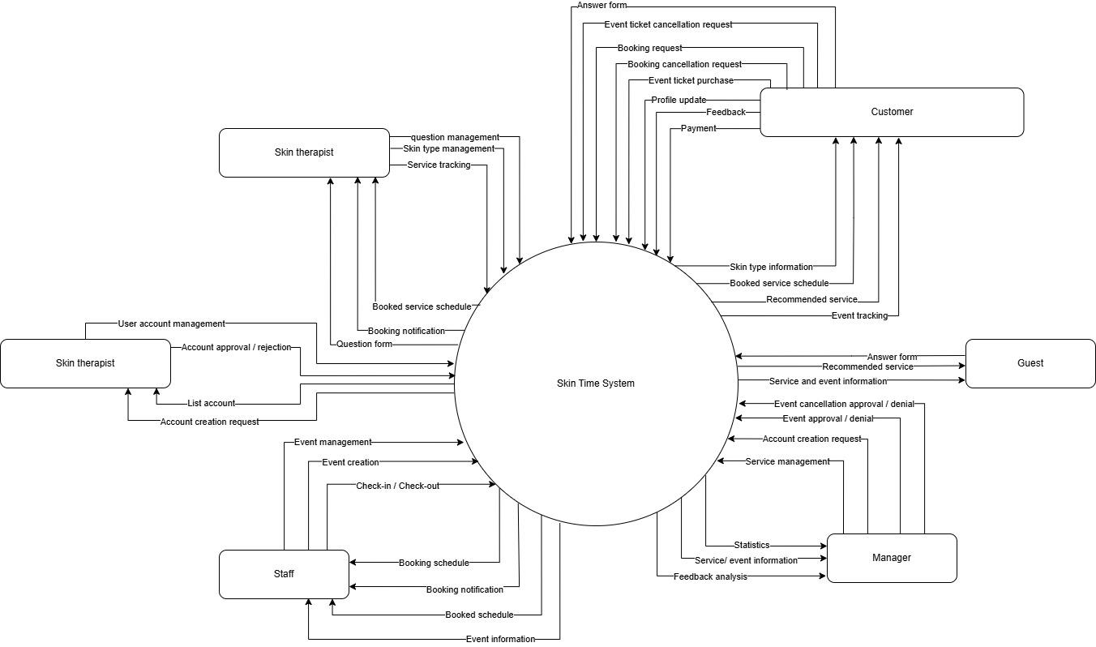

1.1 Actors - Huy

# | Actor | Description
1 | Admin | Manages user access permissions, including staff and skin therapist accounts. Admins review and approve account creation or deletion requests submitted by managers.
2 | Manager | Supervises all services and events in the system. Managers approve or decline events created by staff and request cancellations. They monitor skin therapists' schedules, view feedback, and generate monthly reports on services and events.
3 | Staff | Employees responsible for checking in and checking out customers for services and events. They assist customers in updating the next appointment for multi-step services. Staff can create, edit, and cancel events, view event participants, and communicate with customers, skin therapists, and managers.
4 | Skin therapist | A full-time skincare specialist working from Monday to Sunday, 8 AM to 5 PM. They receive notifications of customer bookings, view customer details and service information, track customer service progress, and manage skin type quizzes.
5 | Customer | A registered user who can browse services, filter services, book skincare services, and purchase event tickets. Customers can cancel services and events following the system's refund policies, provide feedback after services, and communicate with staff and skin therapists.
6 | Guest | A user who is not logged in. They can view information about services, service details, events, and skin therapists in the system. Guests can take a skin type quiz but can only save the result after logging in.

2. User Requirements

2.1 Use case diagram
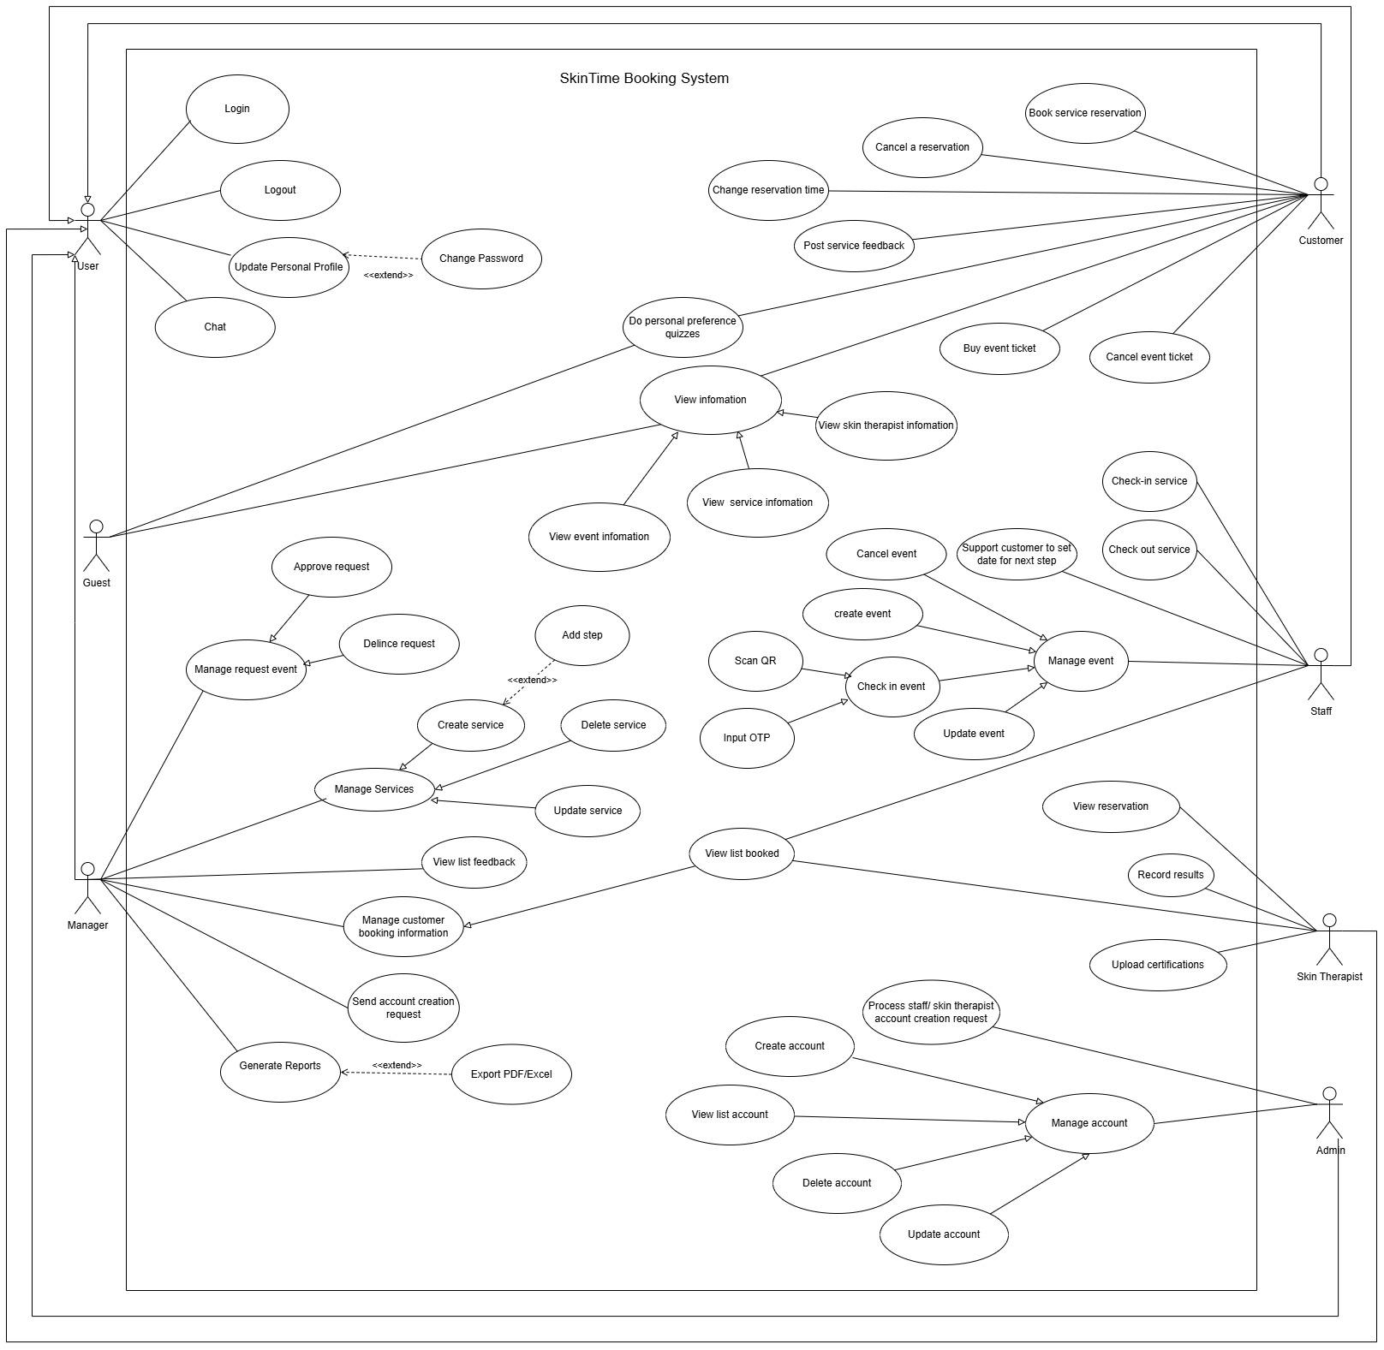

2.2 Use case briefly description

STT | Name use case | Actor | Description
1 | Login | User | Allows users to access the system by entering their credentials.
2 | Logout | User | Enables users to log out of the system.
3 | Chat | User | Allows users to communicate with support or other users through a chat system.
4 | Update Personal Profile | User | Enables users to update their personal information.
5 | Change Password | User | Allows users to change their password.
6 | Book service reservation | Customer | Allows customers to book a skincare service.
7 | Cancel reservation | Customer | Enables customers to cancel their service reservation.
8 | Change reservation time | Customer | Allows customers to reschedule their service reservation.
9 | Post service feedback | Customer | Enables customers to provide feedback on the service they booked.
10 | Buy event ticket | Customer | Allows customers to purchase tickets for events.
11 | Cancel event ticket | Customer | Enables customers to cancel their event ticket.
12 | View information | Customer, guest | Allows customers to view general information about the system.
13 | View service information | Customer, guest | Enables customers to view details about available services.
14 | View event information | Customer, guest | Allows customers to view information about upcoming events.
15 | Do personal preference survey | Customer, guest | Enables customers to complete a survey to receive personalized service recommendations.
16 | Manage request event | Manager | Allows managers to review and manage event requests.
17 | Approve request | Manager | Enables managers to approve event requests.
18 | Delince request | Manager | Allows managers to reject event requests.
19 | Manage Services | Manager | Enables managers to create, update, and delete services.
20 | Create service | Manager | Allows managers to add new services to the system.
21 | Add step | Manager | Enables managers to add steps to service procedures.
22 | Delete service | Manager | Allows managers to remove services from the system.
23 | Update service | Manager | Enables managers to modify service details.
24 | View list feedback | Manager | Allows managers to view feedback submitted by customers.
25 | Manage customer booking infomation | Manager | Enables managers to review and manage customer booking details.
26 | View list booked | Manager, Staff, Skin therapist | Allows managers, staff, and skin therapists to view a list of booked services.
27 | Send account creation request | Manager | Allows managers to request new account creation for staff.
28 | Generate Reports | Manager | Enables managers to generate reports about system activities.
29 | Export PDF/Excel | Manager | Allows managers to export reports in PDF or Excel formats.
30 | Check-in service | Staff | Allows staff to check customers into their service appointment.
31 | Check-out service | Staff | Enables staff to check customers out after their service is completed.
32 | Support customer to set date for next step | Staff | Allows staff to help customers schedule their next appointment step.
33 | Create event | Staff | Enables staff to create events.
34 | Update event | Staff | Allows staff to update event details.
35 | Cancel event | Staff | Enables staff to cancel events.
36 | Check-in event | Staff | Allows staff to check participants into events.
37 | Manage event | Staff | Enables staff to manage event details and participants.
38 | Scan QR | Staff | Allows staff to scan QR codes for check-in.
39 | Input OTP | Staff | Enables staff to input OTP codes for check-in.
40 | View reservation | Skin Therapist | Allows skin therapists to view their assigned reservations.
41 | Record results | Skin Therapist | Enables skin therapists to record treatment results.
42 | Upload certification | Skin Therapist | Allows skin therapists to upload certifications.
43 | Process staff/ skin therapist account creation request | Admin | Allows admins to process account creation requests for staff and skin therapists.
44 | Manage account | Admin | Enables admins to manage user accounts.
45 | View list account | Admin | Allows admins to view a list of all user accounts.
46 | Create account | Admin | Enables admins to create new user accounts.
47 | Update account | Admin | Allows admins to update user account details.
48 | Delete account | Admin | Enables admins to delete user accounts.

2.3 Use case specification

Use Case Specification
Use Case ID and Name: | UC-01: View List Services
Created By: | Phan Thị Hoài Diễm | Date Created: | 24/01/2025
Primary Actor: | Manager | Secondary Actors: | N/A
Trigger: | The Manager can view list service on the available skin care services
Description: | This use case allows the Manager to view list services on the available skin care services. Each service contains information such as Service Name, Description, Price, Duration, Image, and Status.
Preconditions: | Manager is logged in with administrative rights
Post–conditions: | The details of a service are displayed.
Normal Flow: | - Manager logs in and navigates to the dashboard.  - Manager clicks on the “Manage Service” menu item.  The system displays the list of current services along with summary details such as Service Name, Price, and Status.  - Manager selects a specific service (by clicking its name or a “View Details” button). The system opens a detailed view for the selected service, showing full information (Description, Duration, Image, etc.).  - The detailed view remains on screen, with options to return to the list or to choose further actions like Edit or Delete
Alternative Flows: | If the Manager find a service that no longer exists. The system displays an error message “Service not found” and refreshes the list.
Exceptions: | A database or network error prevents the service details from loading properly. The system displays an error message “Unable to retrieve service details, please try again later.”
Priority: | High
Frequency of Use: | Daily or as needed when service information changes
Business Rules: | N/A
Other Information: | N/A
Assumptions: | N/A

Use Case Specification
Use Case ID and Name: | UC-02: Post service feedback
Created By: | Phan Thị Hoài Diễm | Date Created: | 24/01/2025
Primary Actor: | Customer | Secondary Actors: | N/A
Trigger: | The user can submit feedback regarding the service experience
Description: | This use case allows the user to submit feedback regarding the service experience. The feedback includes a rating (e.g., 1–5 stars), comments, and optionally, images. The submitted feedback may be immediately published or queued for moderation.
Preconditions: | - The user must be logged  - The user has completed a service appointment to submit feedback
Post–conditions: | The feedback is stored in the system database and, after any necessary moderation, displayed on the service review page
Normal Flow: | - User logs in and navigates to the “Service Feedback” page. The system displays a list of completed appointments with an option to “Post Feedback” for each service.  - User clicks the “Post Feedback” button for a specific completed service. The system opens a “Post Service Feedback” form containing fields for Rating (e.g., 1–5 stars), Comments, and an option to upload images.  - User enters the required feedback information (selects a rating, writes comments, optionally attaches images).  - User clicks the “Submit Feedback” button.  - The system displays a confirmation message “Feedback submitted successfully”
Alternative Flows: | 2.1 If the user decides to cancel during feedback submission, clicking “Cancel” prompts a confirmation. On confirmation, the system discards the entered data and returns to the previous page
Exceptions: | - If a network or database error occurs during submission, the system shows “Feedback submission failed, please try again later.”  - If the content violates guidelines, the system displays “Your feedback contains inappropriate content and cannot be submitted.”
Priority: | Medium to High
Frequency of Use: | Occurs after every service appointment (potentially daily)
Business Rules: | BR-02, BR-03
Other Information: | N/A
Assumptions: | N/A

Use Case Specification
Use Case ID and Name: | UC-03: Create New Services
Created By: | Phan Thị Hoài Diễm | Date Created: | 24/01/2025
Primary Actor: | Manager | Secondary Actors: | N/A
Trigger: | The Manager can create new service on the available skin care services
Description: | This use case allows the Manager to create new services on the available skin care services. Each service contains information such as Service Name, Description, Price, Duration, Image.
Preconditions: | Manager is logged in with administrative rights
Post–conditions: | The system records new services into the database.
Normal Flow: | - The administrator logs in and navigates to the dashboard.  - The administrator clicks on the “Manage Services” menu item.  - The system displays a list of all existing services along with action buttons (Create, Edit, Delete) below the list.  - The administrator clicks on the “Create New Service” button.  - The administrator enters all required information (e.g name, price, description,... ) into the form.  - The administrator clicks on the “Next” button to go to the Service Step form  - In Service Step, the user chooses to skip if the service has only 1 step, or if it is a field for each step that the service has.  - The administrator clicks on the “Save” button.
Alternative Flows: | 5.1 If the Manager clicks the “Cancel” button while filling out the form  4.1 If the Manager enters incomplete or invalid data. The system highlights the missing or incorrect fields and prompts the Manager to correct them before proceeding
Exceptions: | A system or database error occurs during the saving process. The system shows an error message “Unable to save service due to a system error, please try again later.”
Priority: | High
Frequency of Use: | Daily or as needed when service information changes
Business Rules: | BR-01, BR-10, BR-11
Other Information: | N/A
Assumptions: | N/A

Use Case Specification
Use Case ID and Name: | UC-04: Edit Services
Created By: | Phan Thị Hoài Diễm | Date Created: | 24/01/2025
Primary Actor: | Manager | Secondary Actors: | N/A
Trigger: | The Manager can update service on the available skin care services
Description: | This use case allows the Manager to update service on the available skin care services. Each service contains information such as Service Name, Description, Price, Duration, Image, Status.
Preconditions: | Manager is logged in with administrative rights
Post–conditions: | The system updates new service information into the database.
Normal Flow: | - Manager logs in and navigates to the dashboard.  - Manager clicks on the “Manage Service” menu item.  The system displays a list of all existing services along with action buttons (Create, Edit, Delete) below the list.  - Manager clicks the “Edit” button for a chosen service.  - Manager updates the desired fields (e.g., price, description, or status).  - Manager clicks the “Save Changes” button. The system validates the final data, updates the service record in the database, and shows a confirmation message “Service updated successfully.”
Alternative Flows: | If the Manager clicks “Cancel” during the editing process. The system discards any unsaved changes and returns to the previous service detail view without modifying the data
Exceptions: | A database or system error occurs during the update process. The system displays an error “Unable to update service, please try again later.”
Priority: | High
Frequency of Use: | Daily or as needed when service information changes
Business Rules: | BR-01, BR-10, BR-11
Other Information: | N/A
Assumptions: | N/a

Use Case Specification
Use Case ID and Name: | UC-05: Delete Services
Created By: | Phan Thị Hoài Diễm | Date Created: | 24/01/2025
Primary Actor: | Manager | Secondary Actors: | N/A
Trigger: | The Manager can delete service on the available skin care services
Description: | This use case allows the Manager to delete service on the available skin care services.
Preconditions: | Manager is logged in with administrative rights
Post–conditions: | The system delete services into the database.
Normal Flow: | - Manager logs in and navigates to the dashboard.  - Manager clicks on the “Manage Service” menu item.  The system displays a list of all existing services along with action buttons (Create, Edit, Delete) below the list.  - Manager clicks on the “Delete” button for a specific service. The system prompts a confirmation dialog asking, “Are you sure you want to delete this service?”  - Manager confirms the deletion by clicking “Yes” or “Confirm” in the dialog. The system verifies any dependencies (e.g., if the service is part of an active treatment plan) and then deletes or marks the service as inactive according to the business rules.  - The system displays a confirmation message “Service deleted successfully.” The service list is refreshed, and the deleted service is removed from the display.
Alternative Flows: | 4.1 If the Manager clicks “Cancel” on the confirmation dialog. The system aborts the deletion process and returns to the Manage Service list without any changes.
Exceptions: | The service selected for deletion is linked to an active treatment plan. The system displays a warning “Service is in use and cannot be deleted” and aborts the deletion.  A database or system error occurs during the deletion process. The system shows an error “Unable to delete service due to a system error, please try again later.”
Priority: | High
Frequency of Use: | Daily or as needed when service information changes
Business Rules: | BR-05, BR-06
Other Information: | N/A
Assumptions: | N/A

Use Case Specification
Use Case ID and Name: | UC-06: Scan QR
Created By: | Phúc Tấn | Date Created: | 11/02/2025
Primary Actor: | Customer | Secondary Actors: | System
Trigger: | The customer scans a QR code for event check-in or service verification
Description: | The system processes a QR code scan to verify attendance or access services
Preconditions: | - PRE1: The customer must have an active event or service booking  - PRE2: The QR code must be valid
Post–conditions: | - POST1: The system successfully verifies the QR code  - POST2: The system updates the check-in or service status  - POST3: The customer receives a confirmation message
Normal Flow: | - The customer opens the QR scanner in the app.  - The system activates the camera for scanning.  - The customer scans the QR code.  - The system processes the QR data and validates it.  - If valid, the system updates the check-in or service status.  - The system displays a success message to the customer.
Alternative Flows: | - AF1: If the QR code is invalid, the system displays an error message.
Exceptions: | - EX1: If the customer has already checked in, the system prevents duplicate check-ins
Priority: | High
Frequency of Use: | Often
Business Rules: | BR-07, BR-08, BR-09
Other Information: | The system logs all QR scan attempts for security
Assumptions: | The QR scanner function is reliable

Use Case Specification
Use Case ID and Name: | UC-07: Create event
Created By: | Nguyễn Anh Huy | Date Created: | 18/02/2025
Primary Actor: | Staff | Secondary Actors: | Manager, customer
Trigger: | Staff decides to create an event to promote services
Description: | This use case describes the process of creating an event in the system. The staff enters event details such as title, description, date, time, location, speaker, capacity, and ticket price.
Preconditions: | PRE-1: The staff must be logged into the system  PRE-2: The event start date must be at least one week from the creation date.
Post–conditions: | POST-1: The event is successfully created and awaits manager approval.  POST-2: Staff will be notified via email and system after being approved/ delince by manager.  POST-3: The event details are stored in the system.
Normal Flow: | - Staff logs into the system.  - Staff navigates to the event management section.  - Staff selects "Create Event."  - Staff fills in all required event details.  - System validates input data and checks for conflicts with existing events.  - Staff submits the event form.  - System saves the event details and sends it for manager approval.  - Manager approves or declines the event.
Alternative Flows: | 5a: If required fields are missing, the system prompts the staff to complete them.  5b: If there is an event with the same time, a warning message will be displayed warning of the time overlap.  8a: If the manager declines the event, the system notifies the staff with reasons.
Exceptions: | If the system encounters an error while saving, an error message is displayed
Priority: | High (Medium, Low)
Frequency of Use: | Varies depending on business needs.
Business Rules: | BR-12, BR-13, BR-14, BR-15
Other Information: | N/A
Assumptions: | The staff understands how to use the system.  System performance is stable during event creation.

Use Case Specification
Use Case ID and Name: | UC-08: Approve/ declince event
Created By: | Nguyễn Anh Huy | Date Created: | 18/02/2025
Primary Actor: | Manager | Secondary Actors: | Staff
Trigger: | When the staff has successfully created the event and sent the request for manager approval
Description: | This use case describes the process for a manager to approve or decline an event created by staff.
Preconditions: | PRE-01: The event is created and awaiting approval.
Post–conditions: | POST-01: Once approved, the event will be displayed on the system's main screen.  POST-02: Once an event is declinced, it will be notified to the staff along with a few reasons from the manager.
Normal Flow: | - Manager logs into the system.  - Manager navigates to the event approval section.  - Manager reviews event details.  - Manager either approves or declines the event.  Approve:  A1. Staff received notification that event was successfully initiated  A2. Event is displayed on the main page of the system  Delince:  D1. Staff receive notification and reason for delince event  D2. Event status changed
Alternative Flows:
Exceptions: | If the system encounters an error, an error message is displayed.
Priority: | High
Frequency of Use: | N/A
Business Rules: | N/A
Other Information: | N/A
Assumptions: | Managers regularly review event requests.

Use Case Specification
Use Case ID and Name: | UC-09: Do Personal Preference Quizzes
Created By: | Nguyễn Anh Huy | Date Created: | 18/02/2025
Primary Actor: | Guest, Customer | Secondary Actors:
Trigger: | A guest, customer wants to determine their skin type through the quiz.
Description: | This use case describes the process of a guest taking a quiz to identify their skin type. The quiz consists of several questions regarding skin conditions.
Preconditions: | The user must be on the website.
Post–conditions: | The user receives their skin type results.
Normal Flow: | - Guest, customer visits the website.  - Guest, customer navigates to the quiz section.  - Guest, customer starts the quiz.  - Guest, customer answers all questions.  - System processes responses.  - System displays skin type results.  - The system suggests services suitable for skin type.
Alternative Flows: | N/A
Exceptions: | If the system fails to process the quiz, an error message is displayed.
Priority: | Low
Frequency of Use: | Used whenever a user wants to know their skin type.
Business Rules: | N/A
Other Information: | N/A
Assumptions: | The quiz questions are accurate and scientifically valid.  Users understand the questions and can answer them correctly.

Use Case Specification
Use Case ID and Name: | UC-10: Removed event
Created By: | Nguyễn Anh Huy | Date Created: | 19/02/2025
Primary Actor: | Staff | Secondary Actors: | manager
Trigger: | Staff decides to removed an event due to low registration, scheduling conflicts, or other valid reasons.
Description: | This use case describes the process of removing an event. Staff can remove an event before the manager approves it or request removal if it has already been approved. If customers have already registered, refunds are issued as per the business rules.
Preconditions: | PRE-01: The event exists in the system  PRE-02: The event is either awaiting approval or has been approved but not yet started.  PRE-03: Staff must fill in a valid reason for removing the event.
Post–conditions: | POST-01: If participants have registered, the event is removed after manager approval, and refunds are processed.  POST-02: The system notifies all relevant parties (staff, manager, customers).  POST-03: Events that are removed by staff will be in pending statusfor manager approve/delince and will not appear on the main screen.
Normal Flow: | - Staff logs into the system.  - Staff navigates to the event management section.  - Staff selects an event and chooses "Remove Event."  - Staff provides a removal reason from a predefined list.  - System verifies that the reason meets business rules (e.g., less than 50% capacity).  - Removal request is sent to the manager for approval.  - Manager reviews and approves/rejects the removal.  - If approved, system removes the event, notifies customers, and processes refunds.
Alternative Flows: | AF-01: If the removal time is within 48 hours before the event starts, the system will notify that the event cannot be removed during this time.  AF-02: If removal reason does not meet business rules, the system informs the staff and prevents the request.  AF-03: If the manager rejects the removal request, the event remains active, and staff is notified.  AF-04: After manager approve, system need notice for staff and customer who register this event.
Exceptions: | If the system encounters an error, an error message is displayed, and removal does not proceed.
Priority: | High (Medium, Low)
Frequency of Use: | Varies depending on business needs.
Business Rules: | BR-16, BR-17, BR-18, BR-19
Other Information: | N/A
Assumptions: | Staff members understand removal policies and system workflow.  Customers receive timely notifications of removal.

Use Case Specification
Use Case ID and Name: | UC-11: Cancel ticket event
Created By: | Nguyễn Anh Huy | Date Created: | 19/02/2025
Primary Actor: | Staff | Secondary Actors: | manager
Trigger: | Staff decides to cancel an event due to low registration, scheduling conflicts, or other valid reasons.
Description: | This use case describes the process of canceling an event. Staff can cancel an event before the manager approves it or request cancellation if it has already been approved. If customers have already registered, refunds are issued as per the business rules.
Preconditions: | PRE-01: The event exists in the system  PRE-02: The event is either awaiting approval or has been approved but not yet started.  PRE-03: Staff must fill in a valid reason for canceling the event.
Post–conditions: | POST-01: If participants have registered, the event is canceled after manager approval, and refunds are processed.  POST-02: The system notifies all relevant parties (staff, manager, customers).  POST-03: Events that are cancelled by staff will be in pending statusfor manager approve/delince and will not appear on the main screen.
Normal Flow: | - Staff logs into the system.  - Staff navigates to the event management section.  - Staff selects an event and chooses "Cancel Event."  - Staff provides a cancellation reason from a predefined list.  - System verifies that the reason meets business rules (e.g., less than 50% capacity).  - Cancellation request is sent to the manager for approval.  - Manager reviews and approves/rejects the cancellation.  - If approved, system cancels the event, notifies customers, and processes refunds.
Alternative Flows: | AF-01: If the cancellation time is within 48 hours before the event starts, the system will notify that the event cannot be canceled during this time.  AF-02: If cancellation reason does not meet business rules, the system informs the staff and prevents the request.  AF-03: If the manager rejects the cancellation request, the event remains active, and staff is notified.  AF-04: After manager approve, system need notice for staff and customer who register this event.
Exceptions: | If the system encounters an error, an error message is displayed, and cancellation does not proceed.
Priority: | High (Medium, Low)
Frequency of Use: | Varies depending on business needs.
Business Rules: | BR-20: Event can only cancel before 48 hours from event start time
Other Information: | N/A
Assumptions: | Staff members understand cancellation policies and system workflow.  Customers receive timely notifications of cancellations.

Use Case Specification
Use Case ID and Name: | UC-12: Cancel Service
Created By: | Nguyễn Anh Huy | Date Created: | 19/02/2025
Primary Actor: | Customer | Secondary Actors: | manager
Trigger: | Customer decides to cancel a booked service due to personal reasons or scheduling conflicts.
Description: | This use case describes the process of canceling a booked skincare service. Customers can cancel their booking, but refunds are only processed if the cancellation occurs at least 48 hours before the service start time. If the booking was made for the next day or the cancellation happens within 48 hours of the service, no refund is issued.
Preconditions: | PRE-01: The service booking exists in the system.  PRE-02: The service has not yet started.  PRE-03: The customer initiates the cancellation process through the system.
Post–conditions: | POST-01: If the cancellation occurs before 48 hours of the service start time, a refund is issued.  POST-02: If the cancellation occurs within 48 hours of the service start time, no refund is processed.  POST-03: The system updates the booking status and notifies the relevant parties.
Normal Flow: | - Customer logs into the system.  - Customer navigates to their booking history.  - Customer selects a booked service and chooses "Cancel Service."  - System verifies the cancellation time against the business rules.  - If the cancellation occurs before 48 hours of the service start time, the system processes a refund.  - System updates the booking status and notifies the customer and the service provider.
Alternative Flows: | AF-01: If the cancellation time is within 48 hours of the service start time, the system notifies the customer that no refund will be issued.  AF-02: If the service was booked for the next day and the customer attempts to cancel, the system notifies that the cancellation is possible but without a refund.  AF-03: If the system encounters an error during the cancellation process, an error message is displayed, and the cancellation does not proceed.
Exceptions: | If the service has already started, cancellation is not allowed.  If the refund process fails, the system logs the issue and notifies the administrator.
Priority: | High
Frequency of Use: | Varies depending on customer needs.
Business Rules: | BR-21, BR-22, BR-23, BR-24
Other Information: | N/A
Assumptions: | Customers understand the cancellation and refund policy.  The system accurately tracks booking times and calculates refund eligibility

Use Case Specification
Use Case ID and Name: | UC-13: Record Service Progress
Created By: | Nguyễn Thị Ngọc Thư | Date Created: | 29/1/2025
Primary Actor: | Staff | Secondary Actors: | Customer
Trigger: | The staff wants to view the customer's service schedule, check-in when they start a service, and process checkout when they complete a session.
Description: | Staff can:  - View the customer's service schedule by day.  - Check-in to confirm that a customer has started a service.  - Checkout to mark the service as completed and process payment if required.
Preconditions: | The staff has logged into the system.  The system has customer service schedule data available.
Post–conditions: | The staff can view the customer's scheduled services for a selected day.  The system updates the service status when staff performs a check-in or checkout.  If necessary, the checkout process records the payment confirmation.
Normal Flow: | - The staff accesses the dashboard.  - The staff selects a date from the calendar.  - The system displays a list of customers with scheduled services on that date.  - The staff selects a customer to view their service schedule.  - The system displays the list of scheduled services with their current status.  - When the customer arrives, the staff clicks "Check-in" to mark the service as in progress.  - When the service is completed, the staff clicks "Checkout" to mark the service as done and confirm the payment.  - The system updates the service status and records the checkout time.
Alternative Flows: | A1: If there are no scheduled services on the selected date, the system displays a message: "No services scheduled for this date."  A2: If the customer has already checked in, the system disables the check-in button and allows only checkout.  A3: If the payment is pending, the system prompts the staff to confirm payment before completing the checkout.
Exceptions: | - Staff does not have permission to update the service status → Show an error message.  - System error when retrieving or updating data → Show an error message and ask the staff to try again later.  - Payment issue during checkout → Show a warning and ask staff to retry or select another payment method.
Priority: | High (Medium, Low)
Frequency of Use: | Multiple times per day
Business Rules: | BR-25, BR-26, BR-27, BR-38
Other Information: | The staff can filter and search for customers in the list.  The system should log all check-in and checkout actions for tracking purposes.
Assumptions: | The system already stores customer schedules and service details.  Staff has valid access rights to manage service check-in and checkout.  The checkout process may involve manual payment handling or an integrated payment system.

Use Case Specification
Use Case ID and Name: | UC-14: Staff Check-in for Customer Service
Created By: | Nguyễn Thị Ngọc Thư | Date Created: | 29/1/2025
Primary Actor: | Staff | Secondary Actors: | Customer
Trigger: | The customer arrives at the service location, and the staff initiates the check-in process to mark the service as "In Progress."
Description: | This use case allows staff to check-in a customer when they start a scheduled service. The system updates the service status, logs the check-in time, and ensures that the service progresses correctly.
Preconditions: | - The staff has logged into the system.  - The system has the customer's scheduled service available for the selected date.  - The customer has not yet checked in for the service.
Post–conditions: | - The system updates the service status to "In Progress."  - The check-in time is recorded.  - The system prevents duplicate check-ins for the same service session.
Normal Flow: | - The staff accesses the dashboard.  - The staff selects a date from the calendar.  - The system displays a list of customers with scheduled services for that date.  - The staff selects a customer to view their service details.  - The system displays the list of scheduled services for the customer.  - The staff clicks the "Check-in" button for the service that is starting.  - The system updates the service status to "In Progress."  - The system logs the check-in time and the staff member who performed the action.  - The system updates the UI to disable the check-in button and enable checkout for that service.
Alternative Flows: | A1: If the customer has already checked in, the system disables the check-in button and displays a message:  "Customer has already checked in for this service."  A2: If the customer does not arrive on time, the staff can delay check-in but cannot proceed without customer presence.
Exceptions: | - Staff does not have permission to check in → Show an error message: "You are not authorized to perform this action."  - System error while updating status → Show an error message and retry later.  - Network issue → Show an offline mode notification and allow retry.
Priority: | High (Medium, Low)
Frequency of Use: | Multiple times per day
Business Rules: | BR-04
Other Information: | The check-in action should be time-stamped and stored in the service history.  The system should automatically move the service to "In Progress" after check-in.
Assumptions: | The customer arrives at the scheduled time.  The system is online and functional when the check-in is performed.

Use Case Specification
Use Case ID and Name: | UC-15: Staff Reschedule Next Step Session
Created By: | Nguyễn Thị Ngọc Thư | Date Created: | 29/1/2025
Primary Actor: | Staff | Secondary Actors: | Customer
Trigger: | Customers request a schedule change for their next step after completing the current step.  Staff accesses the scheduling system to adjust the customer's next step.
Description: | This use case allows staff to reschedule the next step for a customer. The system updates the new date and time while ensuring that the treatment order remains valid within the plan.
Preconditions: | - The customer is enrolled in a service.  - The customer has already completed the current session.  - The staff has the necessary permissions to modify the schedule.
Post–conditions: | - The next session is updated with the new date and time.  - The system notifies the customer about the schedule change.  - The updated schedule is visible on the staff dashboard, skin therapist and the customer's account.
Normal Flow: | - The staff accesses the dashboard and selects the customer's service.  - The system displays the current treatment schedule, highlighting the next session.  - The staff selects the reschedule option for the next session.  - The staff chooses a new date and time based on availability.  - The system validates the new schedule (ensuring that the session order remains logical).  - The staff confirms the change and submits the update.  - The system updates the next session with the new date and time.  - The system sends a notification to the customer about the new schedule.  - The updated schedule is displayed on the dashboard.
Alternative Flows: | A1: If the customer wants to skip the next session, the staff can mark it as "Skipped", and the system will automatically adjust the following session.  A2: If the new date is unavailable, the system suggests alternative available slots.
Exceptions: | - The selected date is already fully booked → Show an error message: "Selected time is unavailable. Please choose another slot."  - The rescheduling violates the treatment order → Show a warning and prevent changes.  - The system fails to update the schedule → Display an error message and retry.
Priority: | High (Medium, Low)
Frequency of Use: | Frequent (depends on customer requests)
Business Rules: | BR-28, BR-29
Other Information: | The system should log all rescheduling actions for tracking purposes.  Customers should receive email/SMS notifications for schedule updates.
Assumptions: | Customers might request rescheduling multiple times, so the system should handle frequent changes efficiently.  The staff can access real-time availability of treatment slots

Use Case Specification
Use Case ID and Name: | UC-16: Manage Customer Feedback
Created By: | Lê Minh Trí | Date Created: | 29/1/2025
Primary Actor: | Manager | Secondary Actors: | N/A
Trigger: | The manager wants to manage all feedback of customer
Description: | Manager can:  - View all feedback  - Hiden all feddback
Preconditions: | The manager has logged into the system.  The system has feedback’customer data available.
Post–conditions: | The manager can view view all feed back.  The system updates the feedback status when the manager update status .
Normal Flow: | - The manager accesses the dashboard.  - The manager selects All feedback.  - The system displays all the information  - The manager click status “hiden”.  - The system will update database.
Alternative Flows: | N/A
Exceptions: | N/A
Priority: | Low(Medium, High)
Frequency of Use: | Multiple times per day
Business Rules: | N/A
Other Information: | The manager can filter feedback for date.
Assumptions: | The system already stores all feedback details.

Use Case Specification
Use Case ID and Name: | UC-17: Generate Reports
Created By: | Lê Minh Trí | Date Created: | 29/1/2025
Primary Actor: | Manager | Secondary Actors: | N/A
Trigger: | The manager wants to Generate Reports.
Description: | Manager can:  - View Total of User  - View Total of Service  - View Total of Questions  - View Total of Event
Preconditions: | The manager has logged into the system.  The system has Customer, Service, Question, and Event data available.
Post–conditions: | The manager can view the all information in the system.  The system analyzes all information
Normal Flow: | - The manager accesses the dashboard.  - The manager selects the Generate Reports button  - The system displays all the information
Alternative Flows: | N/A
Exceptions: | N/A
Priority: | Medium(High, Low)
Frequency of Use: | Sometimes.
Business Rules: | N/A
Other Information: | The manager can filter all information on list by field .
Assumptions: | N/A

Use Case Specification
Use Case ID and Name: | UC-18: Export PDF/Excel
Created By: | Lê Minh Trí | Date Created: | 29/1/2025
Primary Actor: | Manager | Secondary Actors: | N/A
Trigger: | The staff wants to Export PDF/Excel
Description: | Manager can:  - View all information of the system  - Export the information by PDF/Excel
Preconditions: | The manager has logged into the system.  The system has all information data available.
Post–conditions: | The staff will the file export.  The system generates the export file
Normal Flow: | - The manager accesses the dashboard.  - The manager selects the Export Reports button  - The system generate and export report.  - The manager have the file in the computer’manager
Alternative Flows: | N/A
Exceptions: | N/A
Priority: | Low(Medium,High)
Frequency of Use: | Somtimes
Business Rules: | N/A
Other Information: | N/A
Assumptions: | N/A

Use Case Specification
Use Case ID and Name: | UC-19: Send account creation request
Created By: | Giang | Date Created: | 01/02/2025
Primary Actor: | Manager | Secondary Actors: | System Admin
Trigger: | The user (with manager role) clicked on the “Add new employee” button on the Employee List screen.
Description: | The manager can send a staff account creation request to the system admin.
Preconditions: | PRE.1: The requesting user must log in with an account with a ”manager” role.
Post–conditions: | POST.1: A new employee account will be added to the employee/staff list if the request is accepted.  POST.2: The manager will be notified about the result from the system admin decision.  POST.2: The employee will be notified about their account creation through email.
Normal Flow: | 1. The manager selects the employee type they want to add. (staff / therapist)  2. The manager fills in the required fields of information. extra required information that requires file upload such as certifications and other files will be prepared by the manager beforehand.  4. The manager can optionally add some notes about the request.  5. When finished, the manager will click on the “Send Request” button at the bottom of the page.  6. The system admin will receive a notification through email from the system.  7. When logged in with the right permission, the system admin navigates to the account request screen.  8. The system will list all available requests on the screen, with the newest at the top and oldest at the bottom.  9. The system admin selects the request that they want to check.  10. The system admin accepts the request by clicking on the “Accept” or “Decline” button on the request.
Alternative Flows: | AF.1: If the admin presses the decline button, they can optionally add in the reason why they refuse to accept. The account information will still be available for the manager to be re-approve later on.
Exceptions: | EX.1: Once the request has been sent, there will be no additional way to unsend it.
Priority: | Low
Frequency of Use: | Only when new employees are hired. So less than once a day.
Business Rules: | N/A
Other Information: | After a week, if there is no further action made on a pending request, it will be automatically removed from the system.
Assumptions: | AS.1: The system admin might be available 24/24 for support.

Use Case Specification
Use Case ID and Name: | UC-20: Book Service Reservation
Created By: | Giang | Date Created: | 01/02/2024
Primary Actor: | Customer | Secondary Actors: | Staff, Payment System
Trigger: | The customer is currently viewing a service information or viewing available service list and clicking on the “book now” button.
Description: | A customer can create a reservation for a service they choose with an option to appoint a therapist they want.
Preconditions: | PRE.1: The customer is currently logged in and viewing available services.
Post–conditions: | POST.1: There will be a confirmation email sent to the customer after all of the steps are completed.  POST.2: The therapist has been appointed either by the staff arrangement or the customer choice will also get a notification from the system.
Normal Flow: | 1. The customer chooses a therapist they want for the service.  2. After the therapist is chosen, the system displays all available time on the current day.  3. The customer can select an available date suitable to them.  4. The system will show all available time according to the customer selected date.  5. The customer selects the available time that they want.  6. The customer will be directed to the confirmation screen.  7. The system will show all information about the reservation for confirmation.  8. The customer clicks on the “Select payment method” button in order to pay a deposit and finish the process.  9. The customer can select one available payment method to process to payment. They must check the checkbox before allowed to continue.  10. The system will redirect the customer to the third party payment system interface to finish the payment.  12. After finishing the payment, the customer will be redirected to the success page.
Alternative Flows: | AF.1: If the customer does not choose a therapist for the reservation or selects the “choose a therapist for me” option, the staff will be the one in charge of arranging the therapist before the day of service.
Exceptions: | EX.1: If the transaction failed while processing the deposit, the customer will be redirected back to the select payment method screen.
Priority: | High
Frequency of Use: | Highly intensive, this is the main business and process of the system. Approximately equal or more than once a day.
Business Rules: | N/A
Other Information: | The deposit payment must be complete in order to book a reservation.
Assumptions: | AS.1: Most customers will select a therapist to their own preference.  AS.2: At least one payment system will be available to use.

Use Case Specification
Use Case ID and Name: | UC-21: Cancel a reservation
Created By: | Giang | Date Created: | 02/02/2024
Primary Actor: | Customer | Secondary Actors: | Payment system
Trigger: | The customer clicks on the “cancel reservation” button while viewing reservation information.
Description: | A customer can cancel an appointment if they don’t want to use the service anymore.
Preconditions: | PRE.1: The customer has already logged in with the account that made the reservation.  PRE.2: The affected reservation time is equal to or larger than the 24 hours duration before the cancelation time.
Post–conditions: | POST.1: The reservation status will be changed to “Canceled”.  POST.2: The time of the reservation will be available for other customers to create a reservation.
Normal Flow: | 1. The system will show a confirmation popup to the customer.  2. The customer clicks on the “Proceed” button.  3. The system will do a refund transaction back to the user.  4. The customer will be redirected to the success page.  4. The system will send a notification to the customer and the therapist about the cancellation.
Alternative Flows: | AF.1: If the reservation is already out of the 24 hour duration after successfully created, there will be no refund.
Exceptions: | EX.1: There will be a notification to the manager in case the refund transaction fails.
Priority: | Medium
Frequency of Use: | Probably once or twice a month. Not as much as creating a reservation..
Business Rules: | N/A
Other Information: | N/A
Assumptions: | N/A

Use Case Specification
Use Case ID and Name: | UC-22: Pay Service Deposit
Created By: | Phúc Tấn | Date Created: | 11/02/2025
Primary Actor: | Customer | Secondary Actors: | System
Trigger: | The customer selects a service and proceeds to make a deposit payment
Description: | The system allows customers to pay a deposit to secure a booking for a service
Preconditions: | - PRE1: The customer must be logged into their accoun  - PRE2: The customer must select a service that requires a deposit
Post–conditions: | - POST1: The deposit payment is processed successfully  - POST2: The system confirms the payment and updates the booking status  - POST3: The customer receives a confirmation receipt
Normal Flow: | - The customer selects a service from the service list.  - The system displays the service details, including the deposit amount.  - The customer clicks on the "Pay Deposit" button.  - The system redirects the customer to the payment page.  - The customer enters their payment details and confirms the transaction.  - The system processes the payment and validates the transaction.  - If successful, the system updates the booking status and generates a rec  - The system notifies the customer of the successful deposit payment.
Alternative Flows: | - AF1: If the payment fails, the system displays an error message and allows the customer to retry.
Exceptions: | - EX1: If the payment gateway is down, the transaction cannot be completed.
Priority: | High
Frequency of Use: | Often
Business Rules: | BR-30
Other Information: | The customer can check payment history in their account.
Assumptions: | The system supports multiple payment methods.

Use Case Specification
Use Case ID and Name: | UC-23: Register Event
Created By: | Phúc Tấn | Date Created: | 11/02/2025
Primary Actor: | Customer | Secondary Actors: | System
Trigger: | The customer decides to register for an event.
Description: | The system enables customers to register for available events
Preconditions: | - PRE1: The customer must be logged into their account.  - PRE2: The event must have available slots.
Post–conditions: | - POST1: The customer is successfully registered for the event.  - POST2: The system updates the event's attendee list.  - POST3: The customer receives a confirmation email.
Normal Flow: | - The customer navigates to the event section.  - The system displays a list of upcoming events.  - The customer selects an event and clicks "Register".  - The system checks availability and prompts for confirmation.  - The customer confirms their registration.  - The system updates the event registration list.  - The system sends a confirmation email to the customer.
Alternative Flows: | - AF1: If the event is full, the system displays an error message.
Exceptions: | - EX1: If the event is canceled, the customer will receive a refund if applicable.
Priority: | Medium
Frequency of Use: | Regularly
Business Rules: | BR-31, BR-32, BR33, BR-36, BR-37
Other Information: | Customers can unregister before the event starts
Assumptions: | The event system is integrated with notifications

2.3 Activity diagram

Create Event - Giang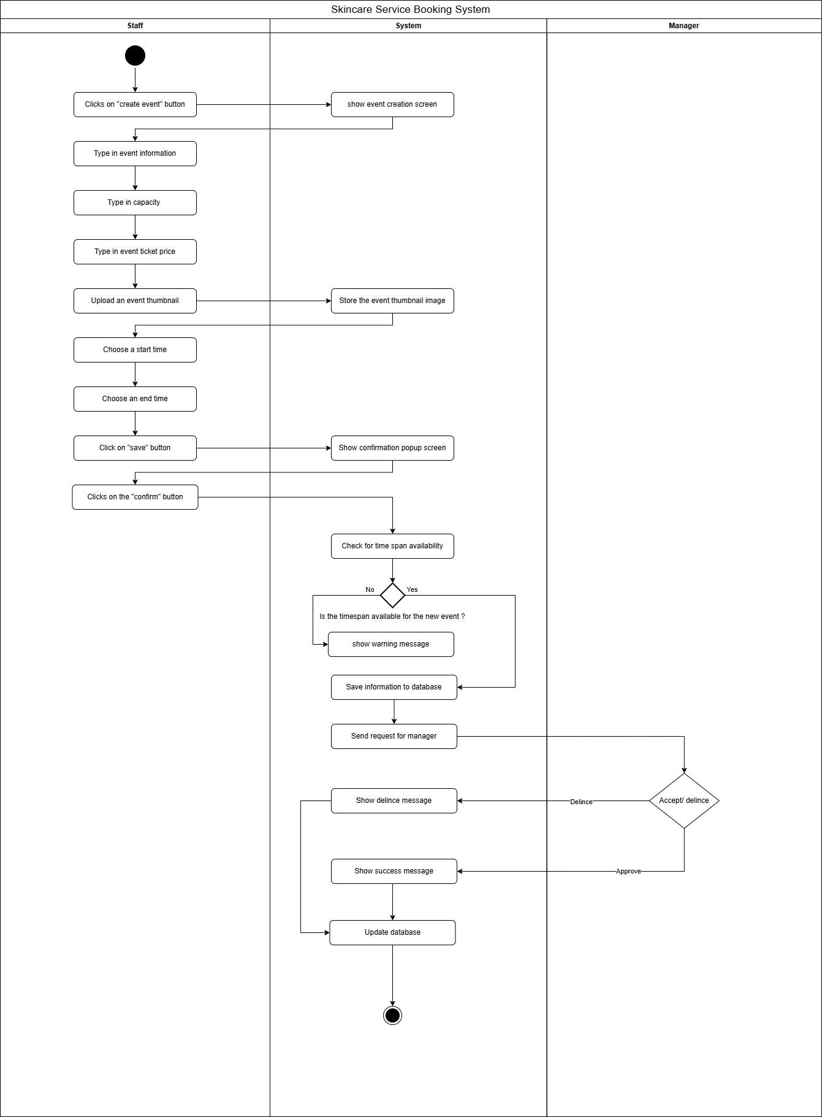

Update Event - Huy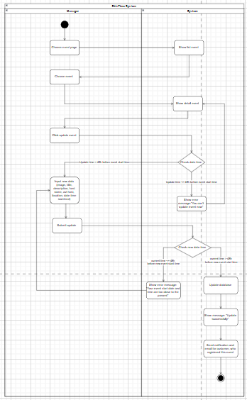

Cancel Ticket Event - Trí
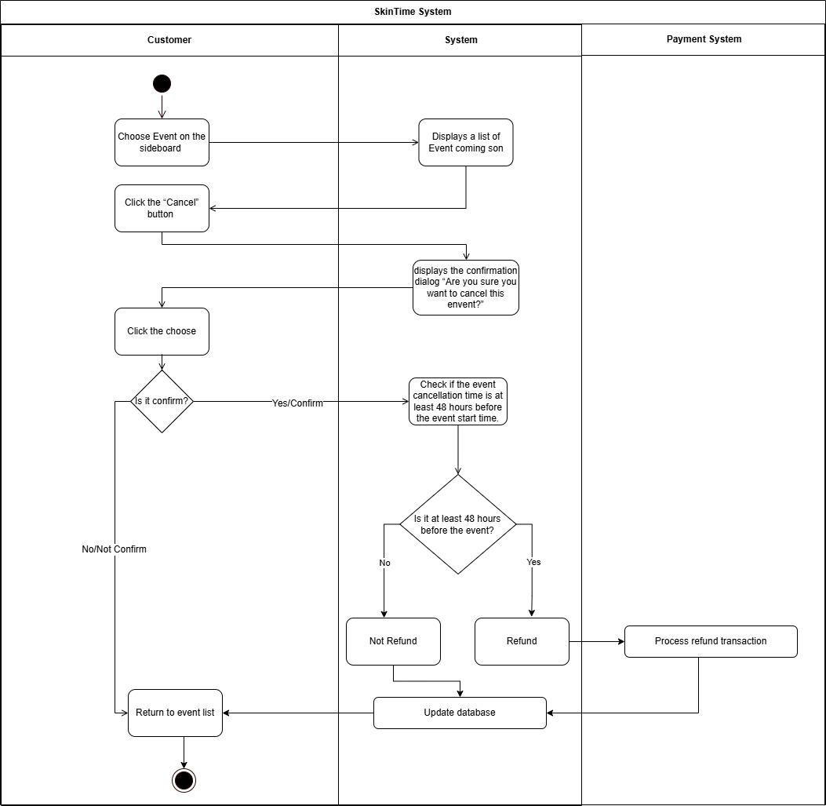

Register Event - Giang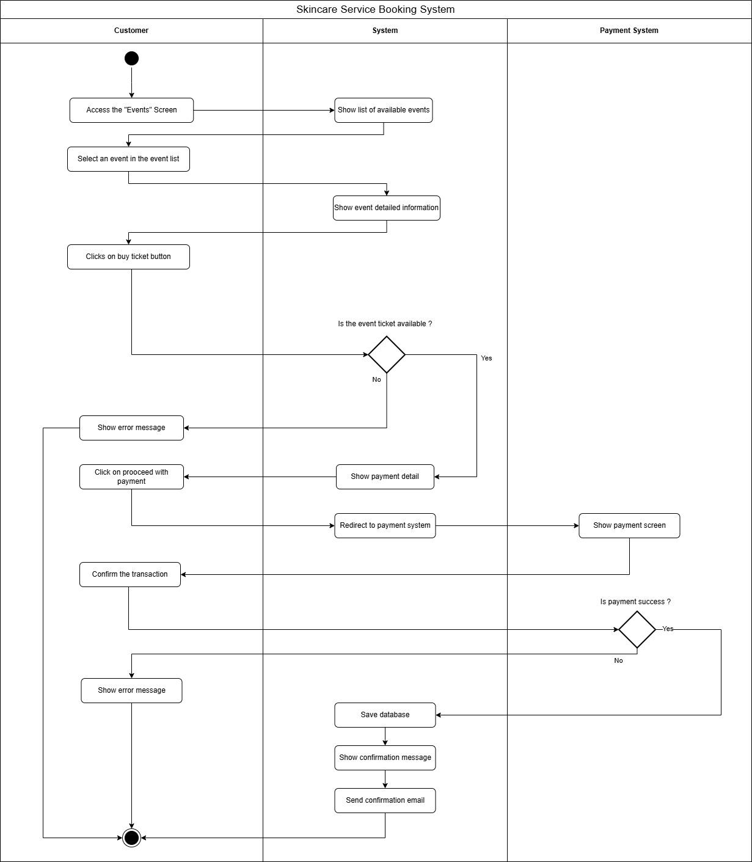

Check-in Event - Huy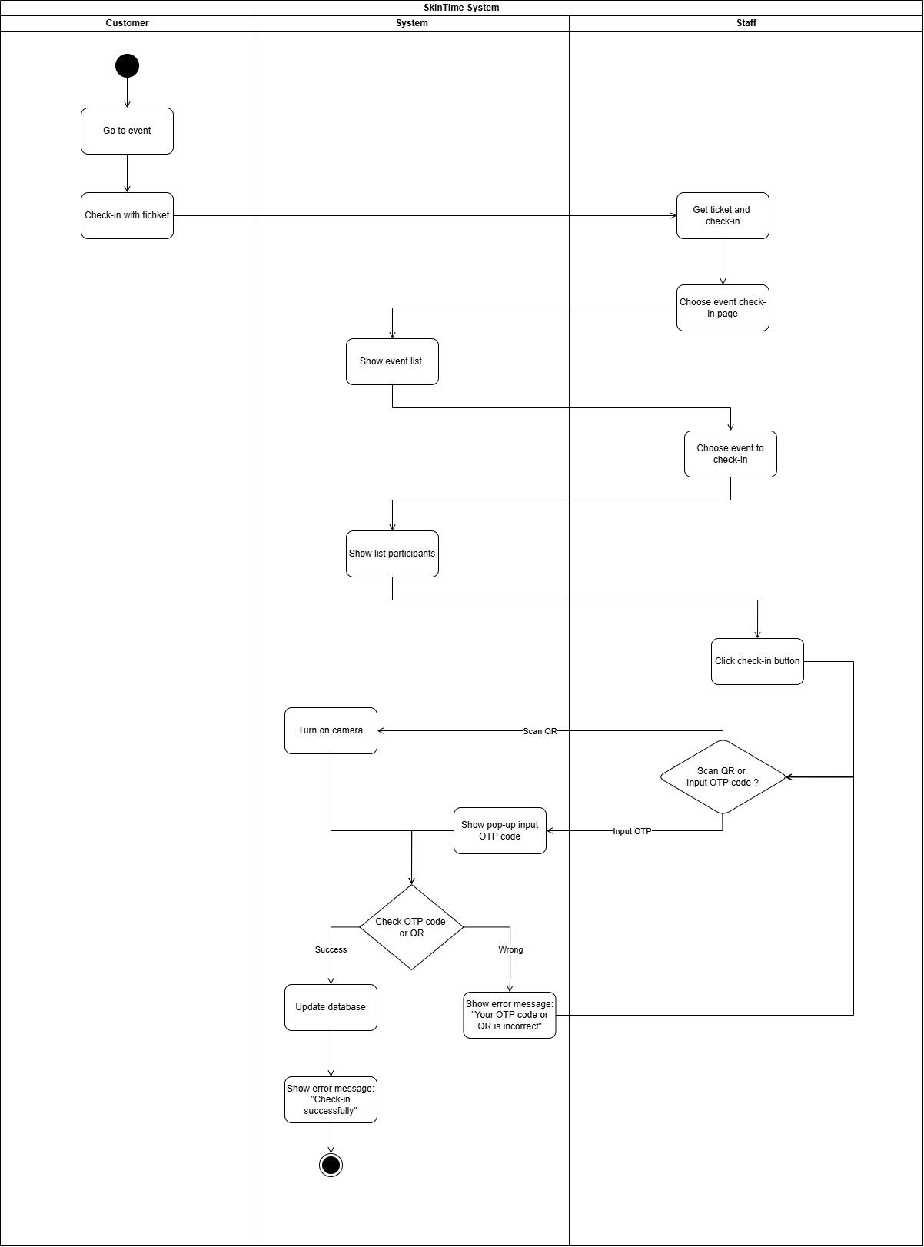

Create Service - Giang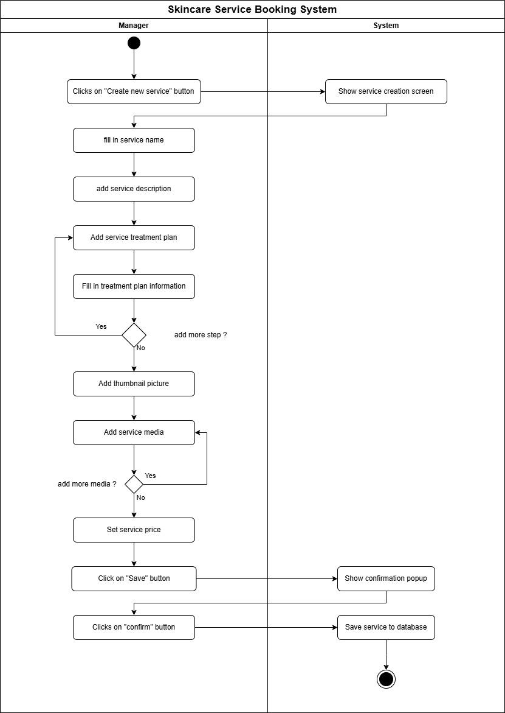

Update Step Date - Thư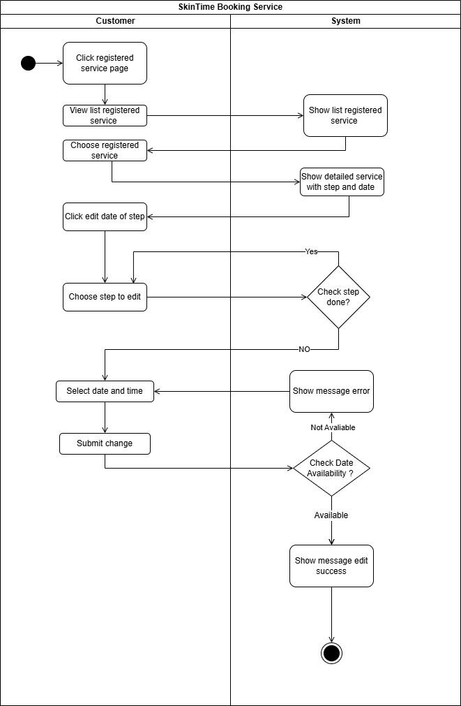

Delete Service - Diễm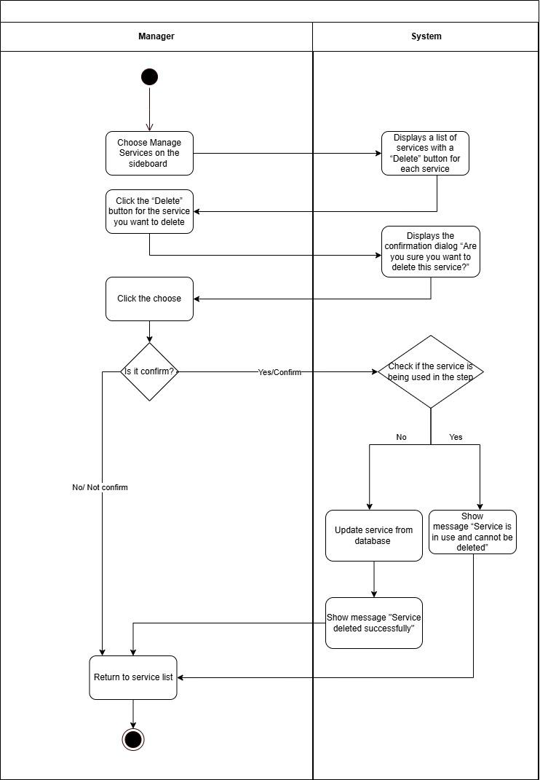

Book Service - Huy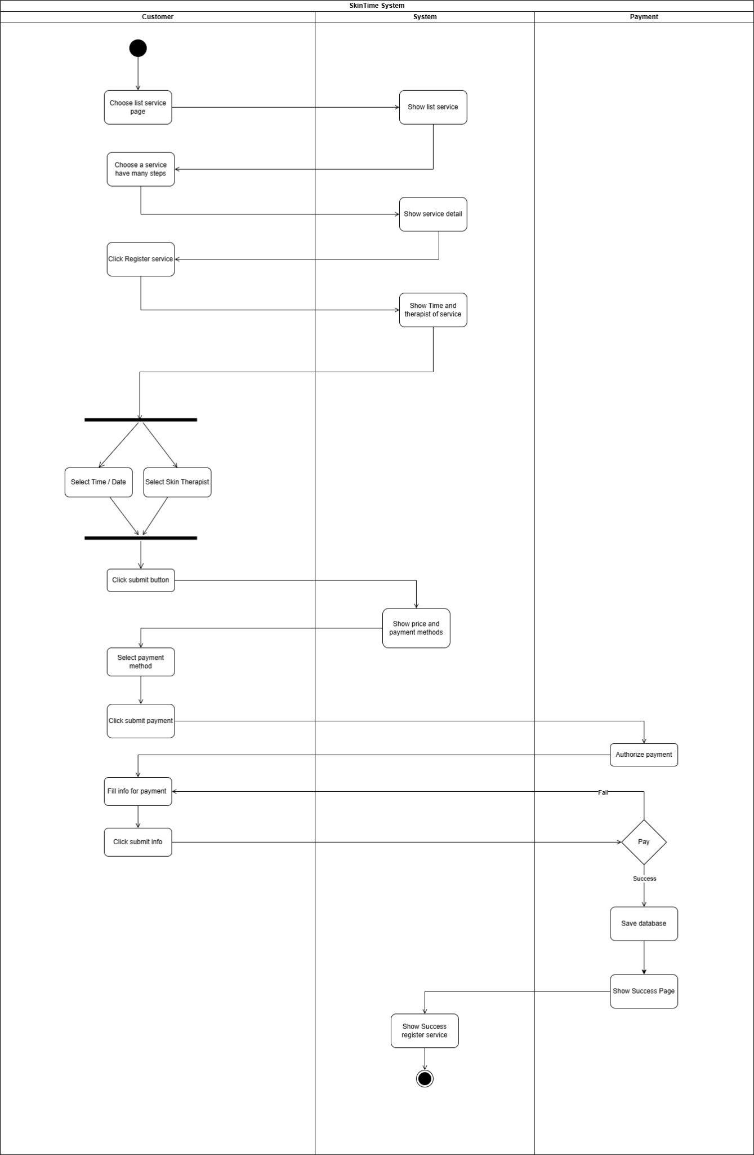

Cancel Booking - Giang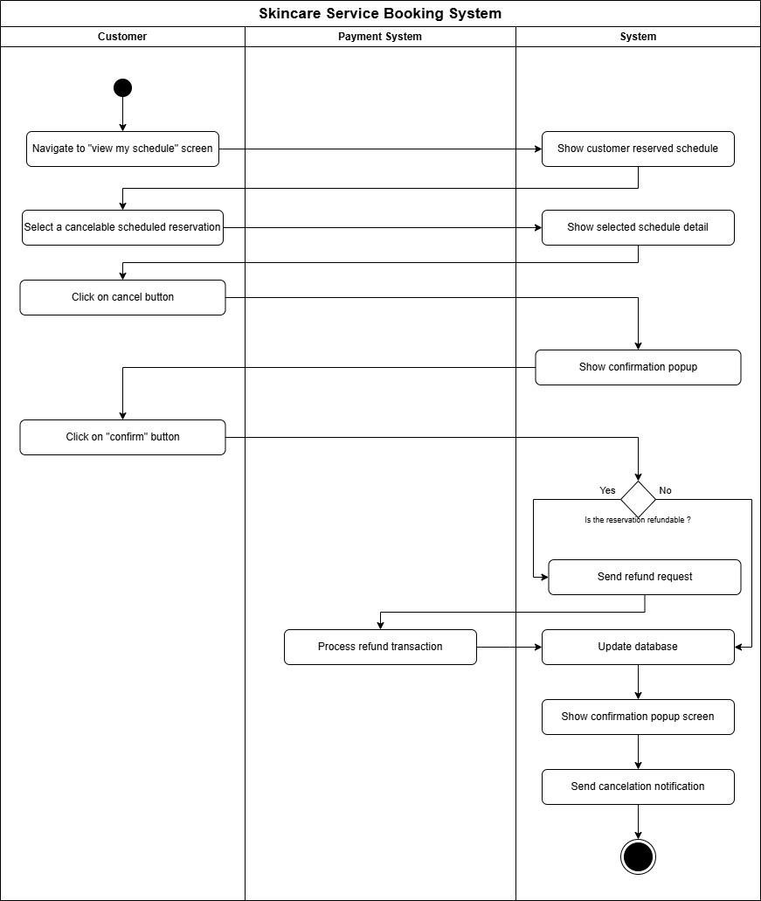

Create Account - Tấn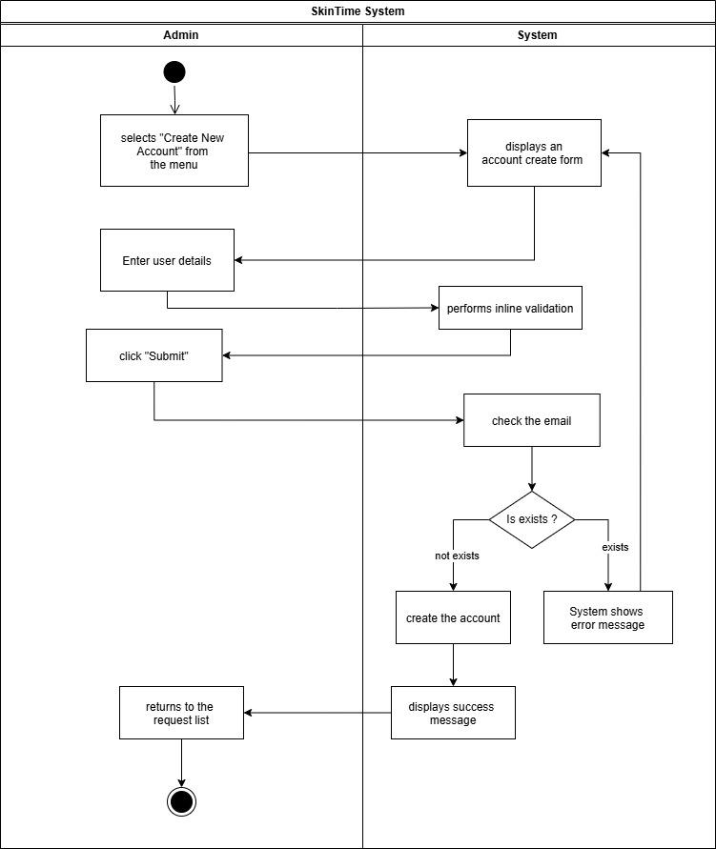

Update Account - Tấn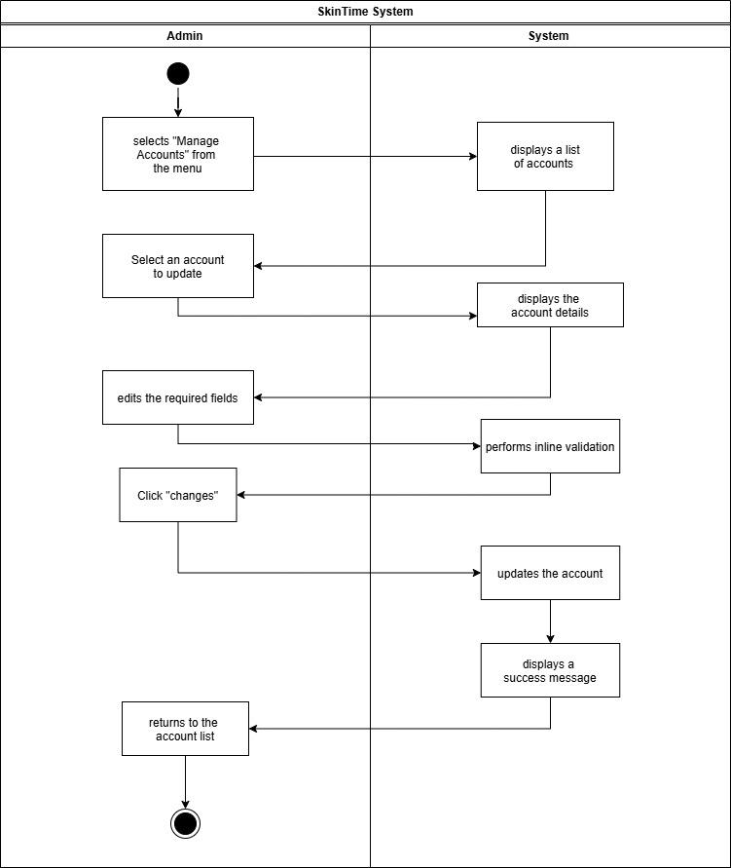

Delete Account - Tấn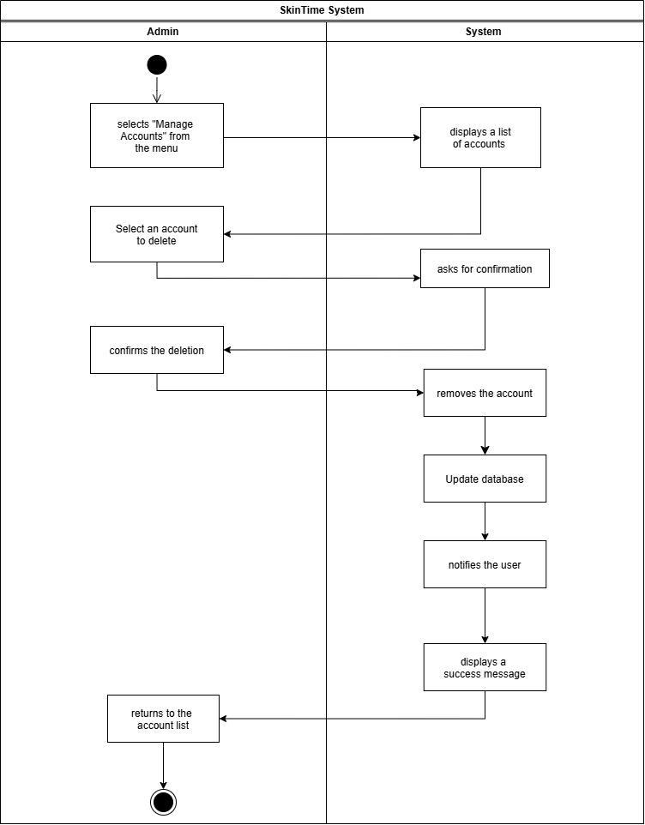

Create Quiz - Trí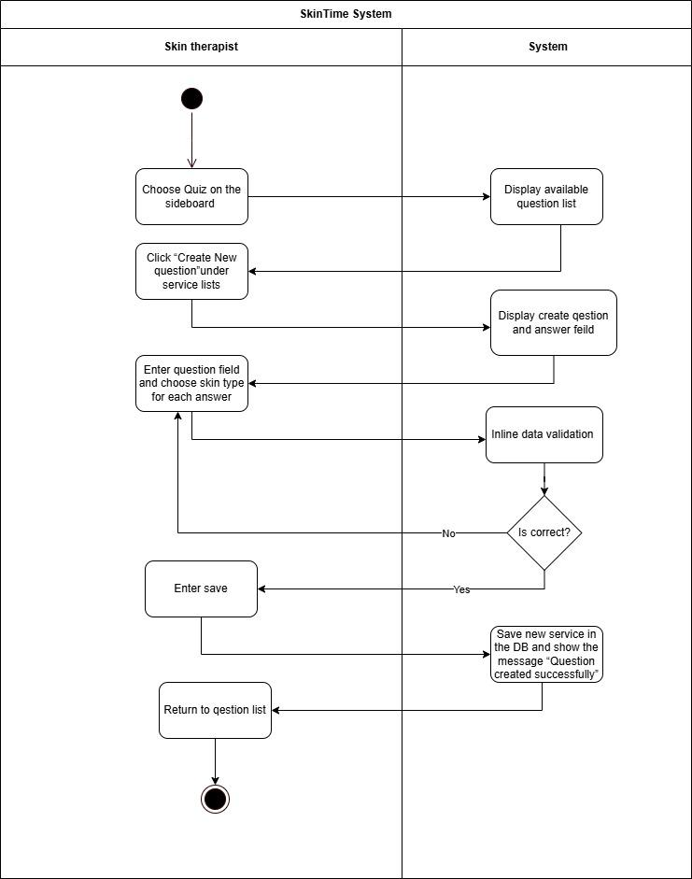

Update quiz - Trí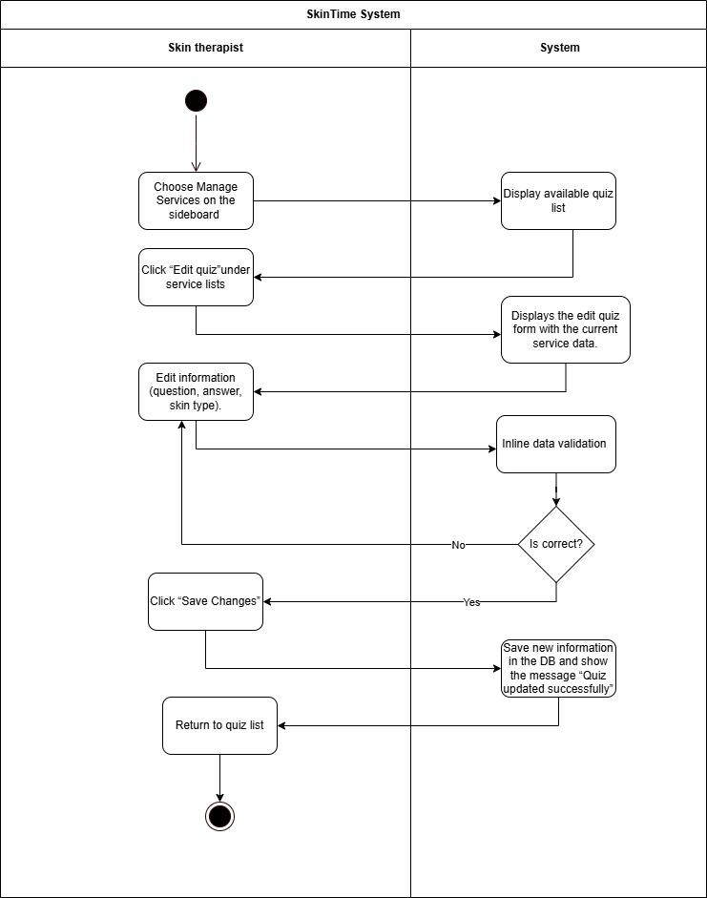

Delete quiz - Trí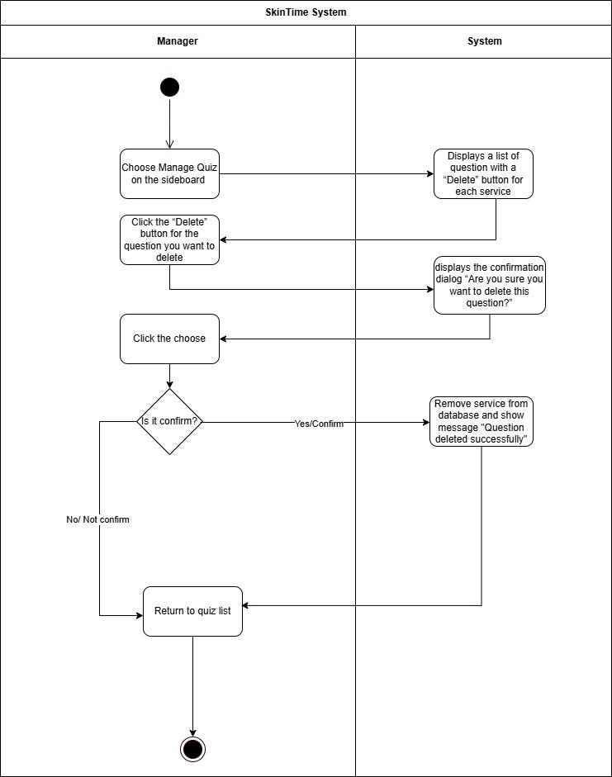

Do Quiz - Trí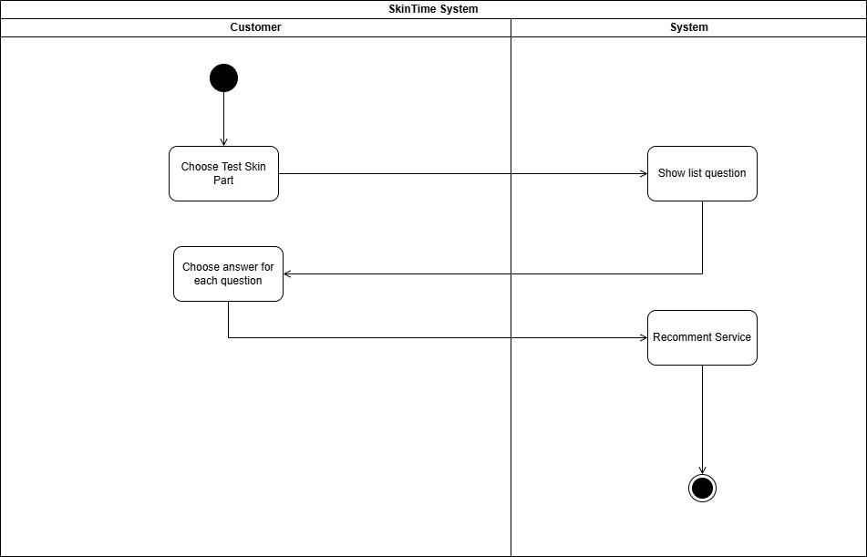

Process Requests - Tấn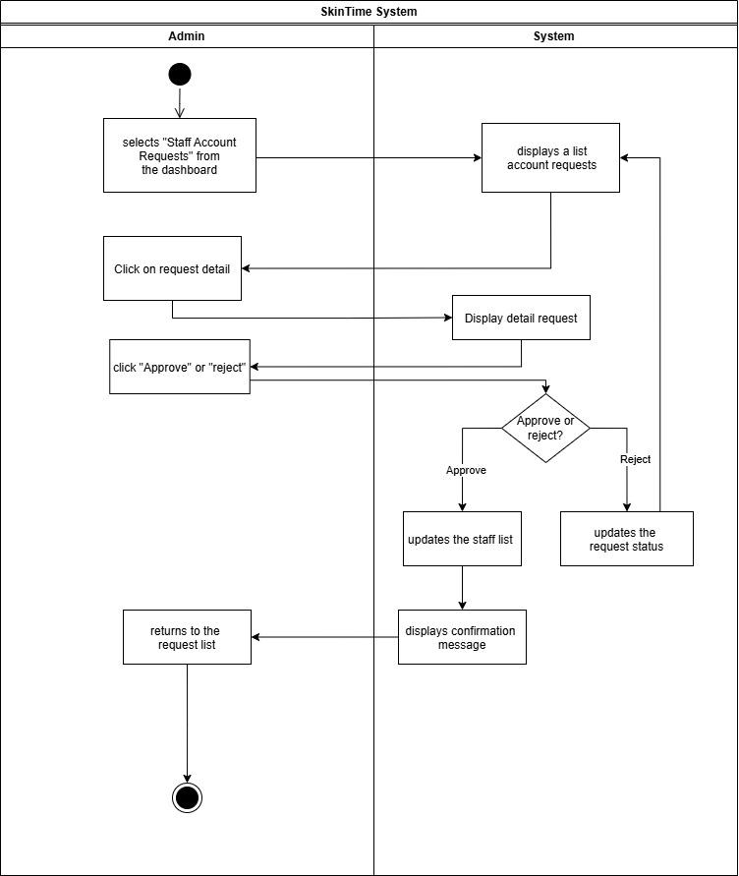

Cancel Process and Refunds - Diễm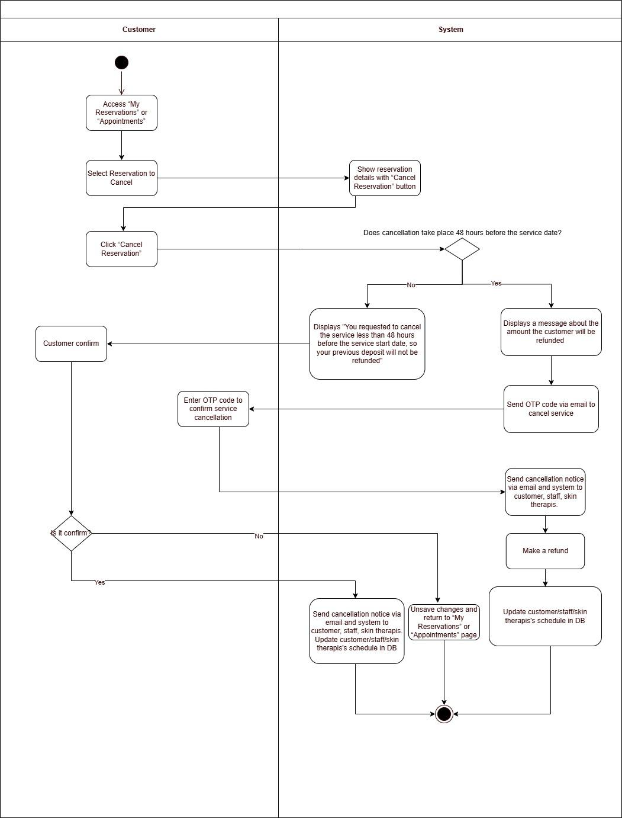

Therapist Sessions - Trí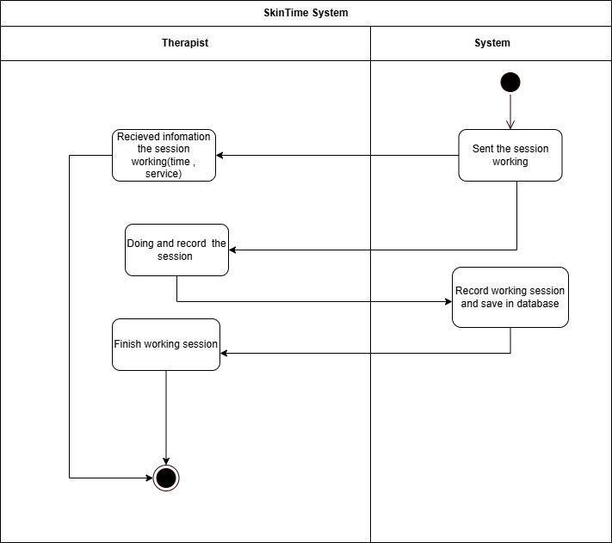

Post Feedback - Thư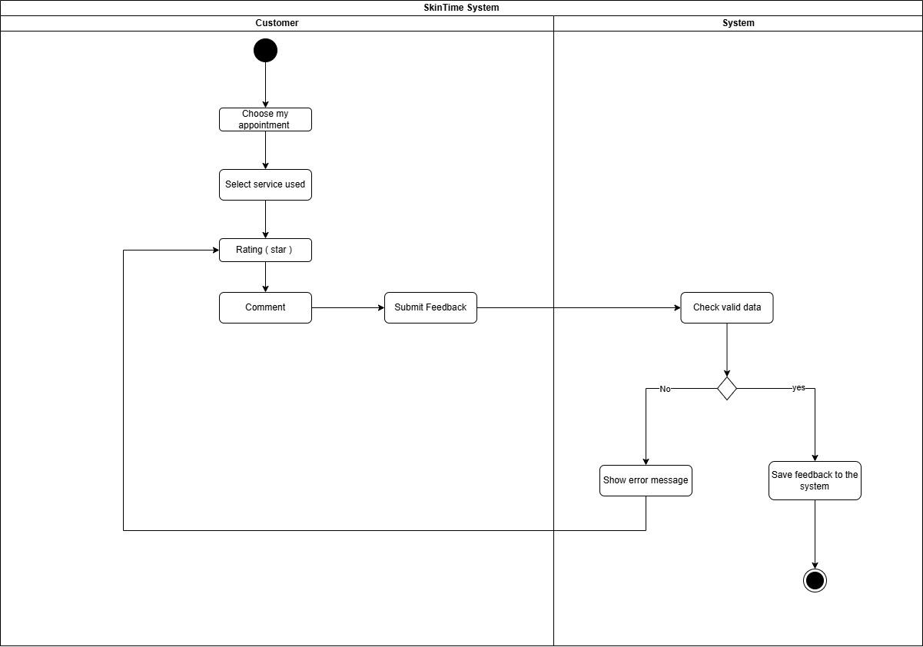

Manager send account creation request - Thư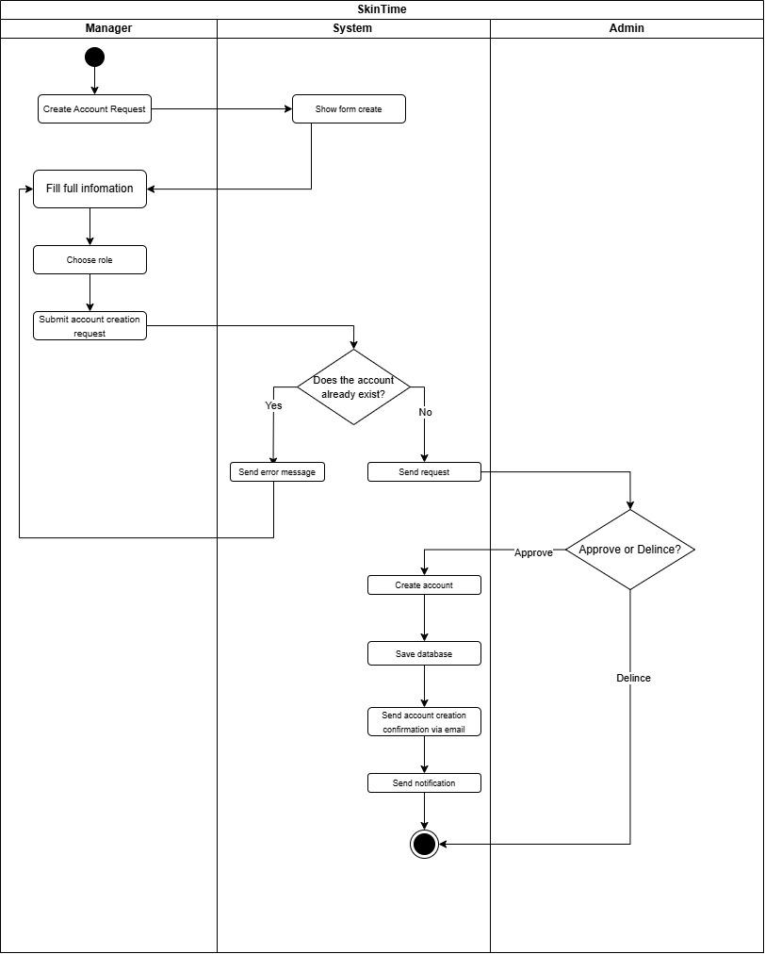

Staff Change Schedule - Thư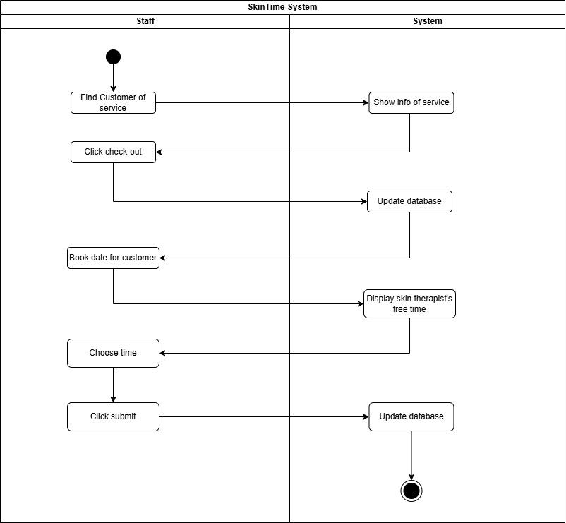

2.4 Business rule

CODE | Description
BR-01 | Must fill in all required information before submitting.
BR-02 | Only feedback for completed services can be submitted
BR-03 | Feedback containing inappropriate language is rejected by the system or flagged for manual review
BR-04 | The check-in time must be logged for tracking.
BR-05 | No one is using this service right now.
BR-06 | The service must be in an unused state.
BR-07 | The QR code is unique per customer and per event/service
BR-08 | QR codes must be from system-issued tickets or sent via email.
BR-09 | Check in must be on time, 30 minutes before the event starts and until the event ends.
BR-10 | Service must have a working time
BR-11 | service must have step
BR-12 | Events must have a start and end time, start time must be before end time.
BR-13 | Events cannot be created for past dates.
BR-14 | Creation time must be equal to or greater than 1 week from event start time
BR-15 | Events that overlap with others must notify the staff about conflicts.
BR-16 | Event can only remove before 48 hours from event start time
BR-17 | All of remove request of staff always need fill the reason for manager approve
BR-18 | If the event has already been attended, a refund must be made and the customer notified.
BR-19 | Canceling an event after approval from the manager must clearly state the reason.
BR-20 | Event can only cancel before 48 hours from event start time
BR-21 | A customer can cancel a service anytime before the start time
BR-22 | If the cancellation occurs at least 48 hours before the service start time, the customer is eligible for a refund.
BR-23 | If the cancellation occurs within 48 hours of the service start time, no refund is issued.
BR-24 | If the booking was made for the next day, no refund is issued upon cancellation.
BR-25 | Only authorized staff can check in or check out services for customers.
BR-26 | If the service is part of a multi-step service, the payment process will only mark one step as completed, not the entire service.
BR-27 | Each service must go through an on-going check-in process and finally checkout.
BR-28 | A customer can only reschedule the next session, not past or completed sessions.
BR-29 | Rescheduling must follow the logical sequence of the treatment plan.
BR-30 | The deposit amount is a fixed percentage of the total service cost.
BR-31 | The number of attendees per event is limited
BR-32 | Registration required before event starts
BR-33 | Must register while slots are available
BR-34 | Customers can only update the time of scheduled steps.
BR-35 | Customers are not updated with completed steps.
BR-36 | One account can only purchase one ticket for one event.
BR-37 | After successfully paying for tickets, customers will receive tickets immediately in the system and personal email.
BR-38 | After checking out the customer in services with many steps, the staff is responsible for making an appointment with the customer in the next step.

3.Functional Requirements

 | Admin | Manager | Staff | Skin Therapist | Customer | Guest
View service |  |  |  |  | x | X
View event infomation |  |  |  |  | x | X
View skin therapist |  |  |  |  | x | X
Do personal preference quizzes |  |  |  |  | X | X
Login | X | X | X | X | X
Logout | X | X | X | X | X
Update Personal Profile | X | X | X | X | X
Change Password | X | X | X | X | X
Chat | x | x | x | x | x
Book service reservation |  |  |  |  | X
Cancel a reservation |  |  |  |  | X
Change reservation time |  |  |  |  | X
Post service feedback |  |  |  |  | X
Pay service, event deposit |  |  |  |  | X
Buy event ticket |  |  |  |  | X
Cancel ticket |  |  |  |  | x
View List Booking |  | X | X | X | X
View reservation |  |  |  | X
Record results |  |  |  | X
Check-in service |  |  | X
Check out service |  |  | X
Support customer to set date for next step |  |  | X
Update event |  |  | X
Cancel event |  |  | x
create event |  |  | X
Input OTP |  |  | X
Scan QR |  |  | X
Export PDF/Excel |  | X
Generate Reports |  | X
Approve request |  | X
Delince request |  | X
View list staff |  | X
Create service |  | X
Add step |  | X
Update event |  | x
Delete event |  | x
View list service |  | X |  |  | X
View list feedback |  | X
Create account | X
View list account | x
Update account | X
Delete account | X
View list Feedback |  | x

IV. Software Design Description

1. System Design

1.1 System Architecture - Huy
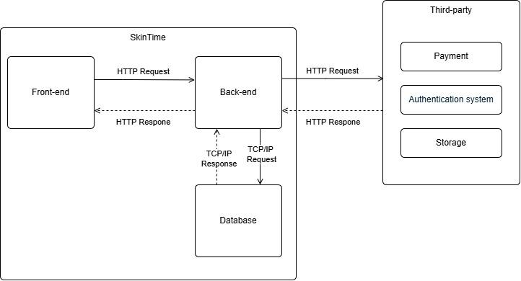

1.2 Package Diagram

1.2.1 Back-end- Huy
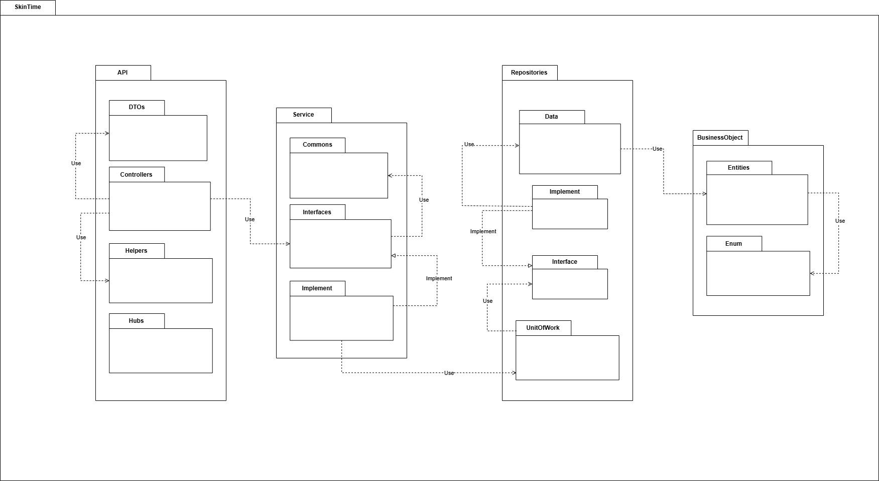

1.2.2.Front-end-Huy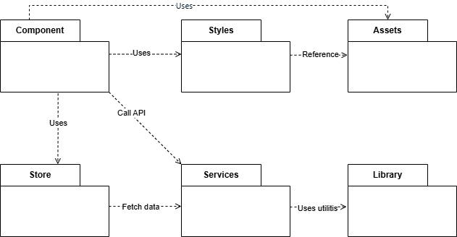

2. Database Design

2.1 ERD - Entity Relationships Diagram
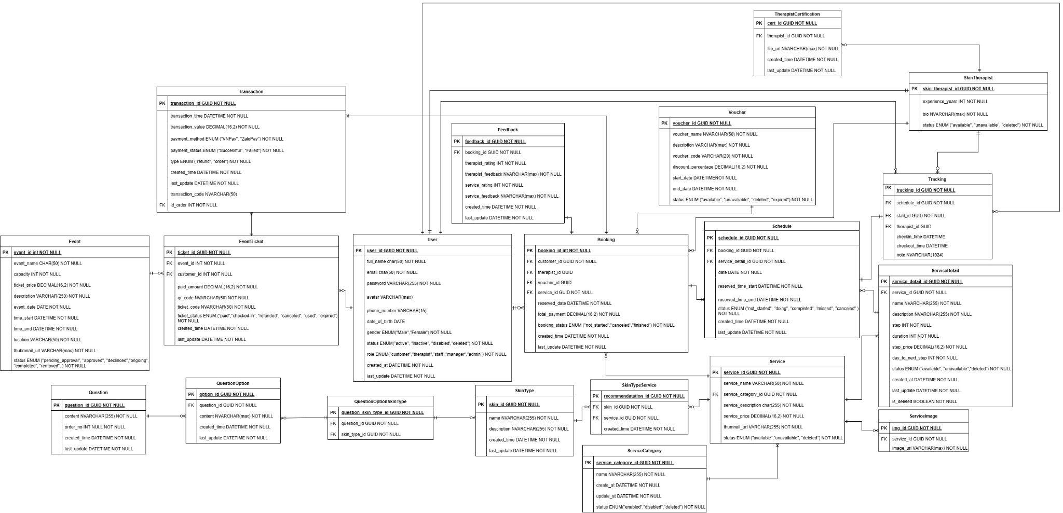

2.1.1 ERD Specification - Huy

ERD Briefly
Table | Description
User | Stores user information of the system.
Booking | Stores customer booking information.
Service | Stores skincare service information.
ServiceDetail | Details of each step in a service.
Schedule | Manage customer booked services
Tracking | Tracks the progress of service execution.
Feedback | Stores customer reviews after using services.
Voucher | Stores discount code information.
SkinTherapist | Information of skincare therapists.
TherapistCertification | Certifications of skincare therapists.
ServiceRecommendation | Suggests suitable services for customers based on quiz results.
SkinType | Common skin types defined
QuestionOption | Options in quiz questions.
Question | Questions in the skin assessment quiz.
EventTicket | Event participation tickets.
Event | Information about skincare center events.
Transaction | Stores payment transaction information.
ServiceImage | Stores image of service
ServiceCategory | Stores service category information of the system.

User
Column Name | Data Type | Constraints | Description
user_id | GUID | PK, NOT NULL | Unique identifier for the user
full_name | CHAR(50) | NOT NULL | User's full name
email | CHAR(50) | NOT NULL, UNIQUE | User's email address (used for login)
password | VARCHAR(255) | NOT NULL | Encrypted password
avatar | VARCHAR(MAX) |  | URL of user's avatar
phone_number | VARCHAR(15) |  | User's phone number
date_of_birth | DATE |  | User's date of birth
gender | ENUM("Male", "Female") | NOT NULL | User's gender
status | ENUM("active", "inactive", "disabled", "deleted") | NOT NULL | Current status of the user
role | ENUM("customer", "therapist", "staff", "manager", "admin") | NOT NULL | User's role in the system
created_at | DATETIME | NOT NULL | Timestamp of account creation
last_update | DATETIME | NOT NULL | Timestamp of the last update

Booking

Column Name | Data Type | Constraints | Description
booking_id | INT | PK, NOT NULL | Unique identifier for each booking
customer_id | GUID | FK, NOT NULL | Customer who makes the booking
therapist_id | GUID | FK | Assigned therapist for the service
voucher_id | GUID | FK | Applied voucher
service_id | GUID | FK, NOT NULL | Booked service identifier
reserved_date | DATETIME | NOT NULL | Reserved date and time
total_payment | DECIMAL(16,2) | NOT NULL | Total payment amount
booking_status | ENUM("not_started", "canceled", "finished") | NOT NULL | Status of the booking
created_time | DATETIME | NOT NULL | Booking creation timestamp
last_update | DATETIME | NOT NULL | Last update timestamp

Service

Column Name | Data Type | Constraints | Description
service_id | GUID | PK, NOT NULL | Unique identifier for each service
service_name | VARCHAR(50) | NOT NULL | Name of the service
service_category_id | GUID | FK, NOT NULL | Identifier of the related service category
service_description | CHAR(255) | NOT NULL | Brief description of the service
service_price | DECIMAL(16,2) | NOT NULL | Price of the service
thumbnail_url | VARCHAR(255) |  | URL of the service thumbnail image
status | ENUM("available", "unavailable", "deleted") | NOT NULL | Service availability status

ServiceDetail

Column Name | Data Type | Constraints | Description
service_detail_id | GUID | PK, NOT NULL | Unique identifier for each service detail
service_id | GUID | FK, NOT NULL | Identifier of the related service
name | NVARCHAR(255) | NOT NULL | Name of the service step
description | NVARCHAR(255) | NOT NULL | Description of the service step
step | INT | NOT NULL | Order of the step in the service process
duration | INT | NOT NULL | Duration of the step in minutes
step_price | DECIMAL(16,2) | NOT NULL | Price of the service step
day_to_next_step | INT | NOT NULL | Number of days between this step and the next
status | ENUM("available", "unavailable", "deleted") | NOT NULL | Availability status of the step
created_at | DATETIME | NOT NULL | Creation timestamp
last_update | DATETIME | NOT NULL | Last update timestamp
is_deleted | BOOLEAN | NOT NULL | Soft delete flag (TRUE: deleted, FALSE: active)

Schedule

Column Name | Data Type | Constraints | Description
schedule_id | GUID | PK, NOT NULL | Unique identifier for each schedule
booking_id | GUID | FK, NOT NULL | Identifier of the related booking
service_detail_id | GUID | FK, NOT NULL | Identifier of the related service step
date | DATE | NOT NULL | Date when the service is scheduled
reserved_time_start | DATETIME | NOT NULL | Start time of the reserved service
reserved_time_end | DATETIME | NOT NULL | End time of the reserved service
status | ENUM("not_started", "doing", "completed", "missed", "canceled") | NOT NULL | Status of the schedule
created_time | DATETIME | NOT NULL | Schedule creation timestamp
last_update | DATETIME | NOT NULL | Last update timestamp

Tracking

Column Name | Data Type | Constraints | Description
tracking_id | GUID | PK, NOT NULL | Unique identifier for each tracking record
schedule_id | GUID | FK, NOT NULL | Identifier of the related schedule
staff_id | GUID | FK, NOT NULL | Identifier of the staff member responsible for the service
therapist_id | GUID | FK | Identifier of the therapist performing the service (optional)
checkin_time | DATETIME |  | Time when staff or therapist starts the service
checkout_time | DATETIME |  | Time when staff or therapist finishes the service
note | NVARCHAR(1024) |  | Additional notes during service execution

Feedback

Column Name | Data Type | Constraints | Description
feedback_id | GUID | PK, NOT NULL | Unique identifier for each feedback entry.
booking_id | GUID | FK, NOT NULL | References the related booking.
therapist_rating | INT | NOT NULL | Rating for the therapist (e.g., 1 to 5).
therapist_feedback | NVARCHAR(MAX) | NOT NULL | Customer's written feedback for the therapist.
service_rating | INT | NOT NULL | Rating for the service (e.g., 1 to 5).
service_feedback | NVARCHAR(MAX) | NOT NULL | Customer's written feedback for the service.
created_time | DATETIME | NOT NULL | Timestamp when the feedback was submitted.
last_update | DATETIME | NOT NULL | Timestamp of the last modification to the feedback.

Voucher

Column Name | Data Type | Constraints | Description
voucher_id | GUID | PK, NOT NULL | Unique identifier for each voucher.
voucher_name | NVARCHAR(50) | NOT NULL | Name of the voucher for display purposes.
description | VARCHAR(MAX) | NOT NULL | Detailed information about the voucher promotion.
voucher_code | VARCHAR(20) | NOT NULL | Unique code that customers enter to apply the voucher.
discount_percentage | DECIMAL(16,2) | NOT NULL | Percentage discount that the voucher provides.
start_date | DATETIME | NOT NULL | Date and time when the voucher becomes active.
end_date | DATETIME | NOT NULL | Date and time when the voucher expires.
status | ENUM | NOT NULL | Status of the voucher:

Skin Therapist

Column Name | Data Type | Constraints | Description
skin_therapist_id | GUID | PK, NOT NULL | Unique identifier for each therapist.
experience_years | INT | NOT NULL | Number of years of experience in the skincare industry.
bio | NVARCHAR(MAX) | NOT NULL | Description of the therapist's qualifications, skills, and background.
status | ENUM | NOT NULL | Status of the therapist:

TherapistCertification

Column Name | Data Type | Constraints | Description
cert_id | GUID | PK, NOT NULL | Unique identifier for each certification.
therapist_id | GUID | FK, NOT NULL | Foreign key linking to the SkinTherapist table.
file_url | NVARCHAR(MAX) | NOT NULL | URL link to the certification file (PDF, image, etc.).
created_time | DATETIME | NOT NULL | Time when the certification was added.
last_update | DATETIME | NOT NULL | Time when the certification information was last updated.

ServiceRecommendation

Column Name | Data Type | Constraints | Description
recommendation_id | GUID | PK, NOT NULL | Unique identifier for each recommendation.
skin_id | GUID | FK, NOT NULL | Foreign key linking to SkinType table (customer's skin result).
service_id | GUID | FK, NOT NULL | Foreign key linking to Service table (recommended service).
created_time | DATETIME | NOT NULL | Time when the recommendation was created.

Skin Type

Column Name | Data Type | Constraints | Description
skin_id | GUID | PK, NOT NULL | Unique identifier for each skin type.
name | NVARCHAR(255) | NOT NULL | Name of the skin type (e.g., Oily, Dry, Combination).
description | NVARCHAR(255) | NOT NULL | Brief description of the skin type characteristics.
created_time | DATETIME | NOT NULL | Time when the skin type record was created.
last_update | DATETIME | NOT NULL | Time when the skin type record was last updated.

Question Option

Column Name | Data Type | Constraints | Description
option_id | GUID | PK, NOT NULL | Unique identifier for each option.
question_id | GUID | FK, NOT NULL | References the Question table, linking the option to its respective question.
skin_type_id | GUID | FK, NOT NULL | References the SkinType table, indicating which skin type the option is associated with.
content | NVARCHAR(max) | NOT NULL | The text content of the option (e.g., "Oily skin", "Dry skin").
created_time | DATETIME | NOT NULL | Time when the option was created.
last_update | DATETIME | NOT NULL | Time when the option was last updated.

Question

Column Name | Data Type | Constraints | Description
question_id | GUID | PK, NOT NULL | Unique identifier for each question.
content | NVARCHAR(255) | NOT NULL | The question text (e.g., "What is your skin type?").
order_no | INT | NOT NULL | Display order of the question in the quiz flow.
created_time | DATETIME | NOT NULL | Time when the question was created.
last_update | DATETIME | NOT NULL | Time when the question was last updated.

Event Ticket

Column Name | Data Type | Constraints | Description
ticket_id | GUID | PK, NOT NULL | Unique identifier for each ticket.
event_id | INT | FK, NOT NULL | Foreign key linking to the Event table.
customer_id | INT | FK, NOT NULL | Foreign key linking to the Customer table.
paid_amount | DECIMAL(16,2) | NOT NULL | Amount paid by the customer for the ticket.
qr_code | NVARCHAR(50) | NOT NULL | QR code for ticket check-in.
ticket_code | NVARCHAR(50) | NOT NULL | Unique ticket code for the booking.
ticket_status | ENUM | NOT NULL | Ticket status with possible values: "paid", "checked-in", "refunded", "canceled", "used", "expired".
created_time | DATETIME | NOT NULL | Time when the ticket was created.
last_update | DATETIME | NOT NULL | Time when the ticket information was last updated.

Event

Column Name | Data Type | Constraints | Description
event_id | INT | PK, NOT NULL | Unique identifier for each event.
event_name | CHAR(50) | NOT NULL | Name of the event.
capacity | INT | NOT NULL | Maximum number of participants allowed.
ticket_price | DECIMAL(16,2) | NOT NULL | Price of one ticket.
description | VARCHAR(250) | NOT NULL | Brief description of the event.
event_date | DATE | NOT NULL | Date of the event.
time_start | DATETIME | NOT NULL | Start time of the event.
time_end | DATETIME | NOT NULL | End time of the event.
location | VARCHAR(50) | NOT NULL | Location where the event will be held.
thumbnail_url | VARCHAR(max) | NOT NULL | URL of the event thumbnail image.
status | ENUM | NOT NULL | Event status with possible values: "pending_approval", "approved", "declined", "ongoing", "completed", "removed".

Transaction

Column Name | Data Type | Constraints | Description
transaction_id | GUID | PK, NOT NULL | Unique identifier for each transaction.
transaction_time | DATETIME | NOT NULL | Timestamp of when the transaction occurred.
transaction_value | DECIMAL(16,2) | NOT NULL | Amount of the transaction.
payment_method | ENUM | NOT NULL | Payment method: "CreditCard", "Cash", "BankTransfer", "E-Wallet".
payment_status | ENUM | NOT NULL | Payment result: "Successful", "Failed".
is_refund_transaction | BOOLEAN | NOT NULL | Indicates if the transaction is a refund (true or false).
created_time | DATETIME | NOT NULL | Timestamp when the record was created.
last_update | DATETIME | NOT NULL | Timestamp of the last update.

Service Category

Column Name | Data Type | Constraints | Description
service_category_id | GUID | PK, NOT NULL | Unique identifier for each service category.
name | NVARCHAR(255) | NOT NULL | Name of the service category.
create_at | DATETIME | NOT NULL | Timestamp when the category was created.
update_at | DATETIME | NOT NULL | Timestamp of the last update.
status | ENUM | NOT NULL | Category status: "enabled", "disabled", "deleted".

Service Image

Column Name | Data Type | Constraints | Description
img_id | GUID | PK, NOT NULL | Unique identifier for each image.
service_id | GUID | FK, NOT NULL | Foreign key references Service.service_id.
image_url | VARCHAR(max) | NOT NULL | URL link of the image stored in the system or cloud storage.

2.2 State Machine Diagram

Service status - Tấn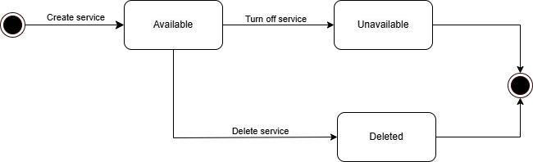

Booking status - Trí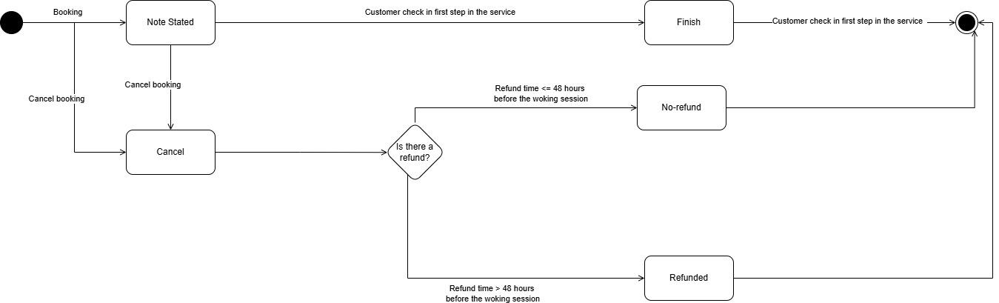

Event status - Huy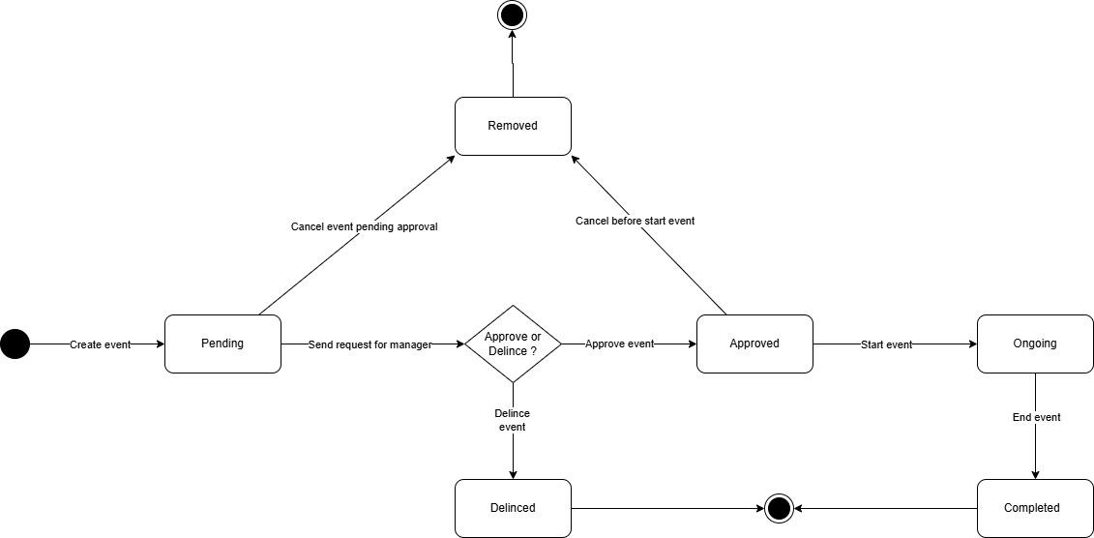

Schedule status - Huy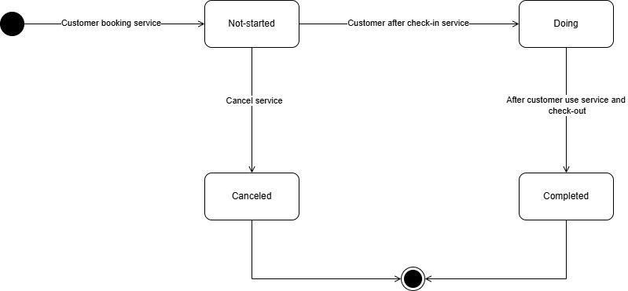

Skin therapist status - Diễm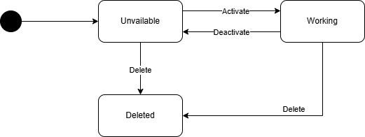

Ticket event status - Huy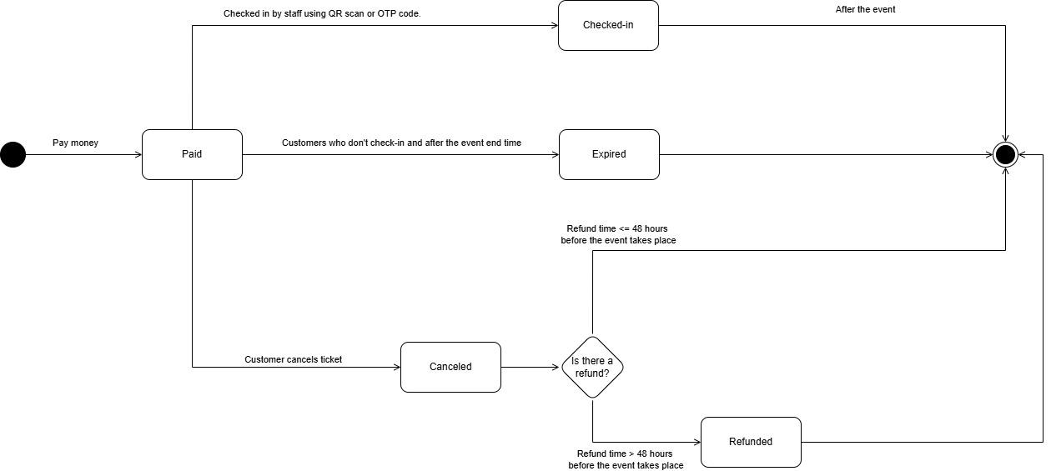

User status - Giang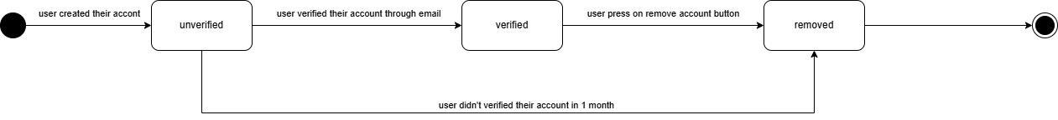

3. Detailed Design

3.1 Class diagram

3.1.1 Customer Cancel booking service - Huy
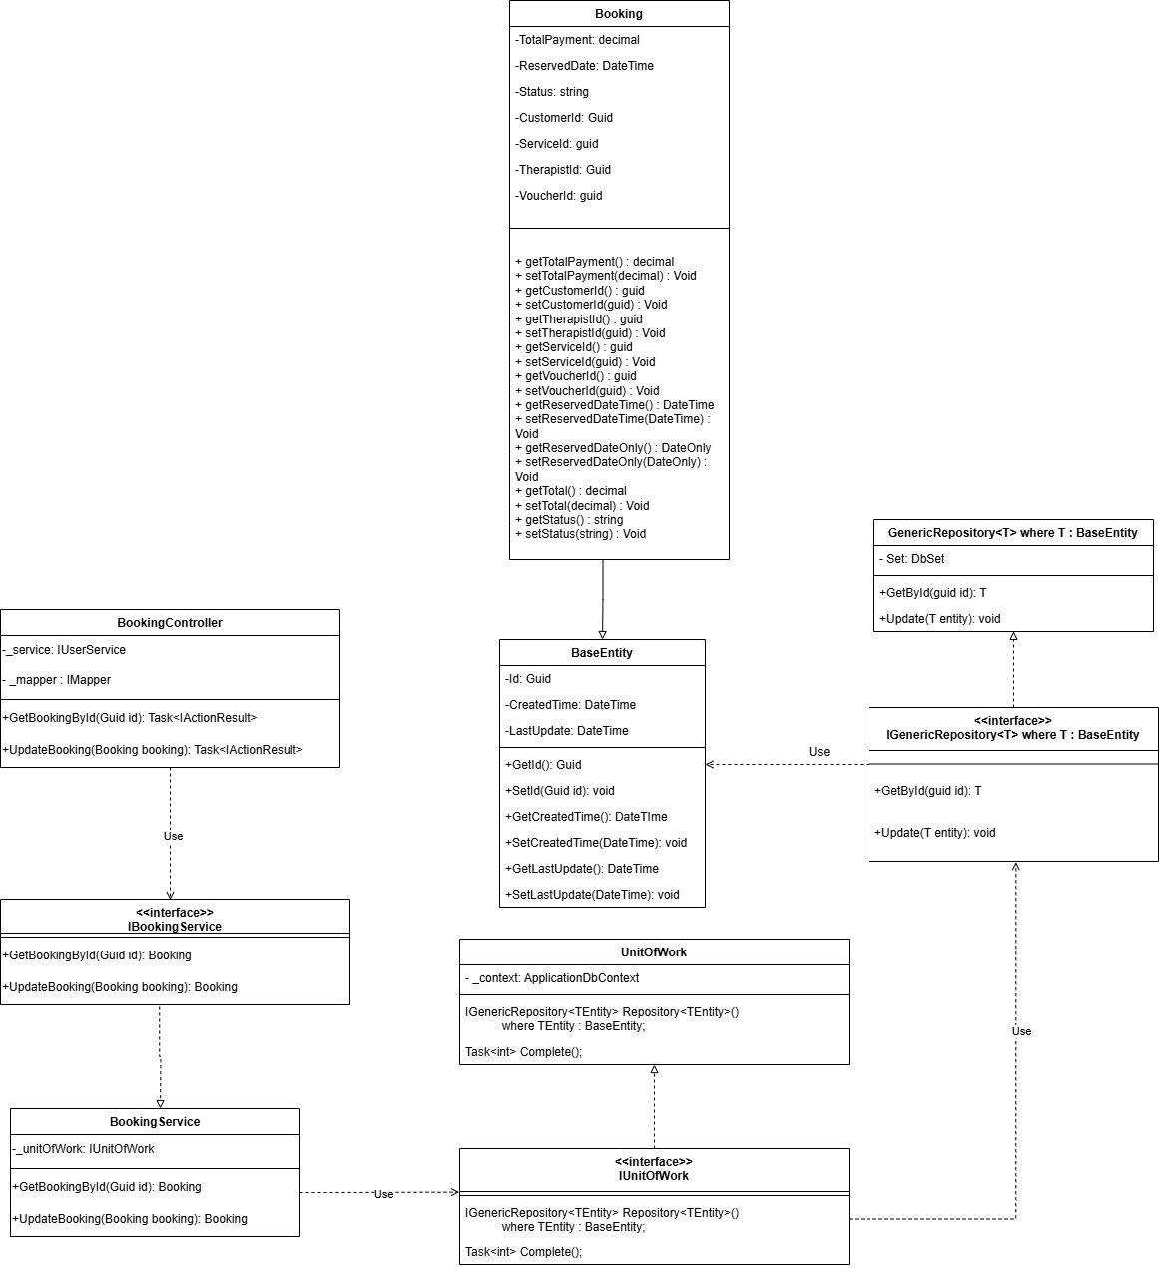

3.1.2 Customer view history service - Huy
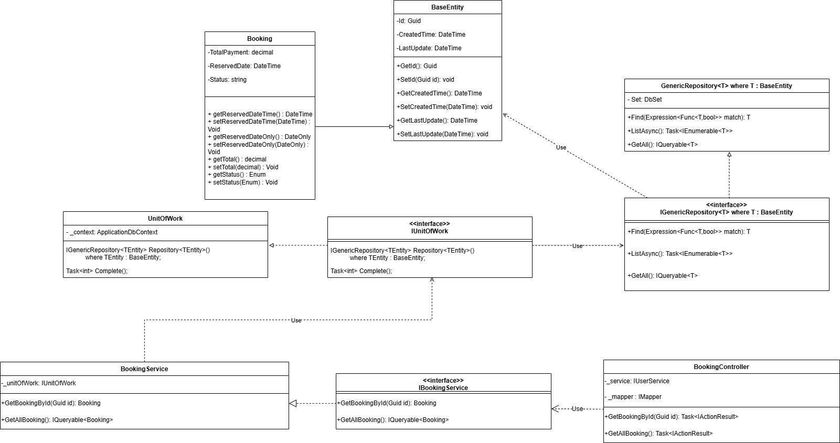

3.1.3 Customer update step of service - Huy
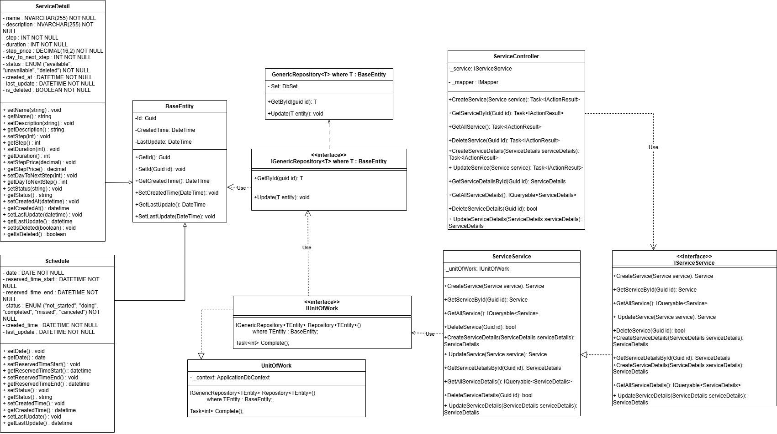

3.1.4 Staff create event - Huy
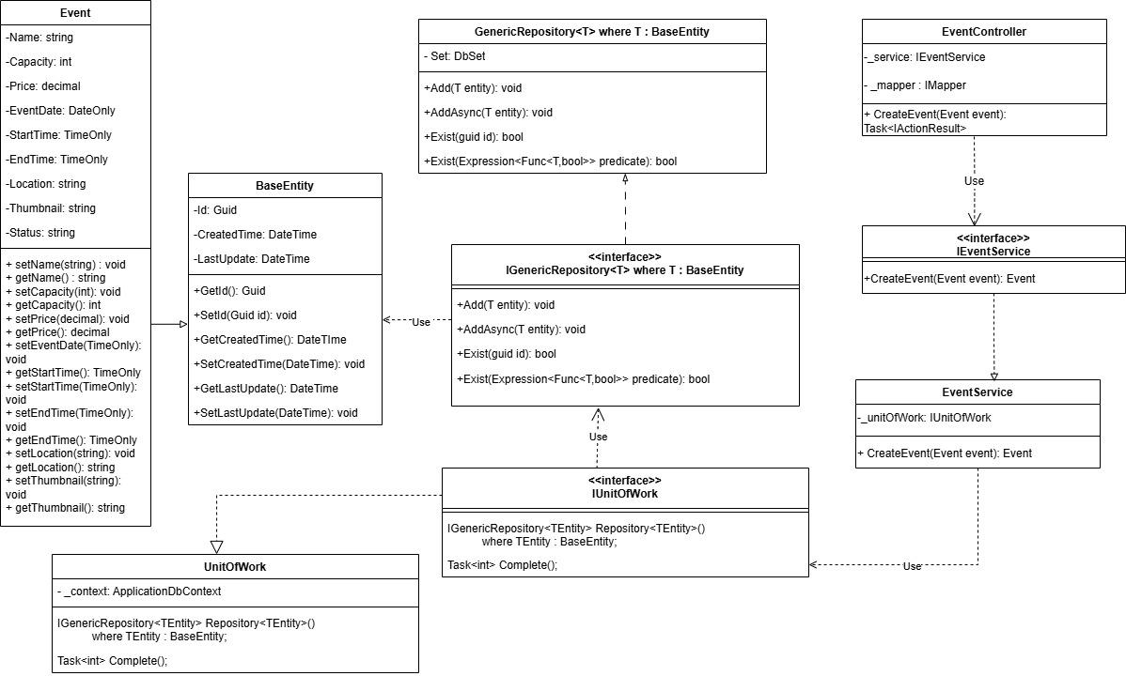

3.1.5 Staff cancel event - Huy
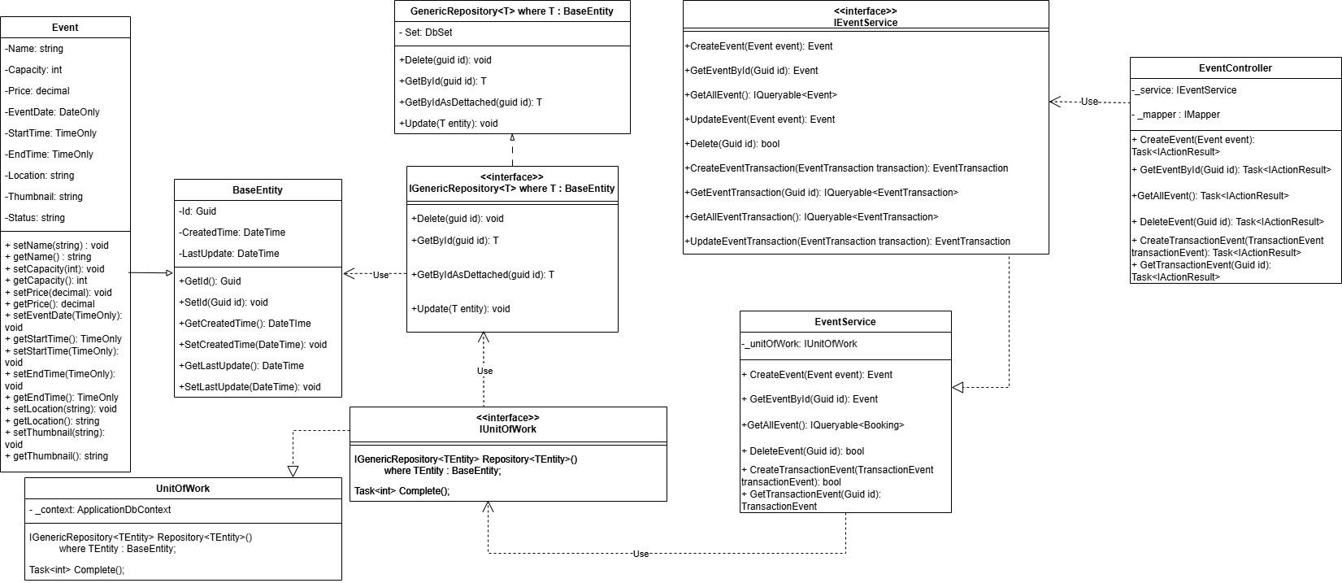

3.1.6 Customer View event history - Diễm
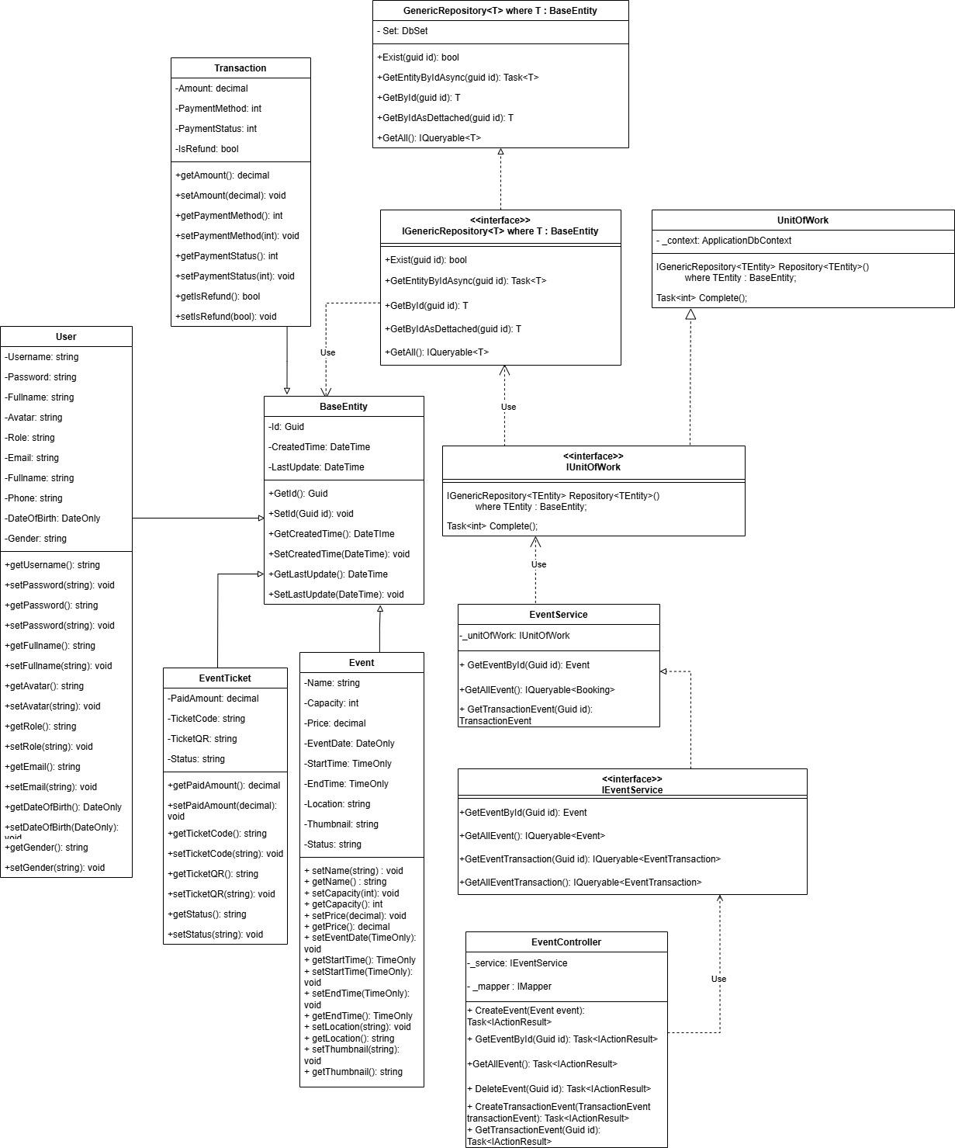

3.1.7 Admin create account - Diễm
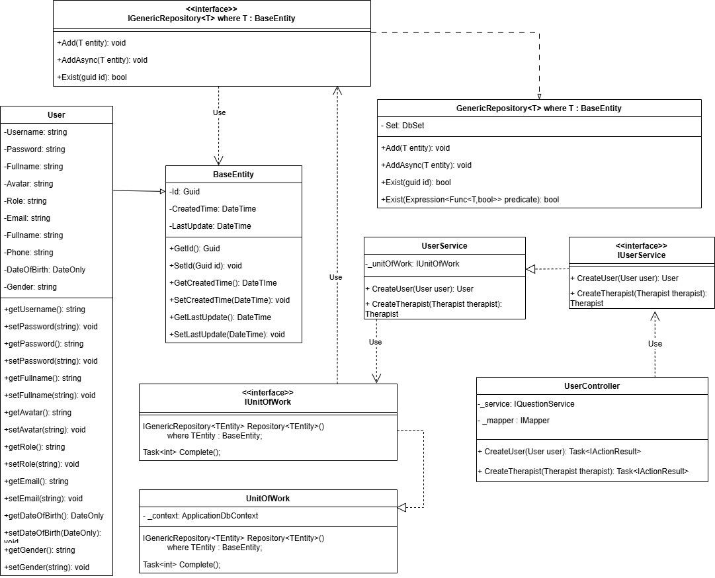

3.1.8 Admin delete account - Diễm
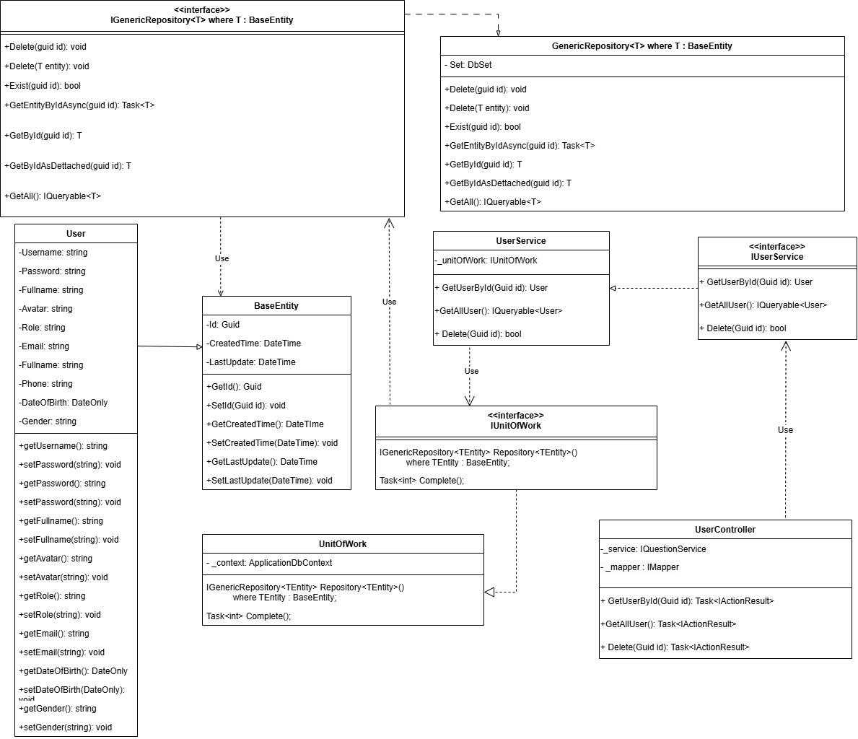

3.1.9 Customer do quiz - Tấn
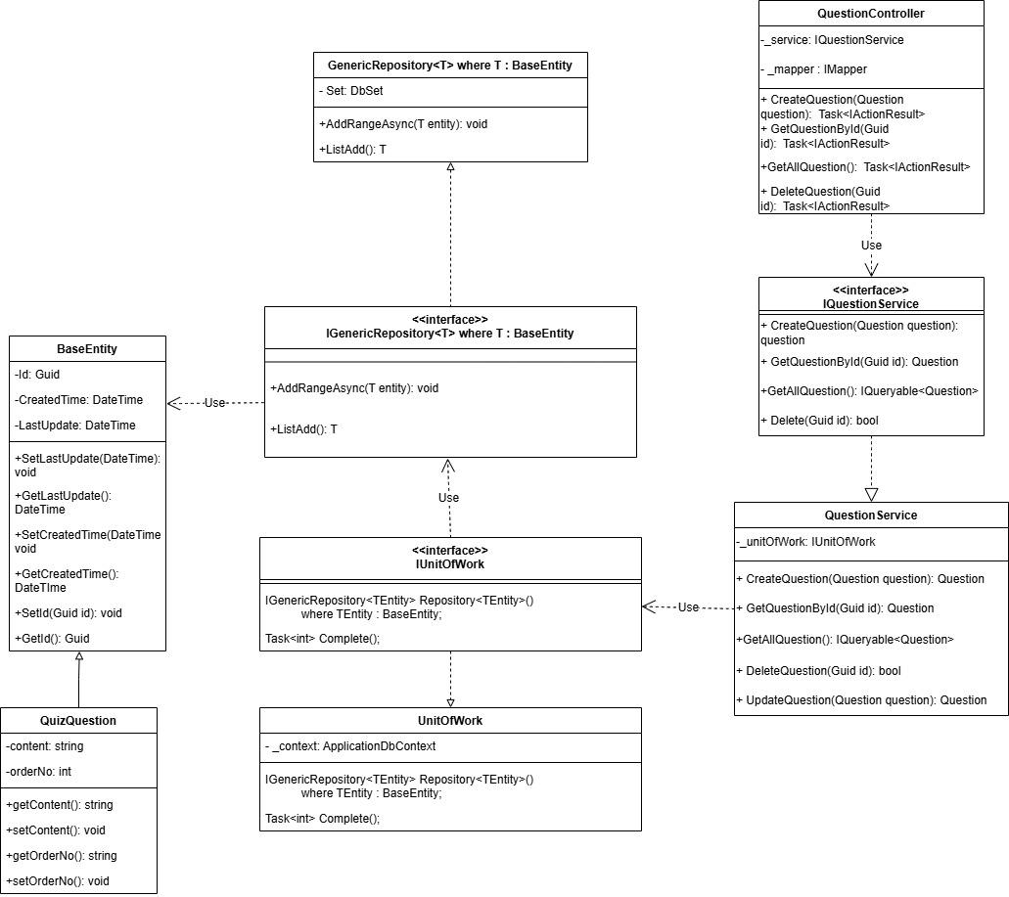

3.1.10 Skin therapist create quiz - Tấn
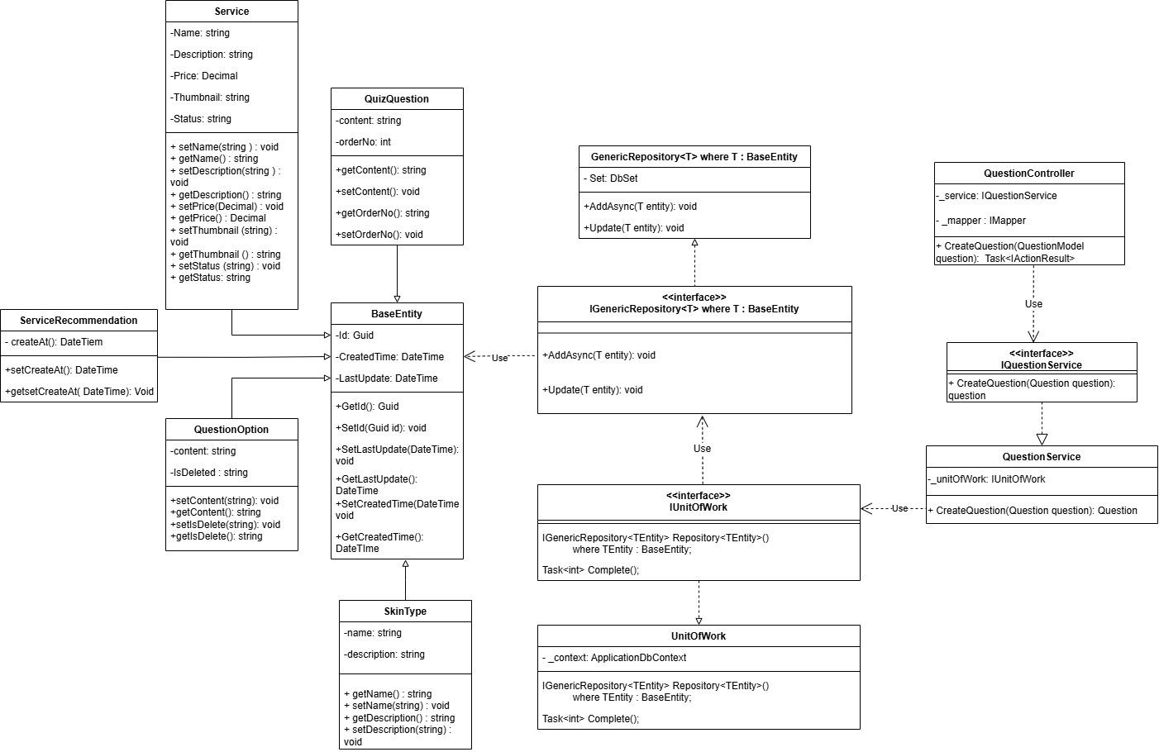

3.1.11 Skin therapist Update quiz - Tấn
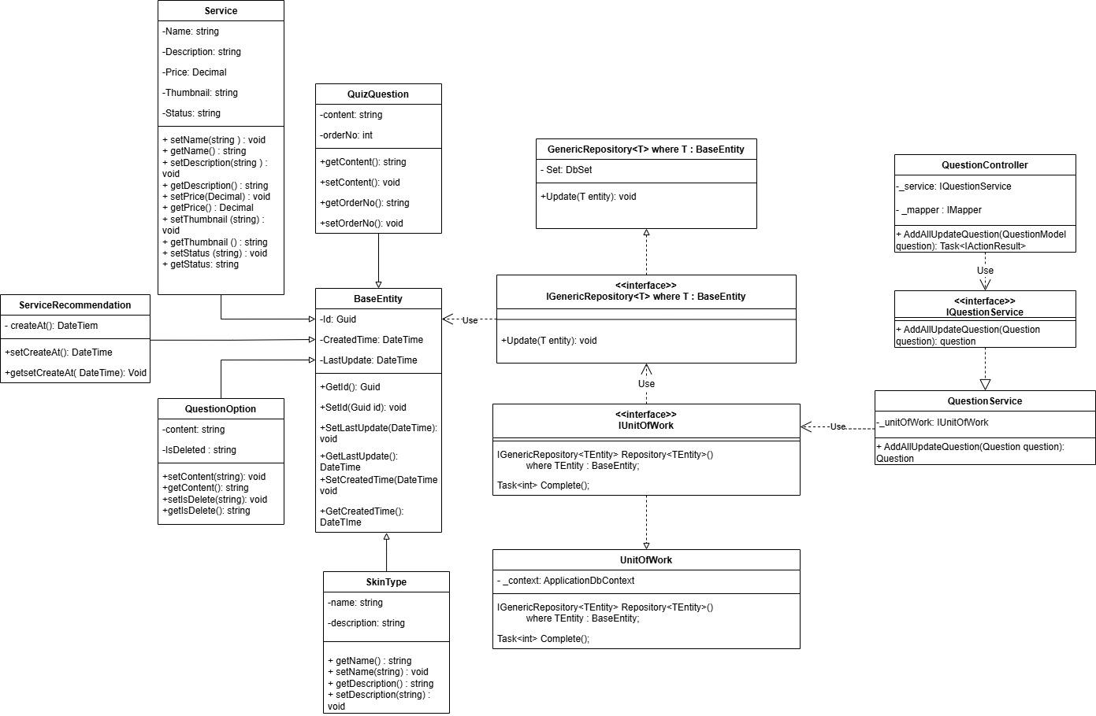

3.1.12 Skin therapist delete question - Tấn
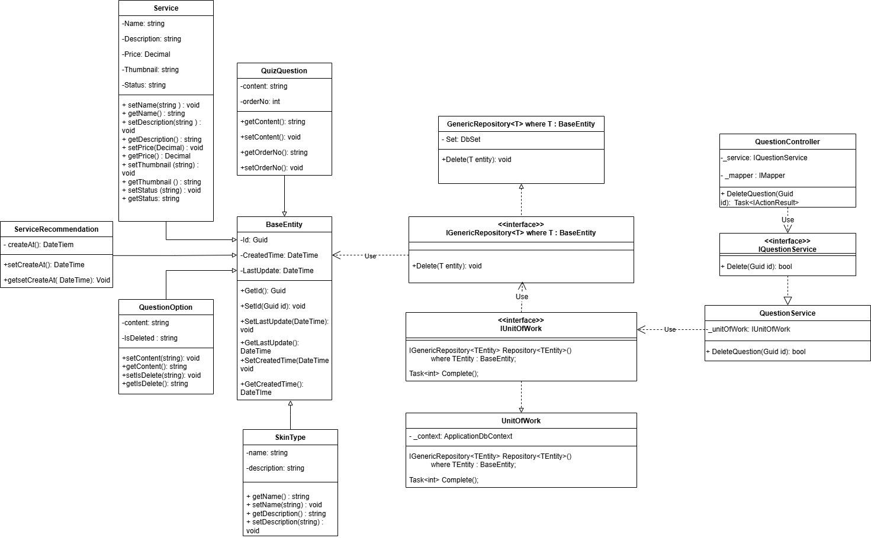

3.1.13 Skin therapist create skin type - Thư
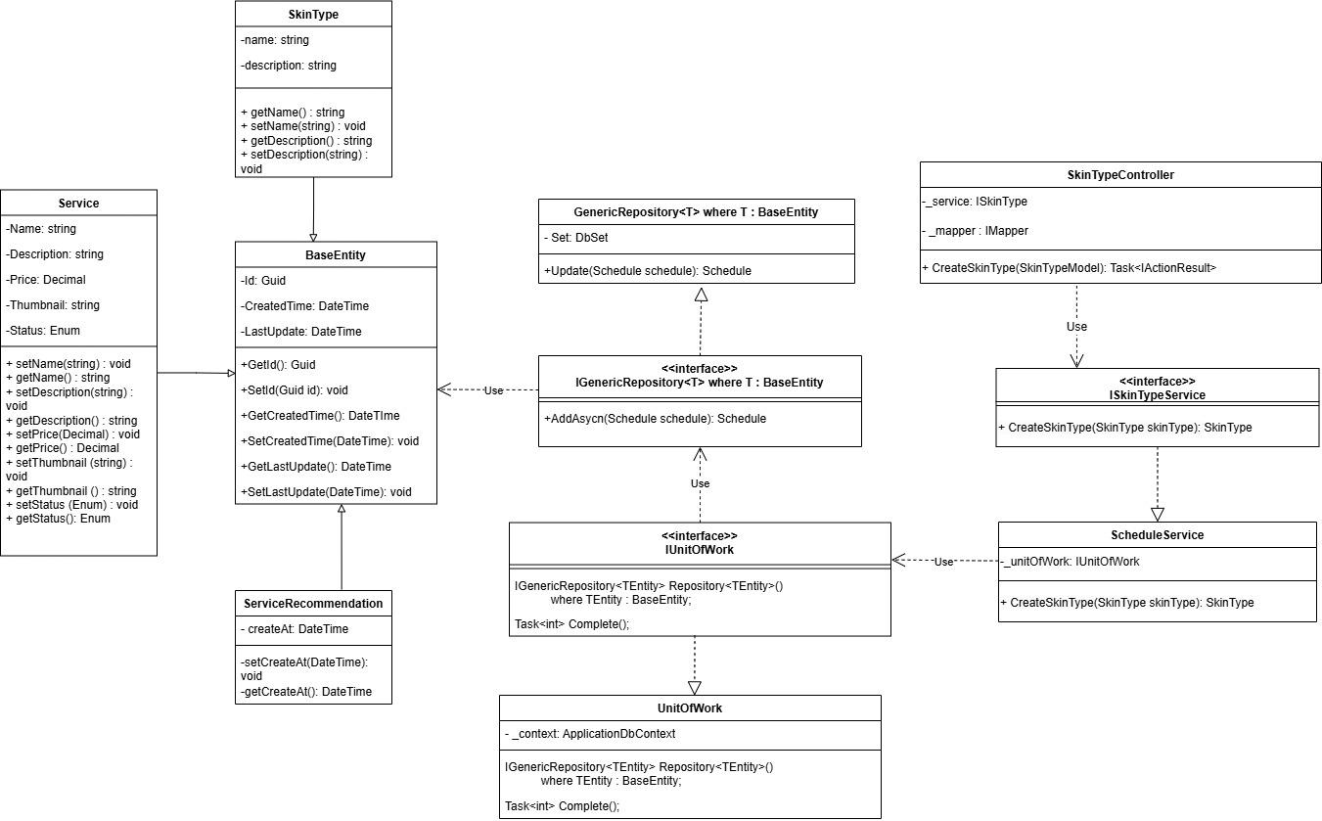

3.1.14 Skin therapist Update skin type - Thư
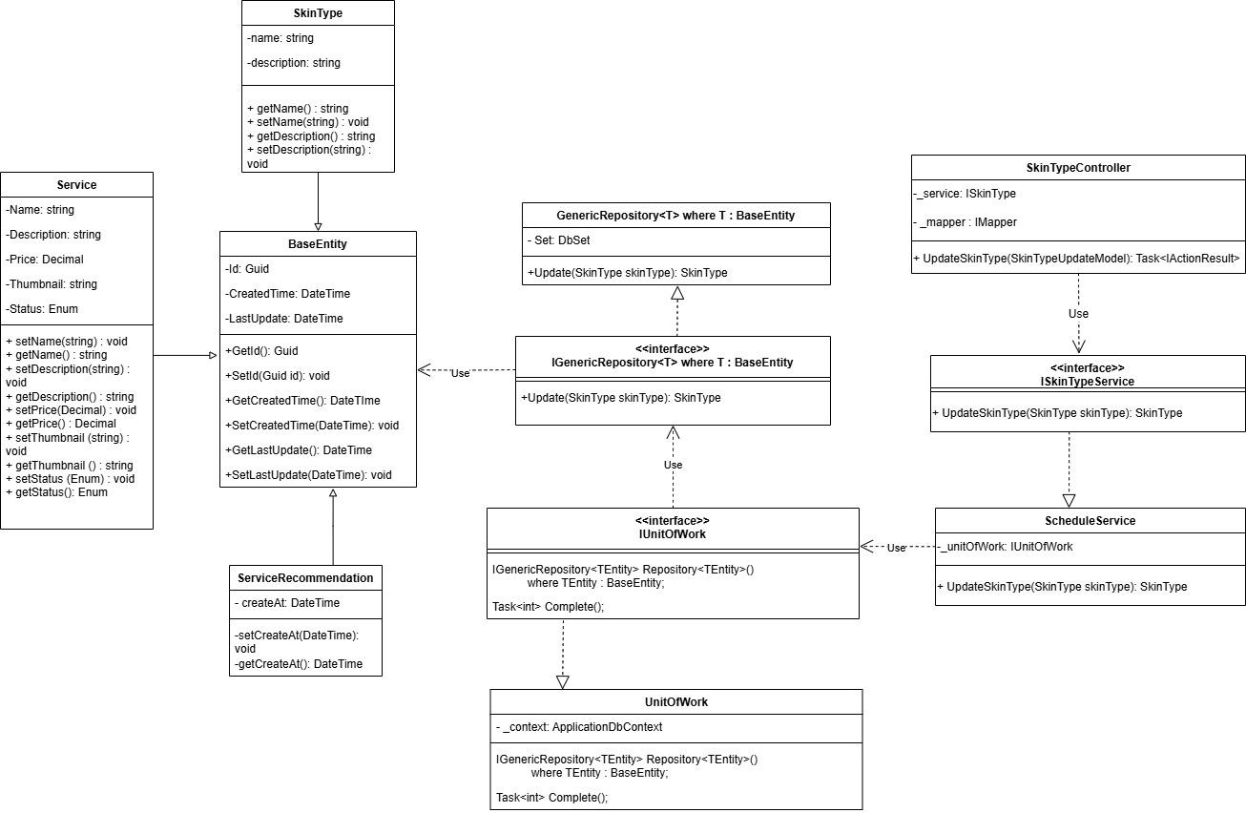

3.1.15 Skin therapist Delete skin type - Thư
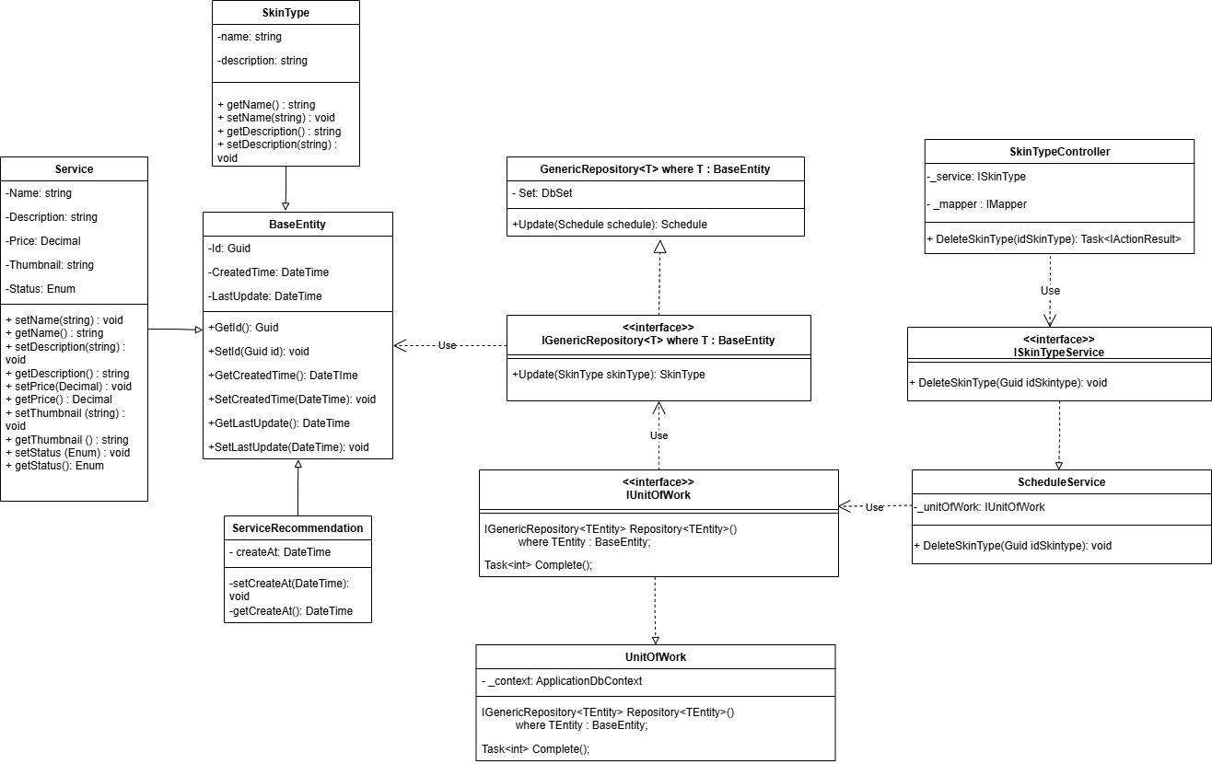

3.1.16 Staff support customer booking date next step - Trí
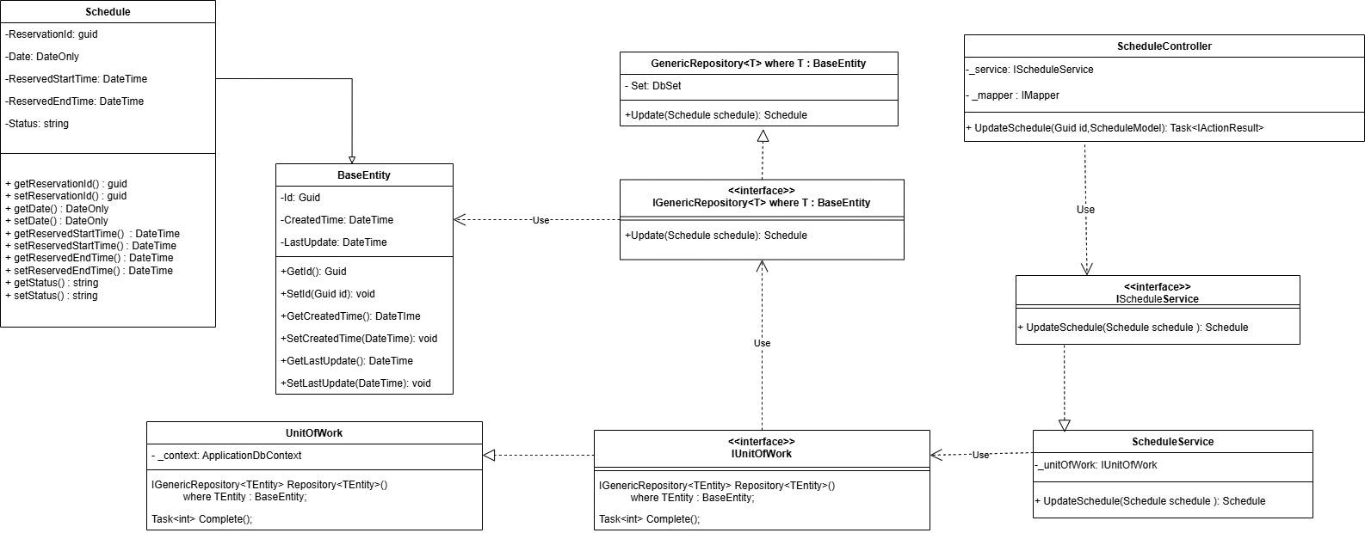

3.1.17 Manager create service - Trí
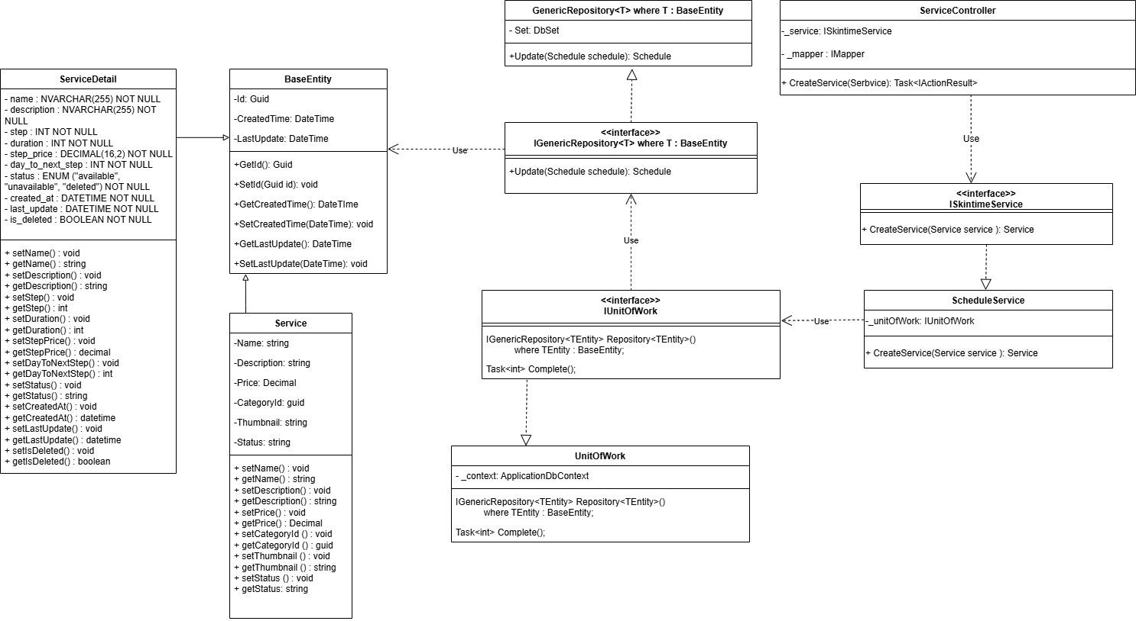

3.1.18 Manager approve/ delince event Trí

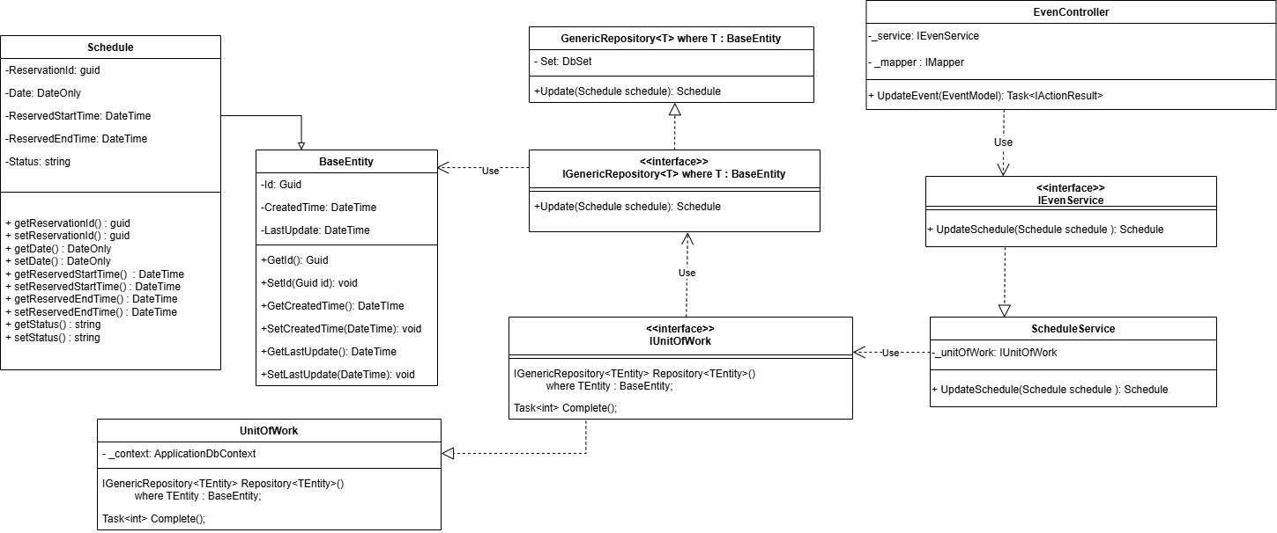

3.1.19 Update service - Giang
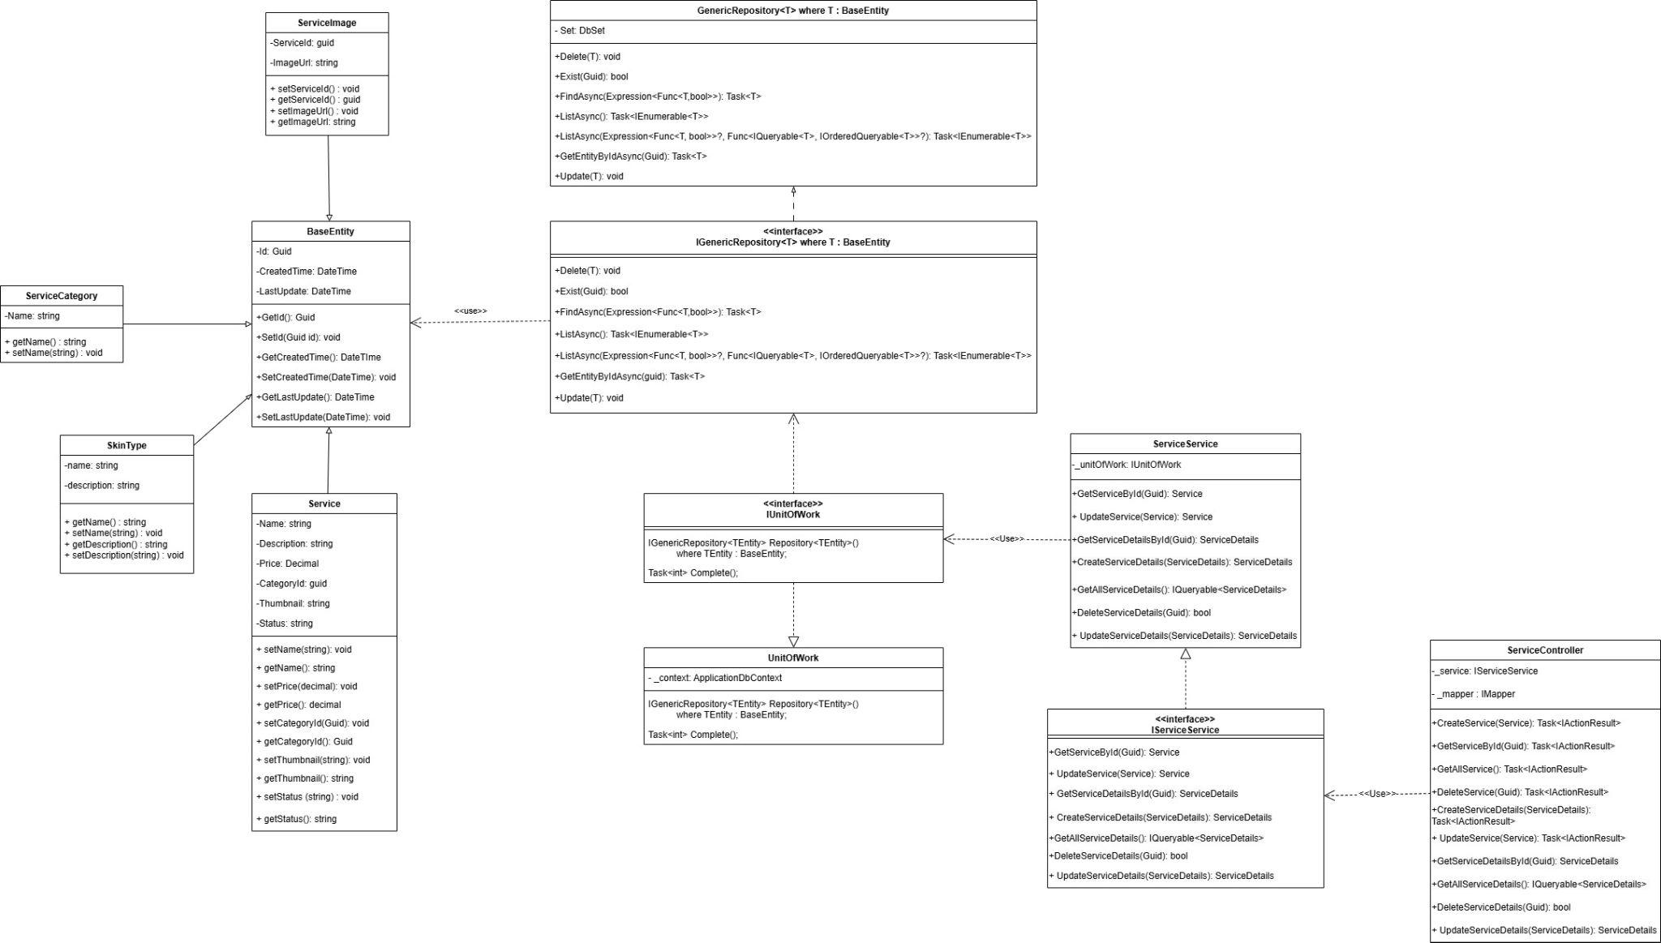

3.1.20 Delete service - Giang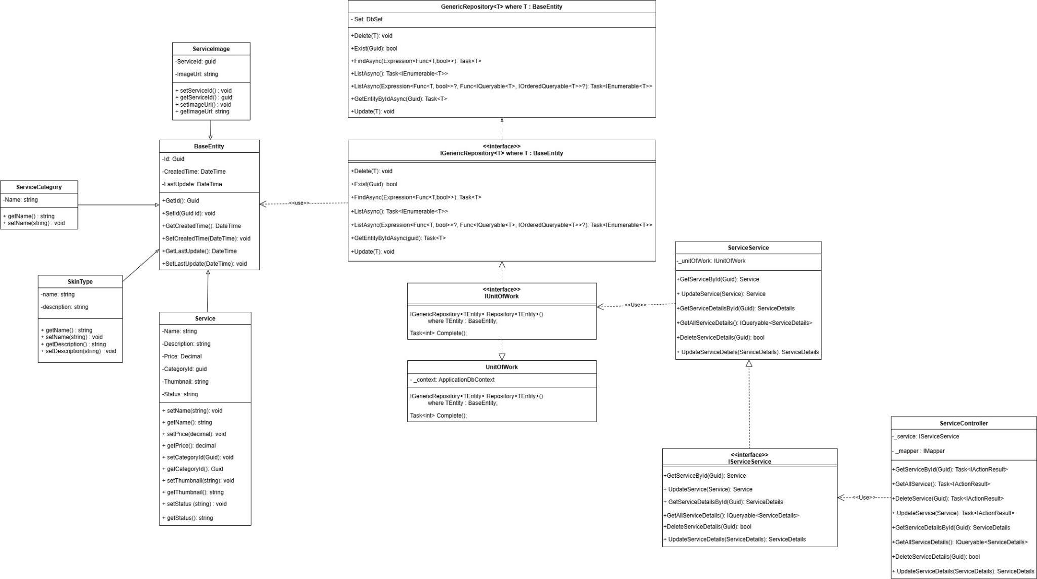

3.1.21 Register service - Giang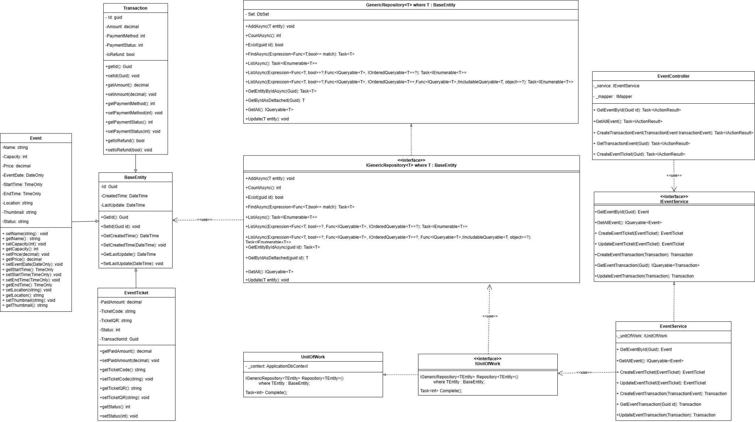

3.1.22 Cancel service - Giang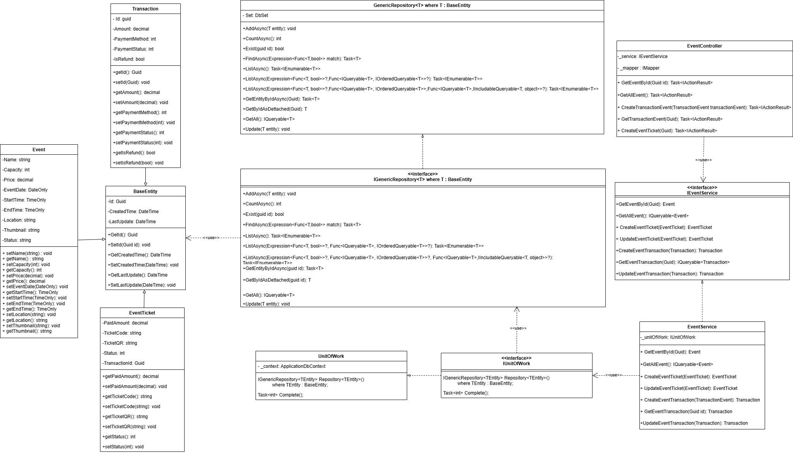

3.1.23 Booking service - Giang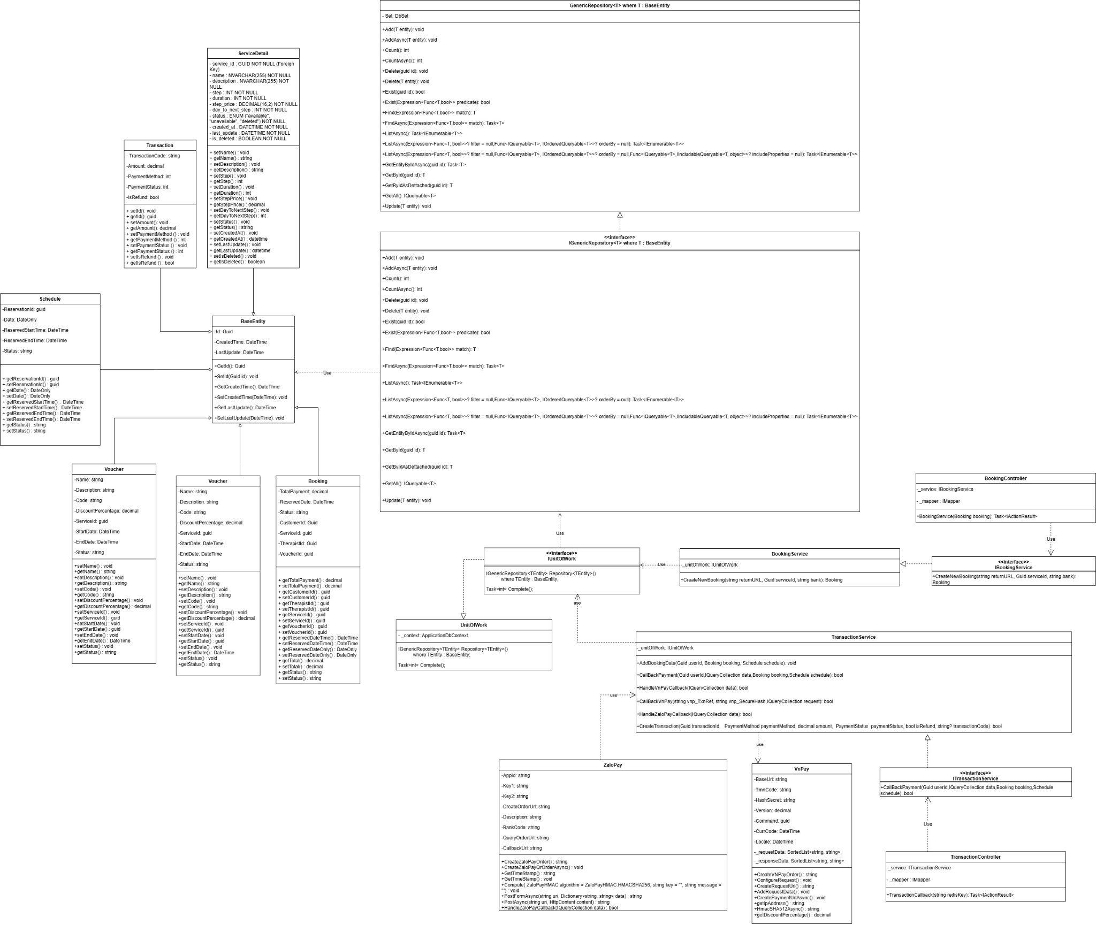

3.2 Sequence Diagram

3.2.1 Update event - Huy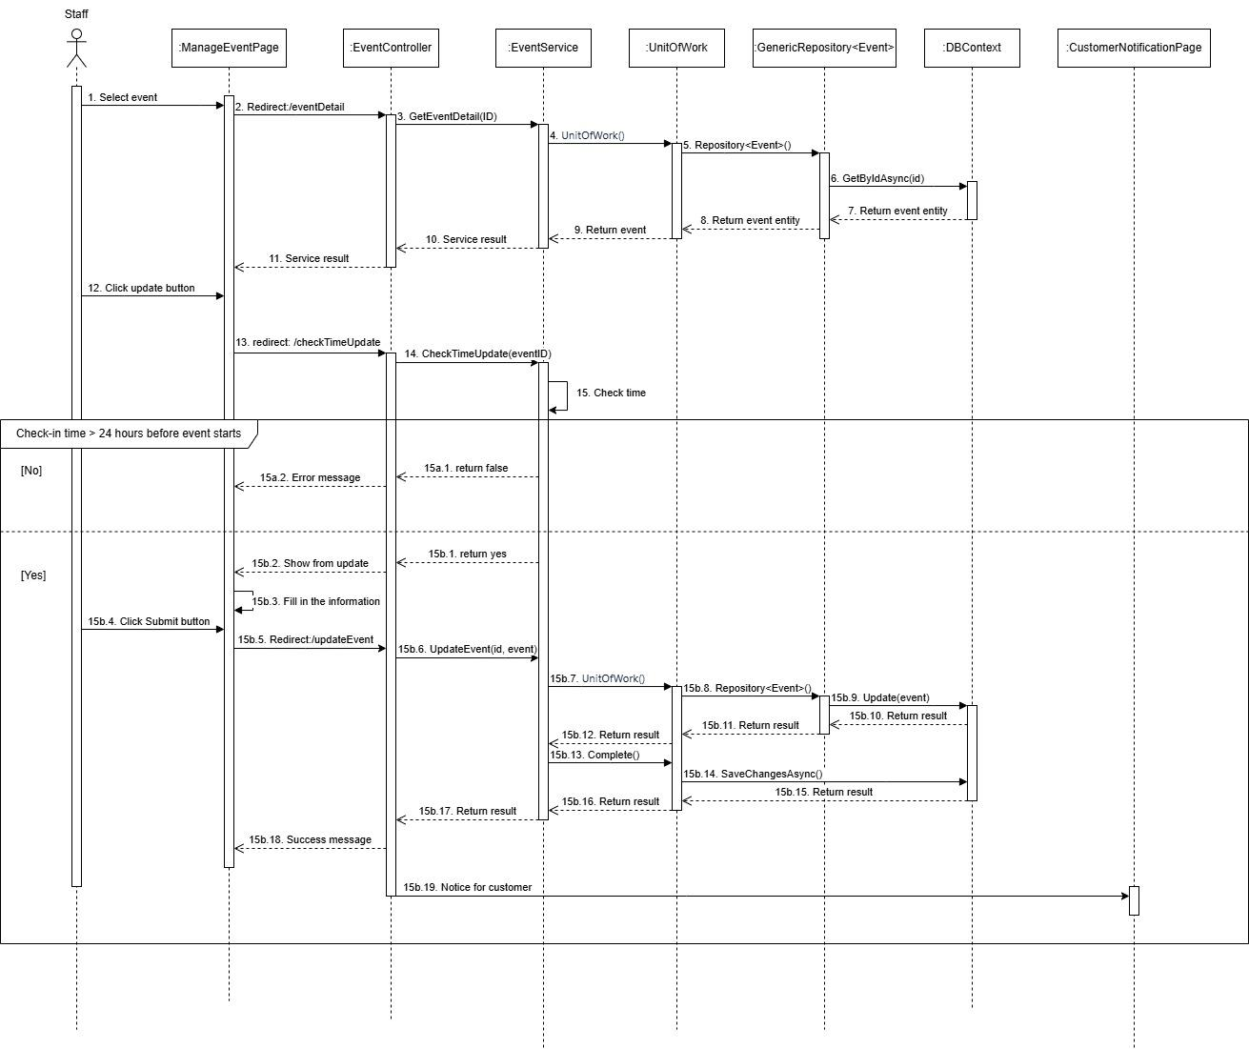

3.2.2 Check-in event by QR code and OTP code - Huy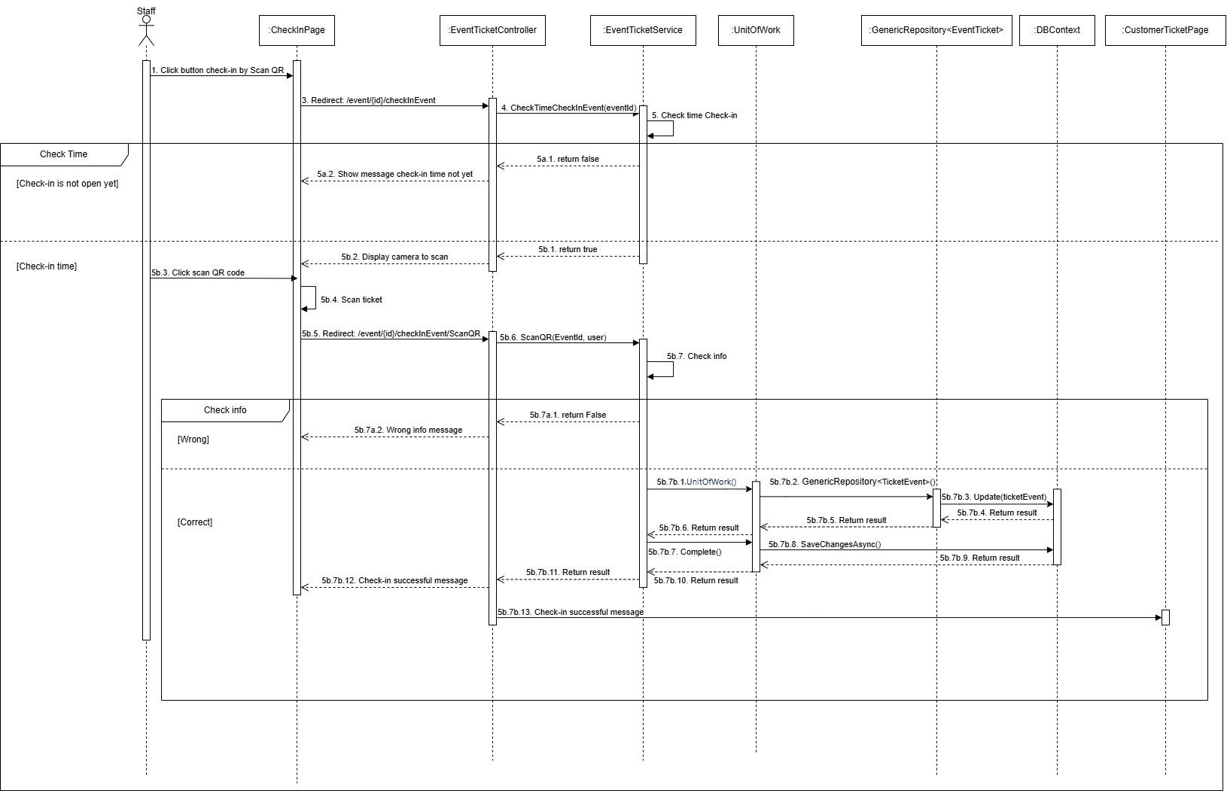

3.2.3 Cancel service - Huy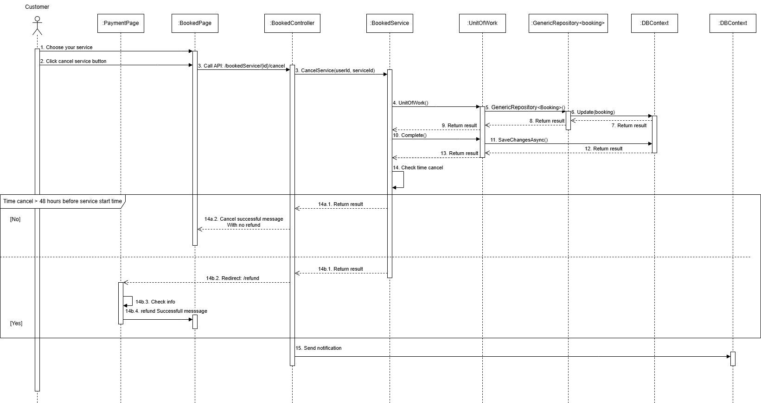

3.2.4 Remove event - Huy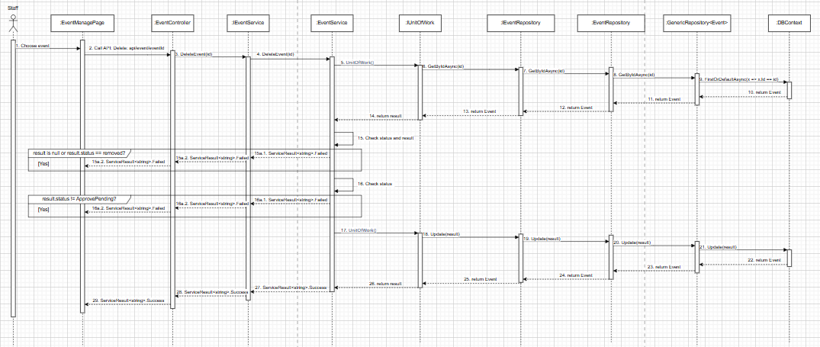

3.2.5 Booking service - Huy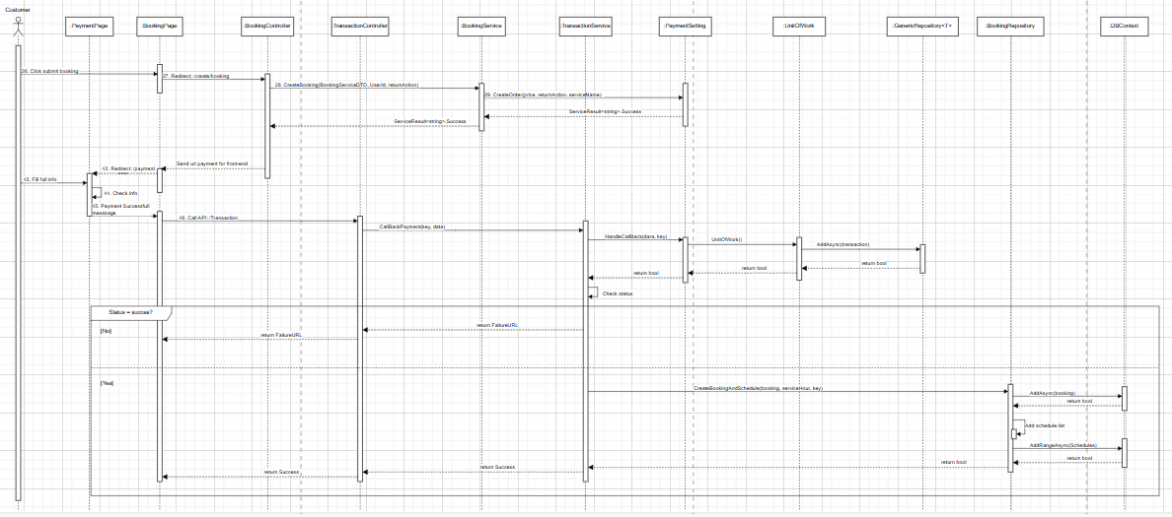

3.2.6 Delince request creation event - Huy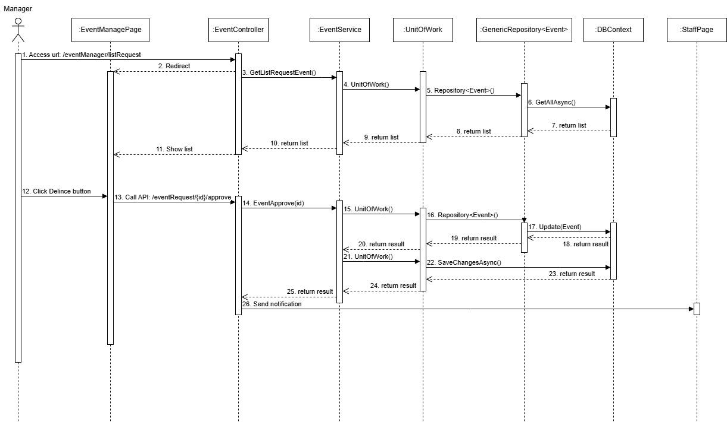

3.2.7 Approve request creation event-Huy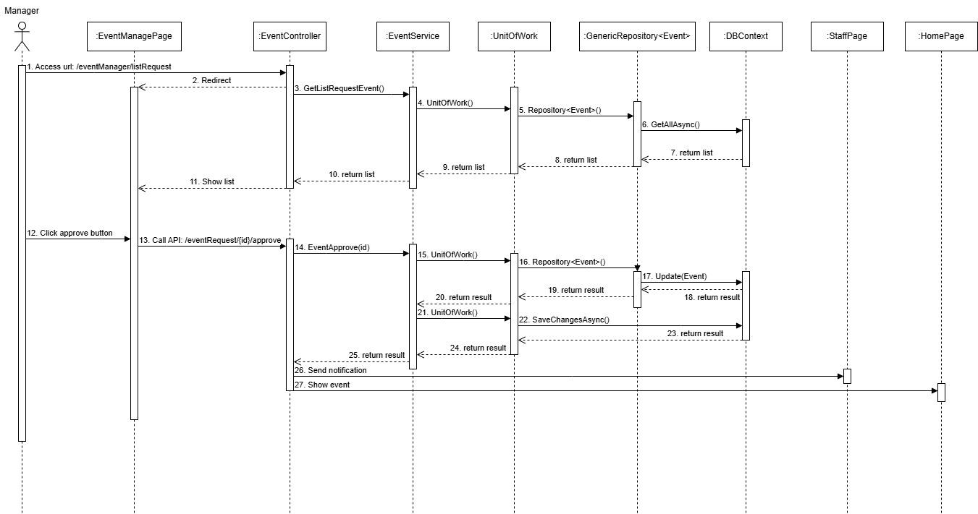

3.2.8 Check-out service - Thư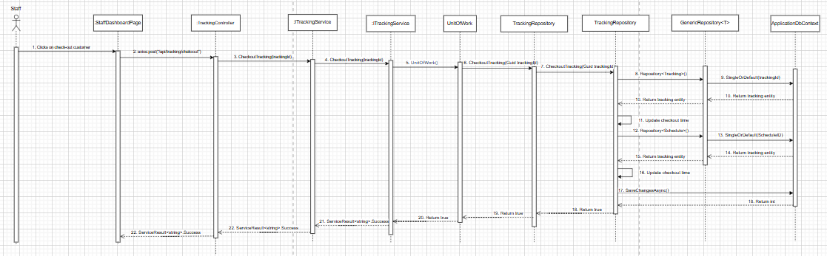

3.2.9 View all schedule ( manager ) - Thư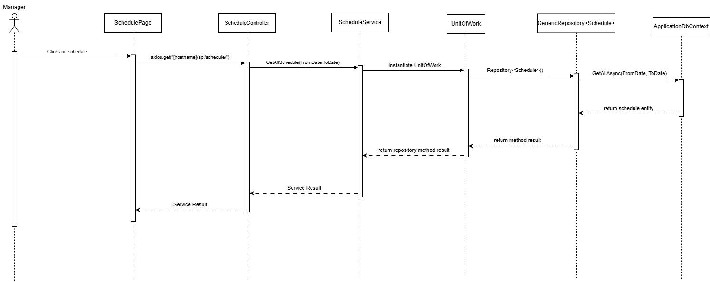

3.2.10 Skin therapist view check booked - Thư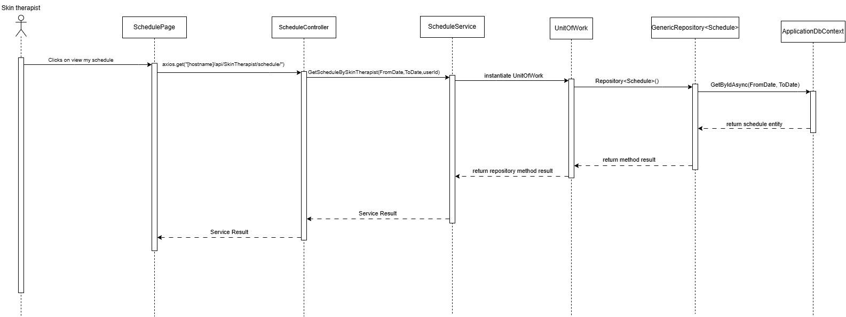

3.2.11 Staff support customer to book date for next step - Thư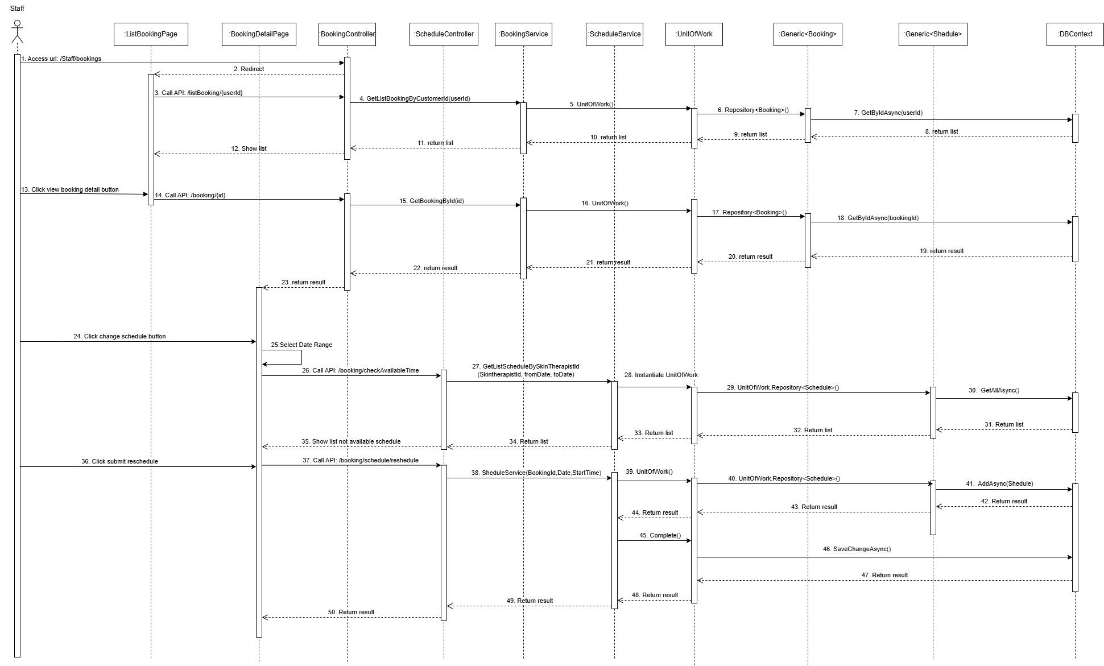

3.2.12 Reschedule -Thư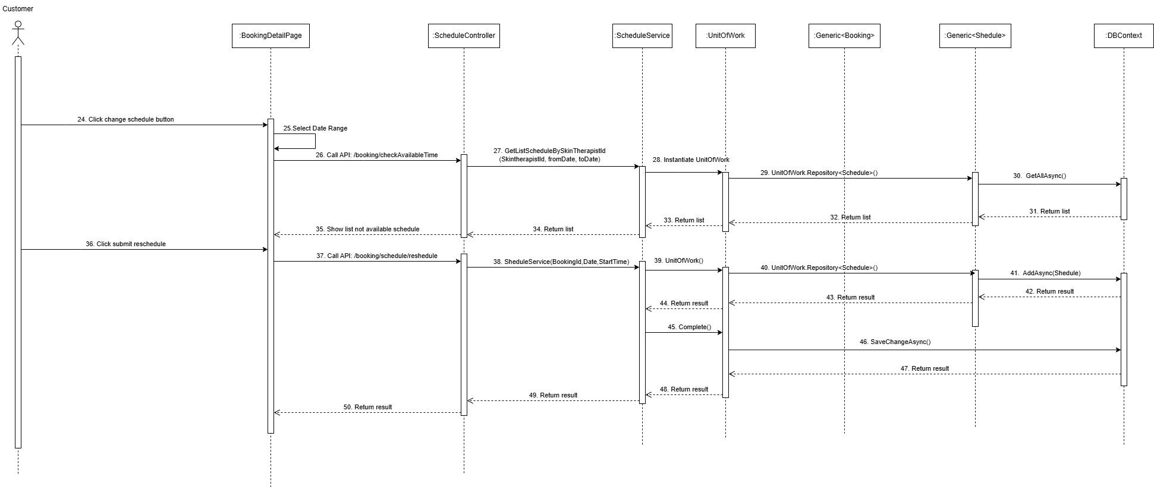

3.2.13 Tracking service result - Trí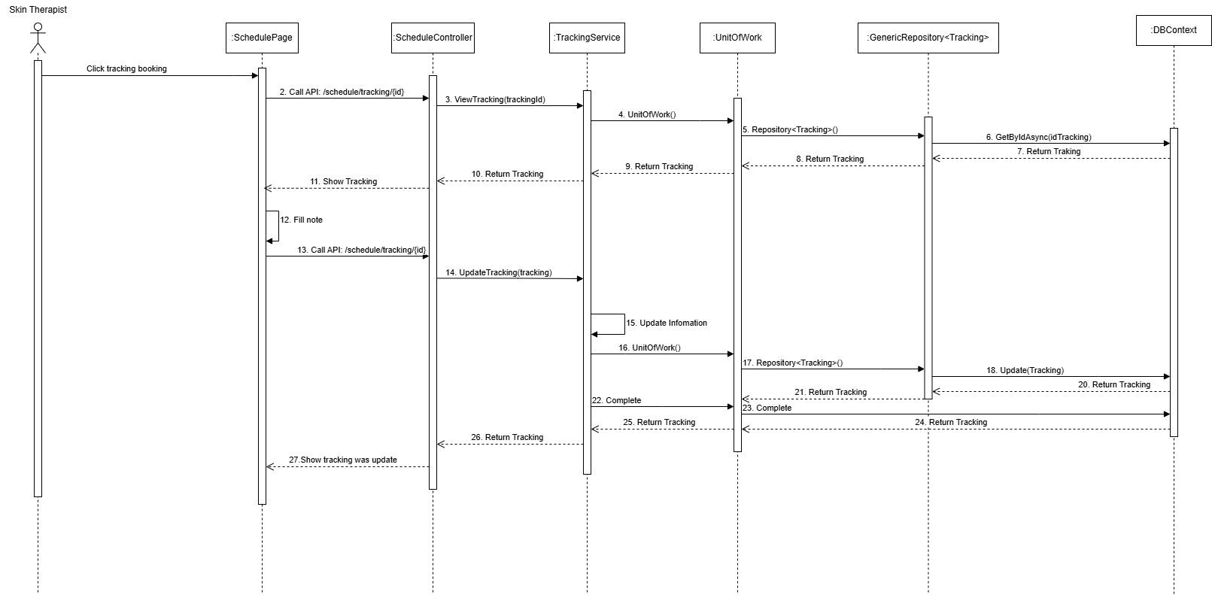

3.2.14 Create quiz - Trí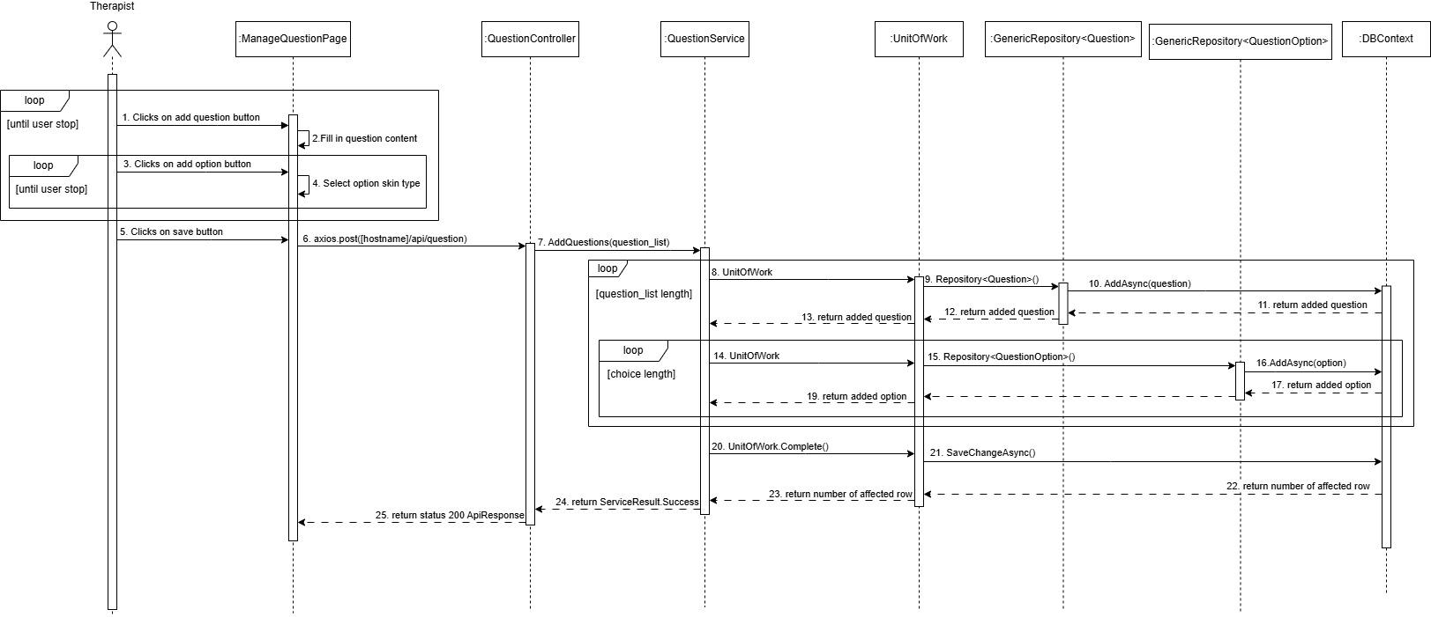

3.2.15 Update quiz - Trí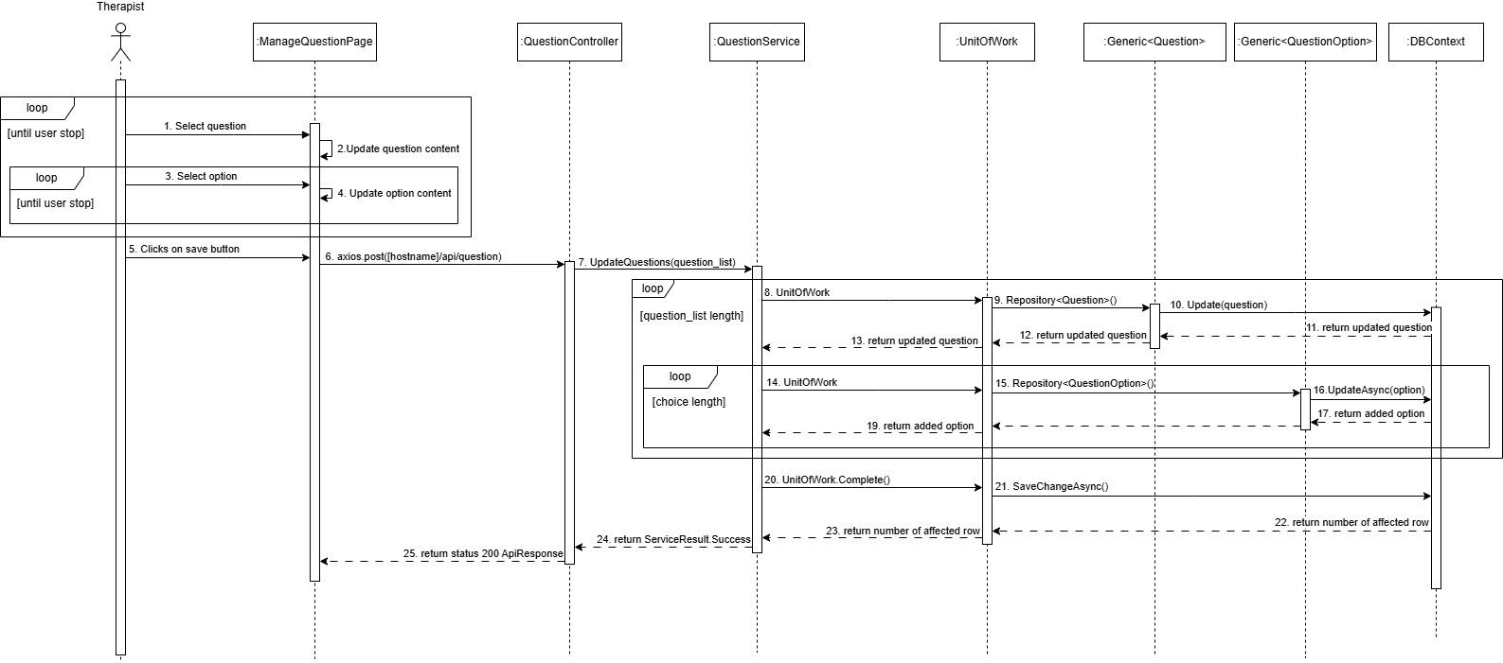

3.2.16 Update date of step - Trí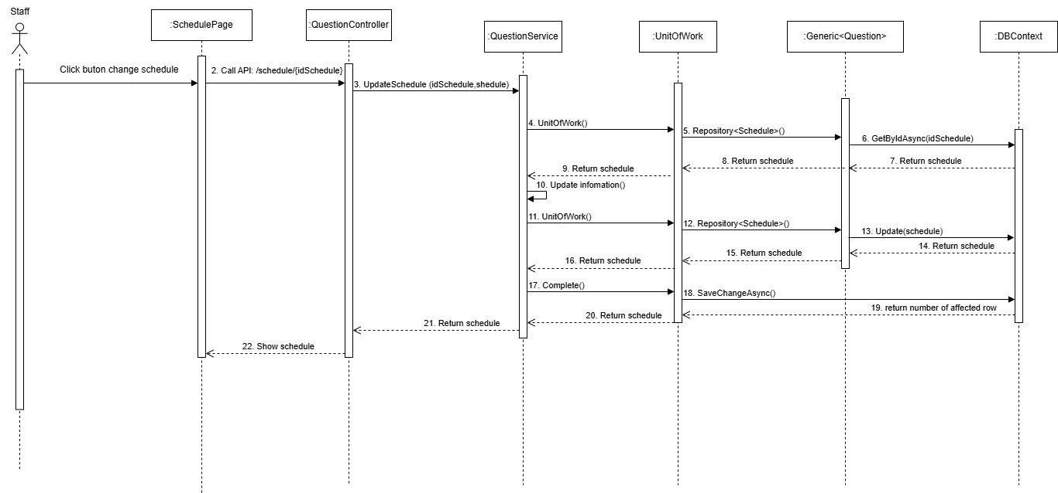

3.2.17 Login via google - Trí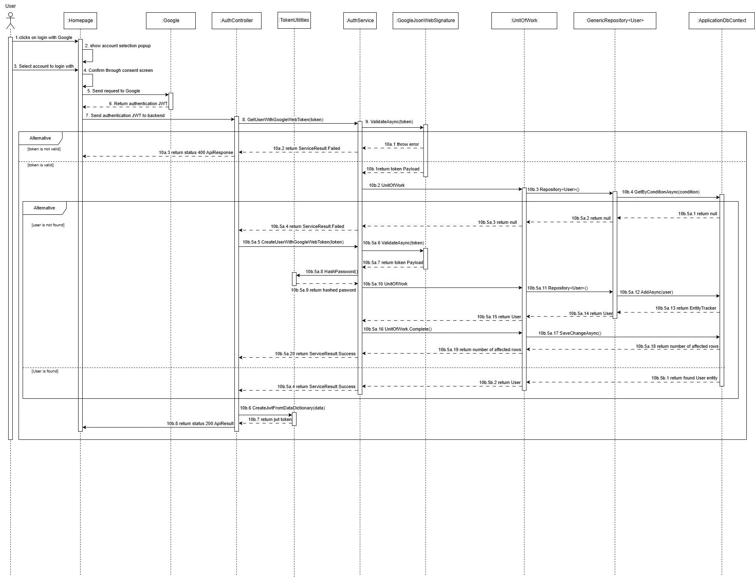

3.2.18 View service detail - Trí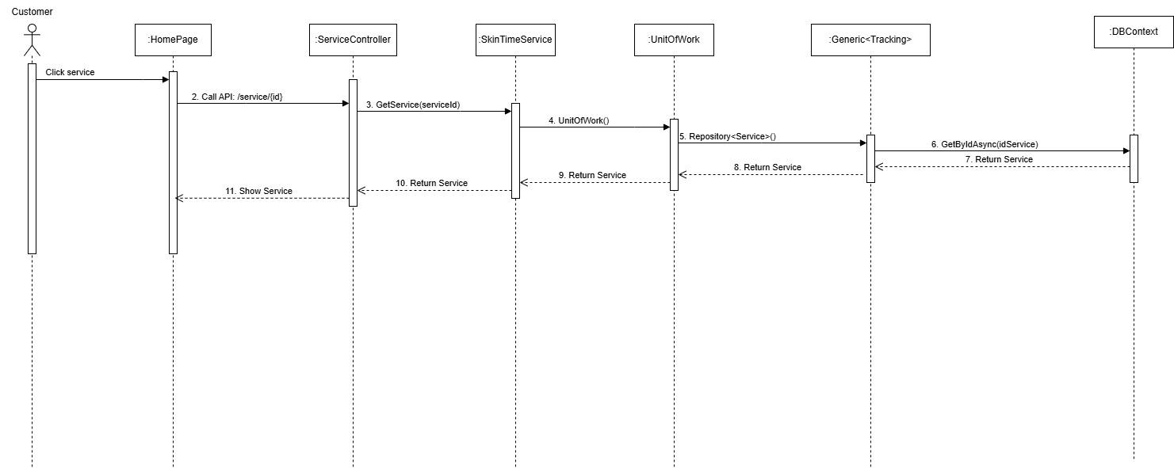

3.2.19 View booked schedule (staff) - Tấn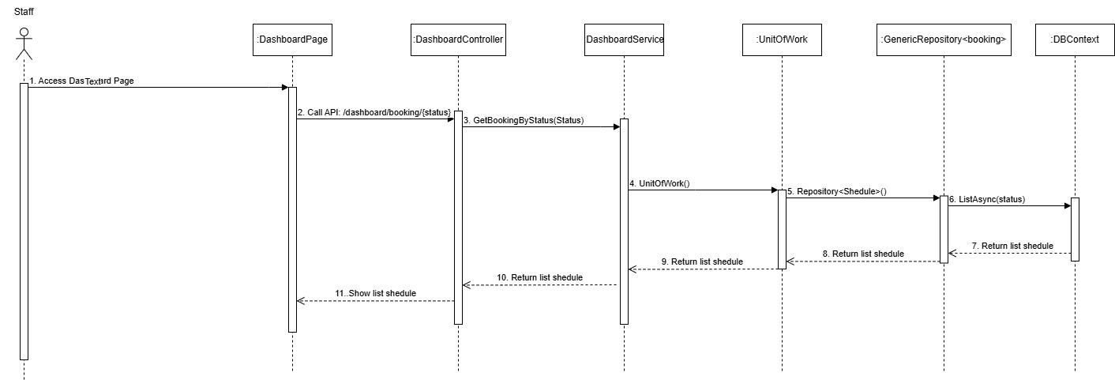

3.2.20 Do quiz - Tấn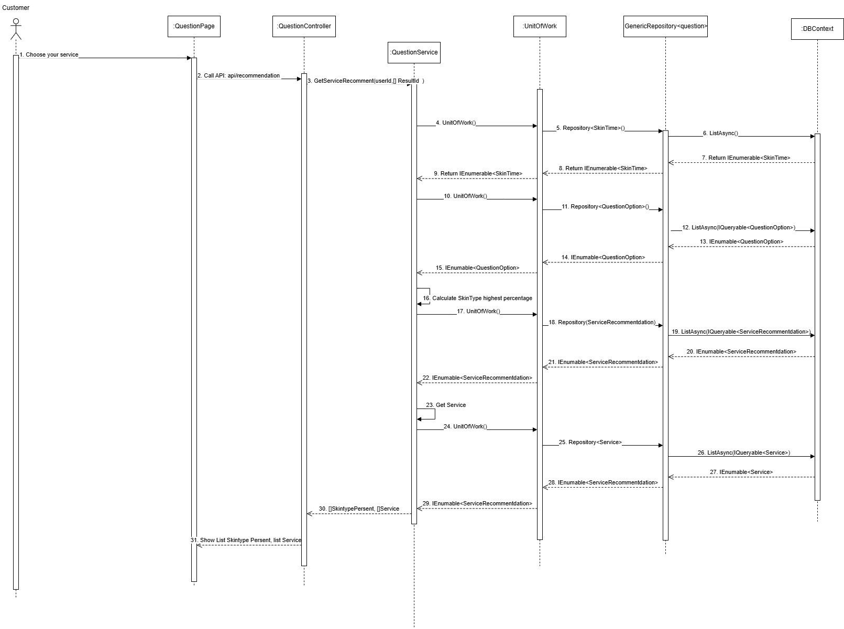

3.2.21 Upload certification - Tấn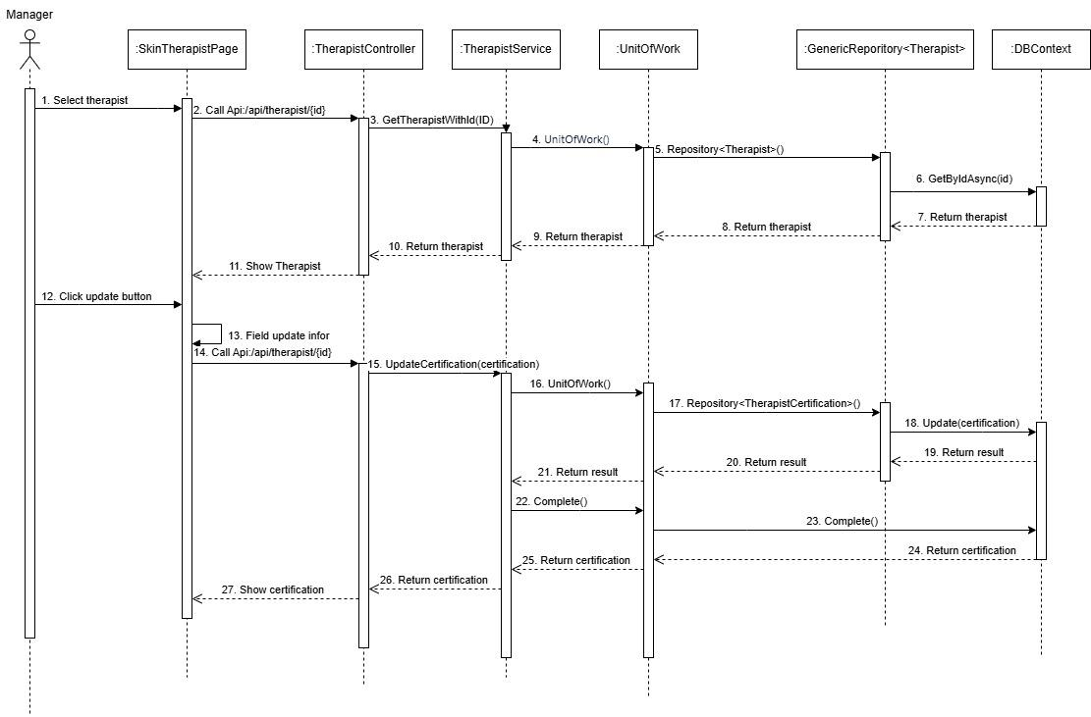

3.2.22 Create skin type - Thư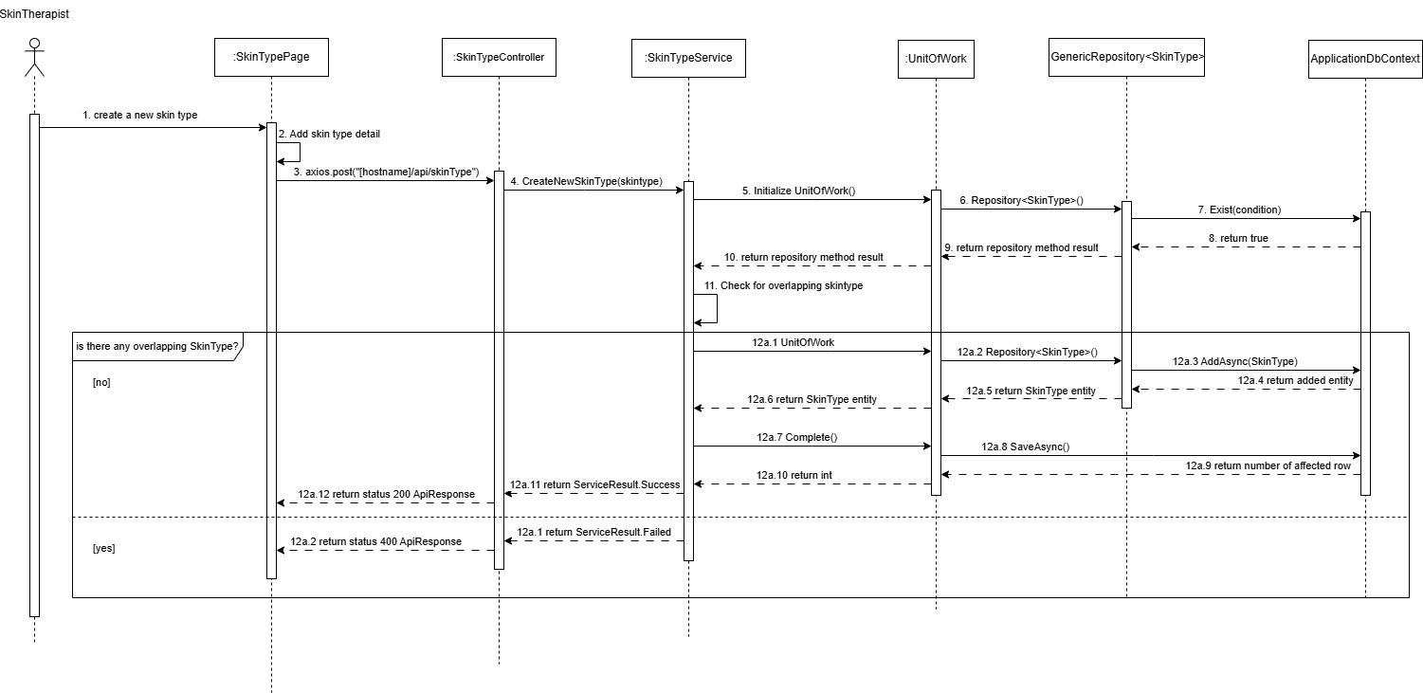

3.2.23 View service detail - Tấn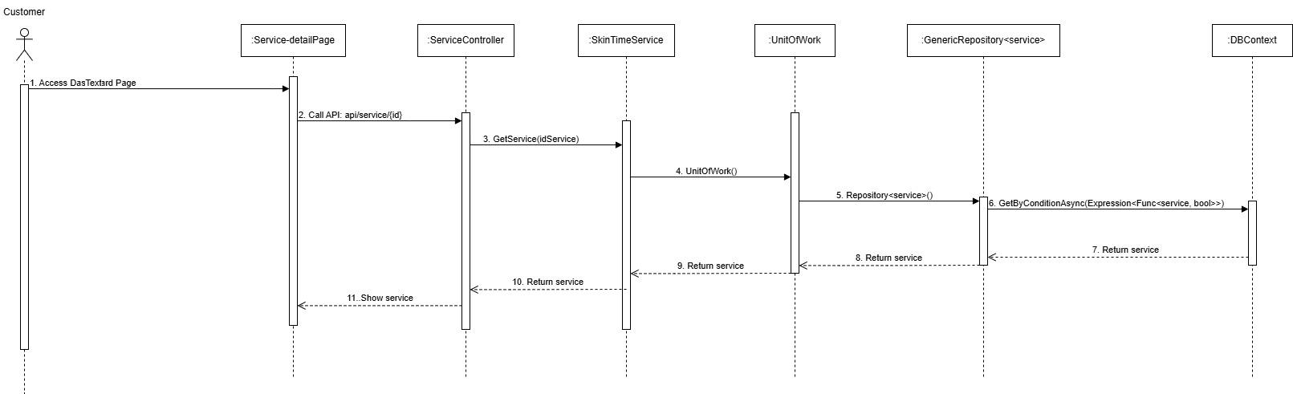

3.2.24 View skin therapist detail - Tấn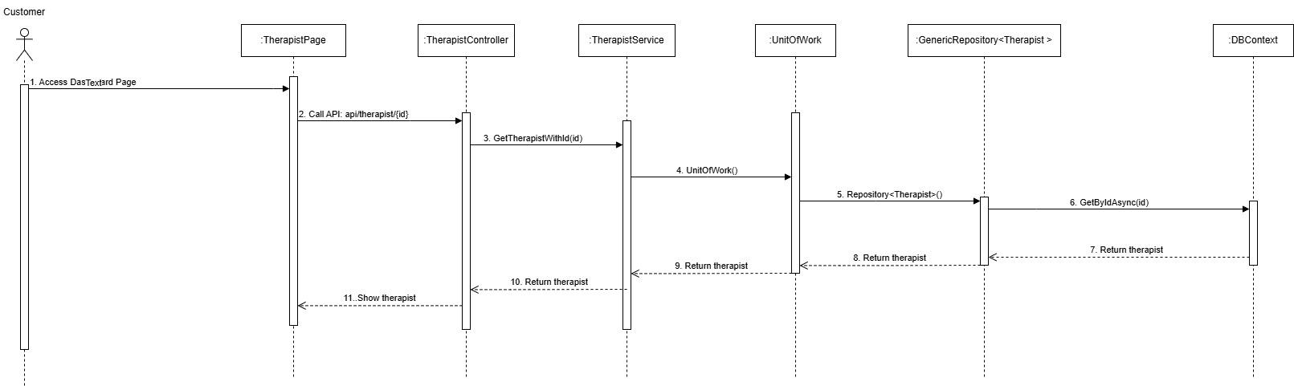

3.2.25 View event statistics(manager) - Diễm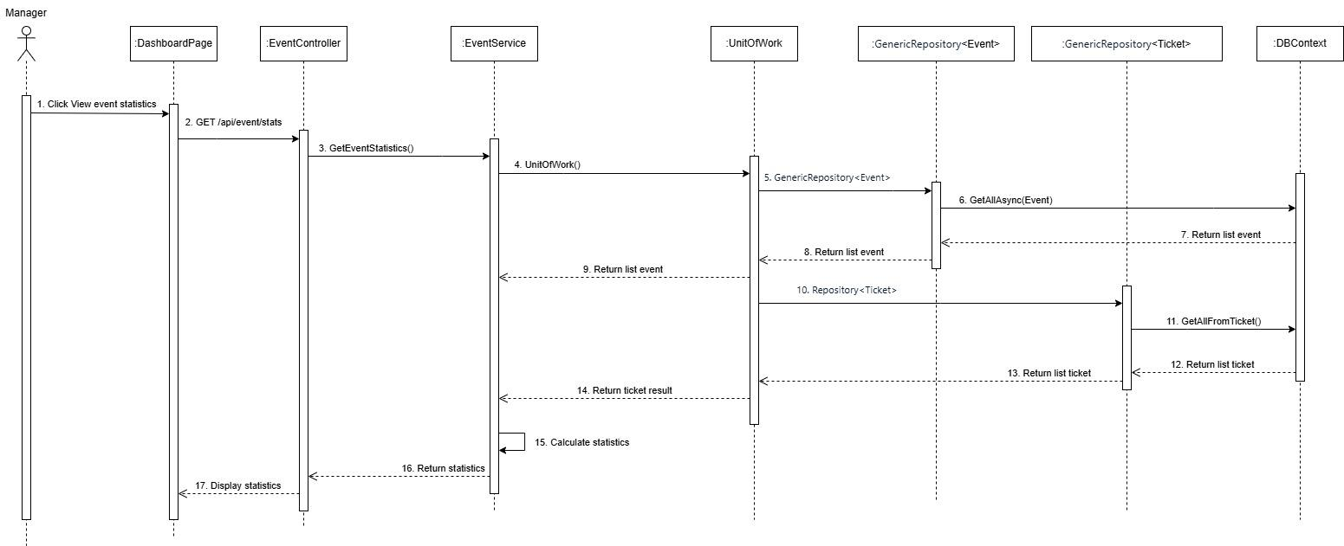

3.2.26 Create Account (admin) - Diễm fix by Huy
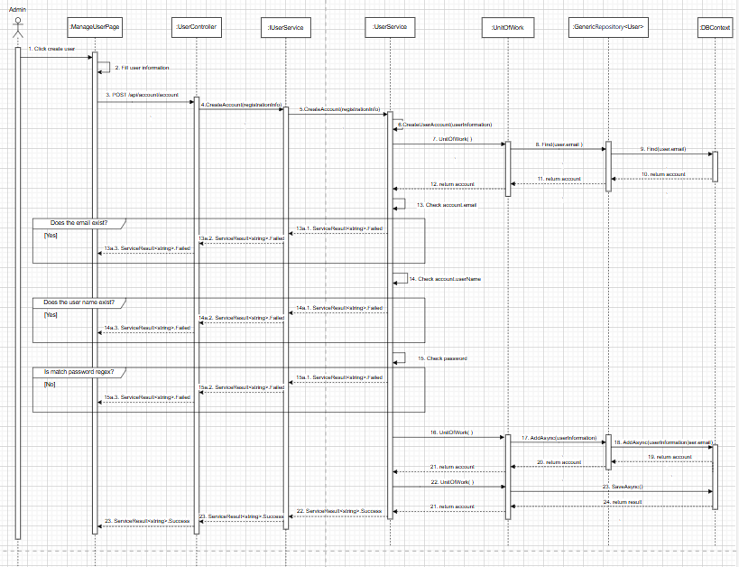

3.2.27 Delete Account (admin) - Diễm fix by Huy
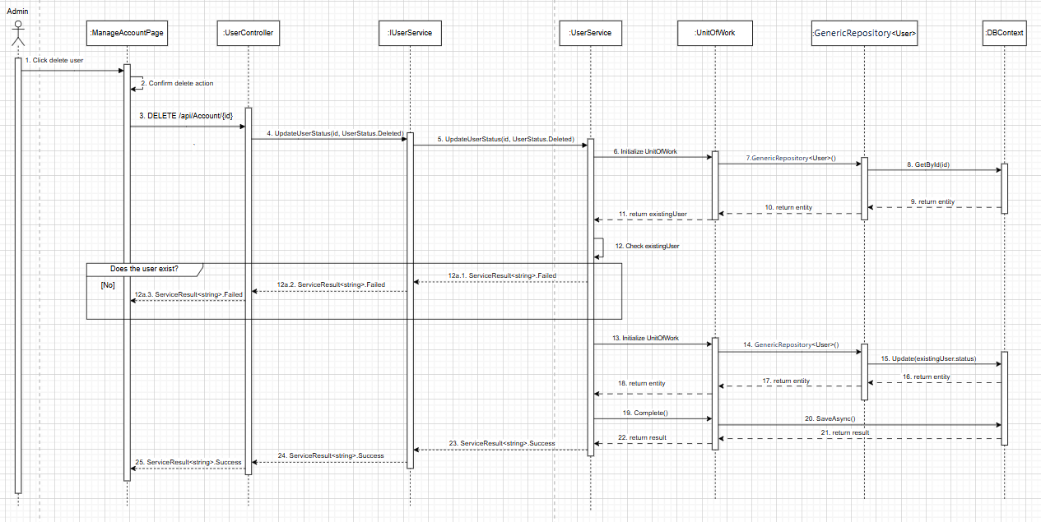

3.2.28 Post feedback - Diễm fix by Huy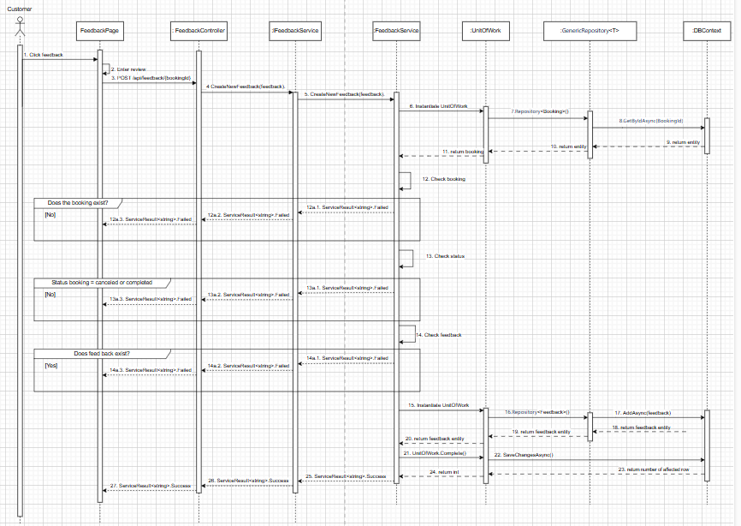

3.2.29 View service + feedback dash board (manager) - Diễm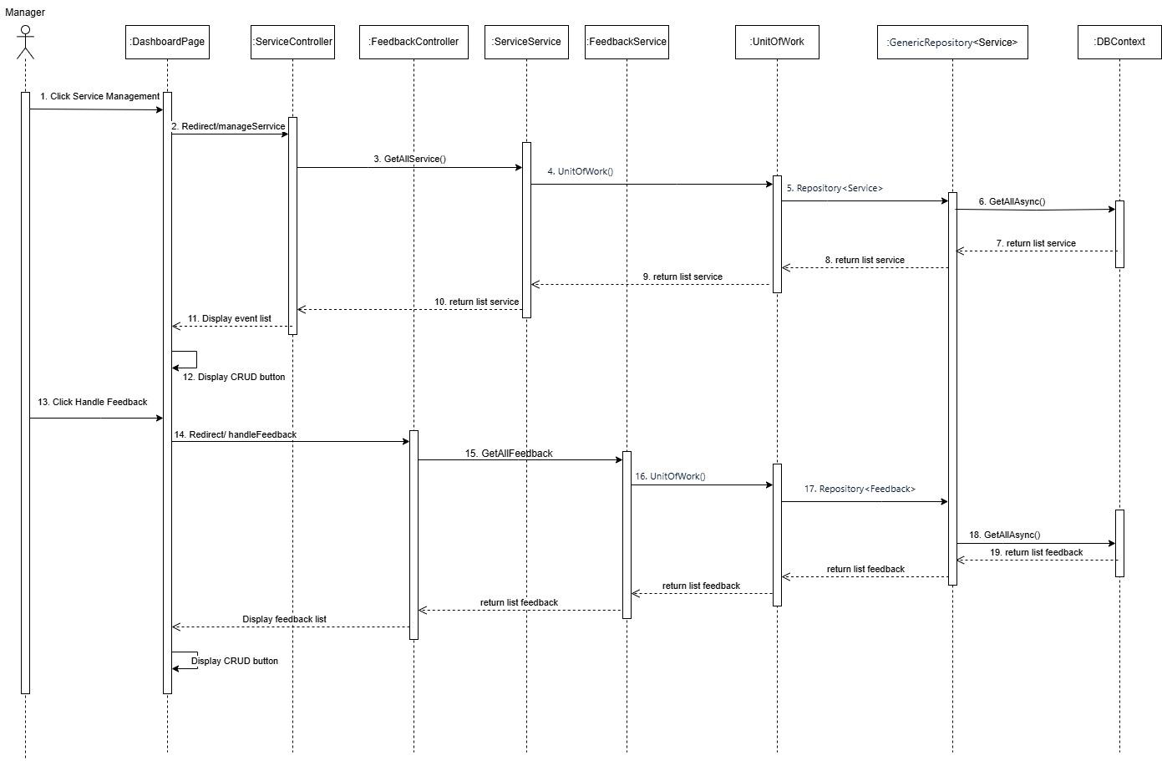

3.2.30 Login system - Giang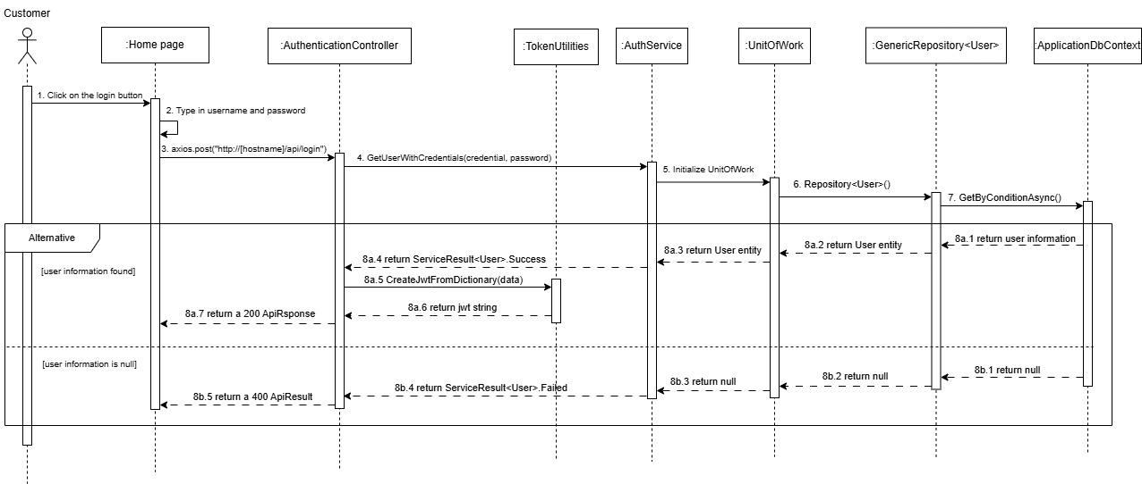

3.2.31 Create Event - Giang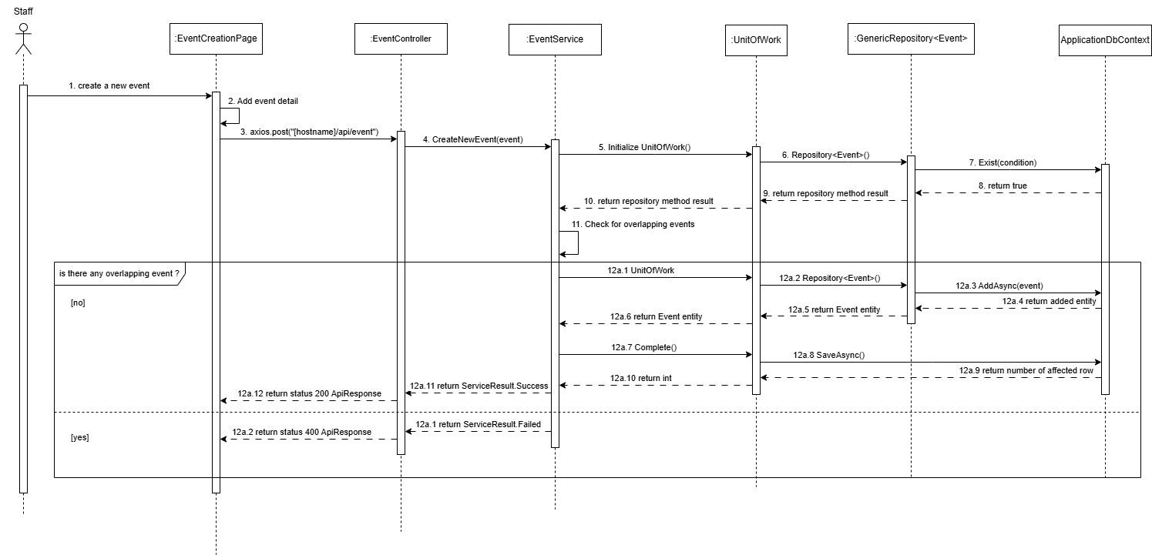

3.2.32 Buy ticket event - Giang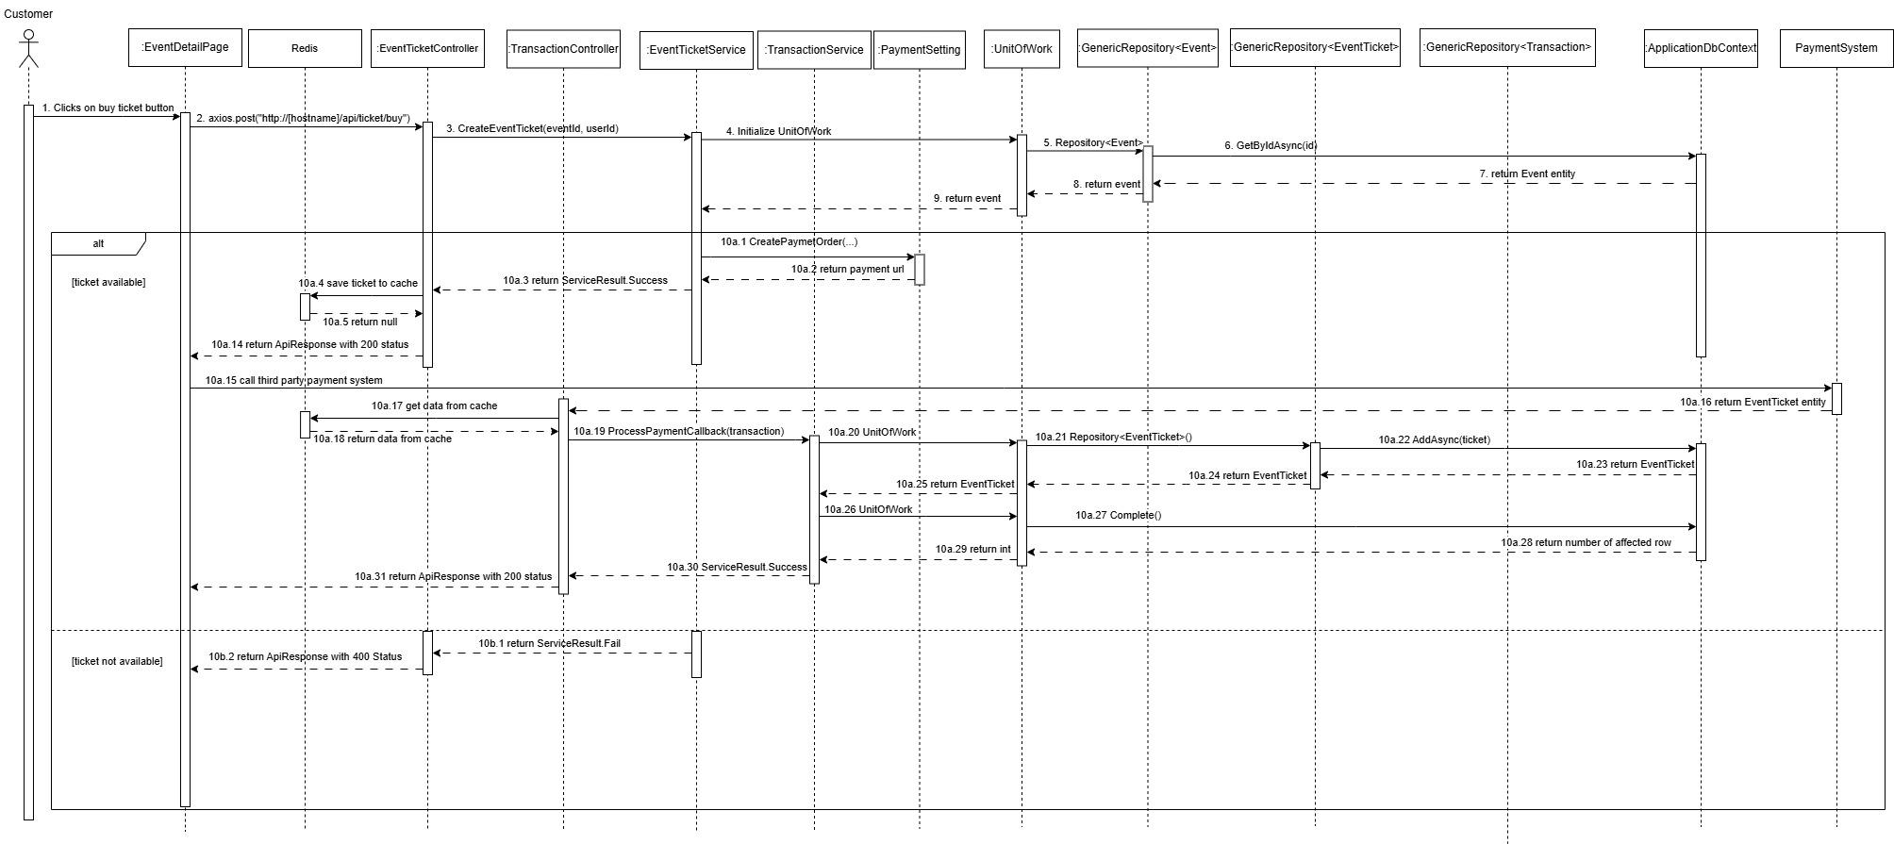

3.2.33 Cancel ticket event - Giang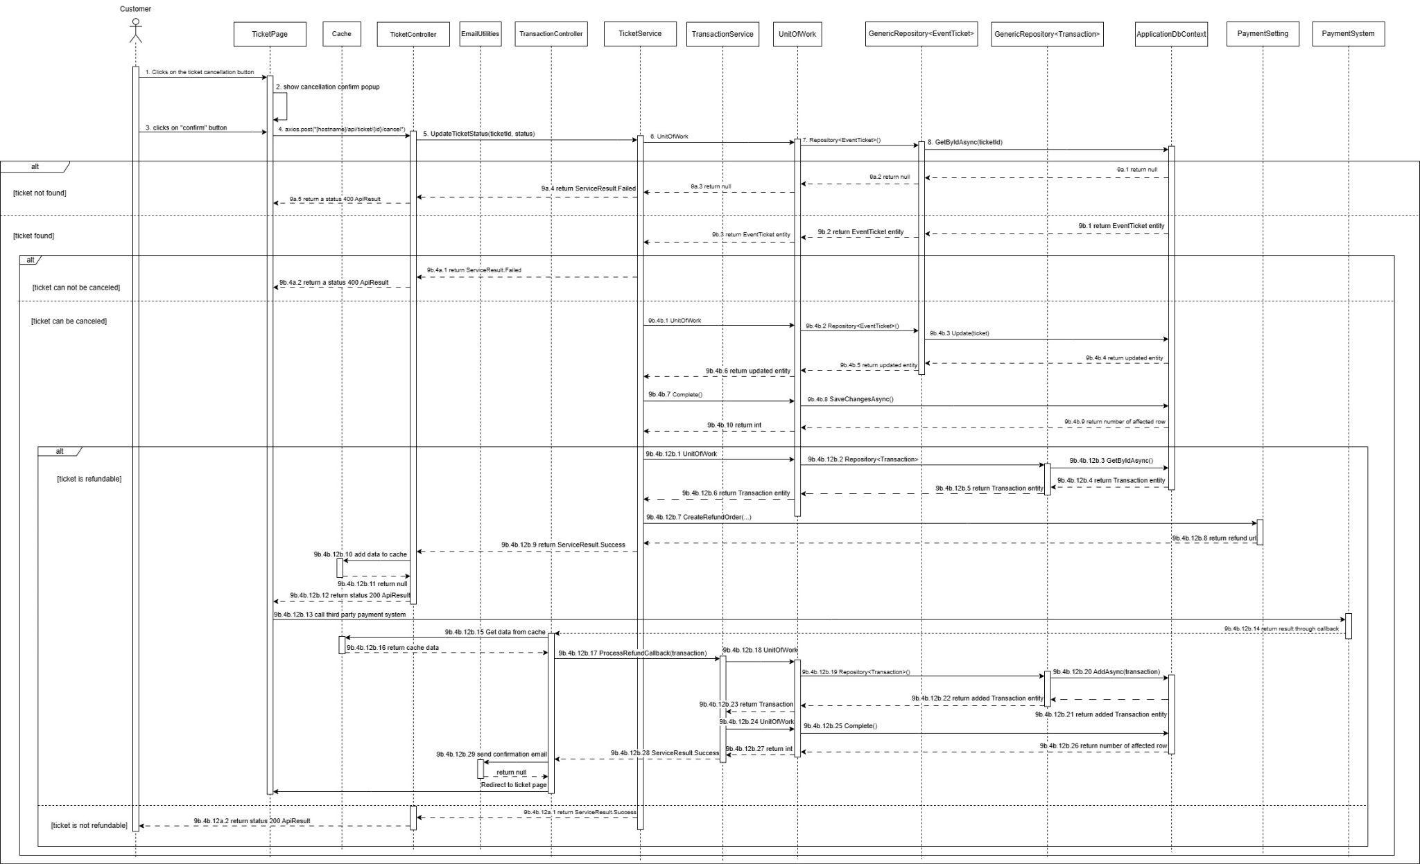

3.2.34 Check-in service - Giang 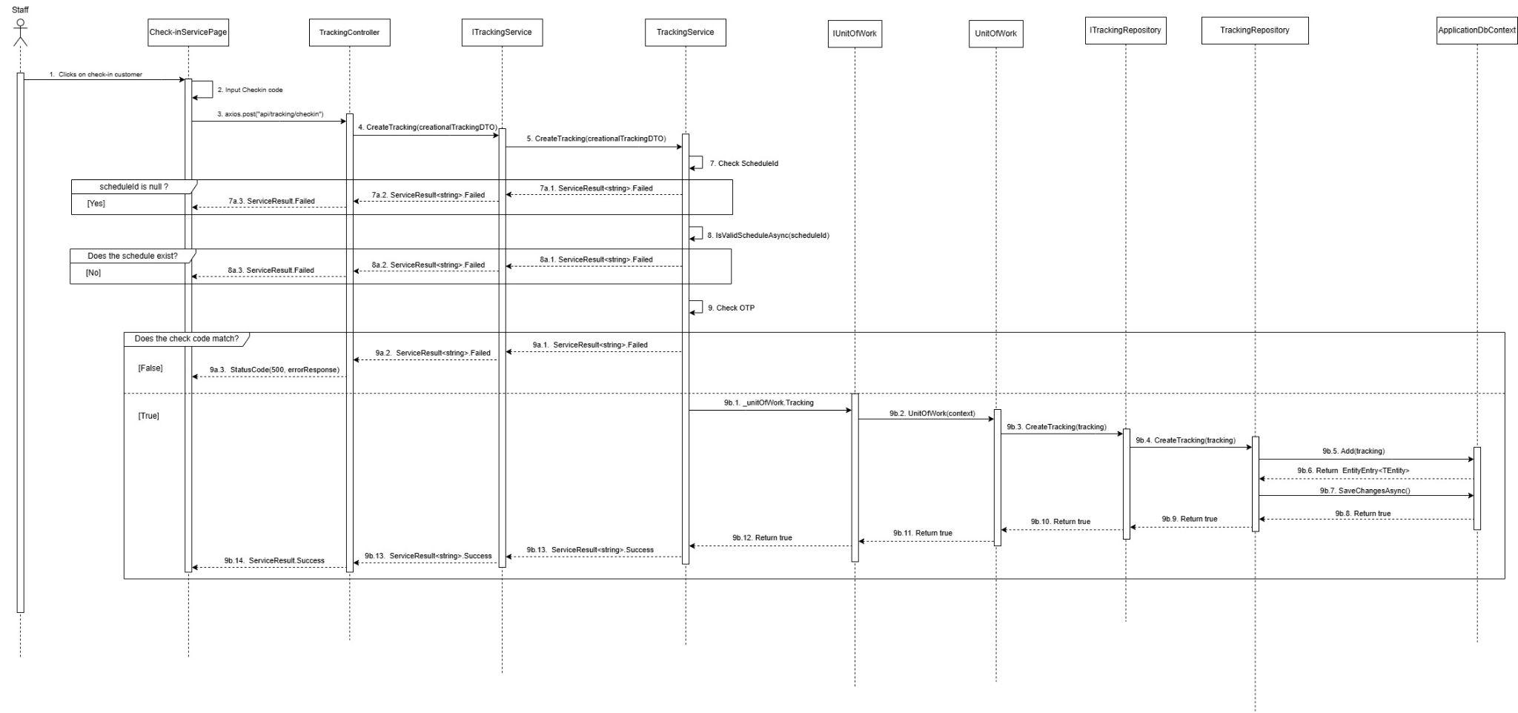

3.2.35 Create customer account - Giang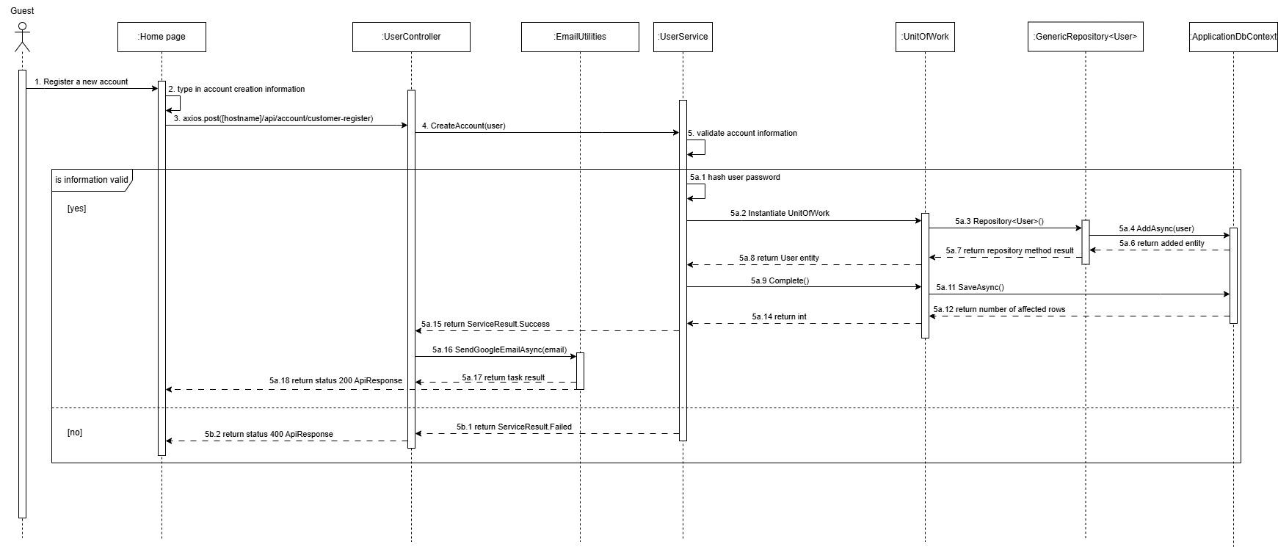

VI. Release Package & User Guides

1. Deliverable Package
No. | Deliverable Item | Description
1 | Schedule/Task Tracking | Task tracker: SWD391
2 | Project Backlog | https://github.com/SWD391-SkinTimeSystem
3 | Source Codes | https://github.com/SWD391-SkinTimeSystem

VII. Change request

14/03/2025
- Package Diagram: create new diagram
- Change ERD

15/03/2025
- Change system Architecture
- Change package diagram

21/03/2025
- Change sequence diagram
  - Check-in service

27/03/2025
- Change sequence diagram:
  - Remove event,
  - Create Account
  - Remove account
  - Post feedback
  - Check-out event

28/03/2025
- Change sequence diagram
  - Booking service

